


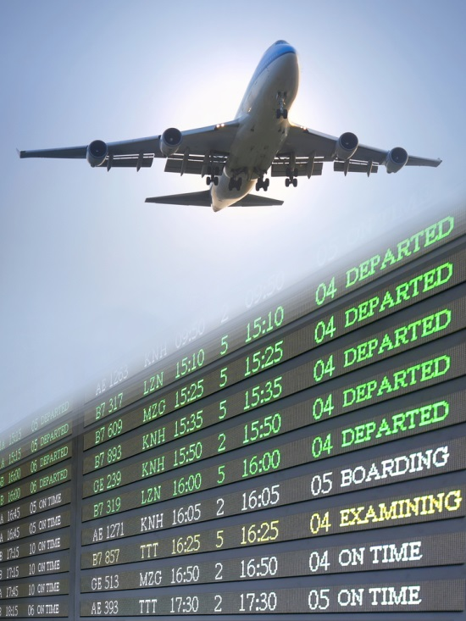



Audit financial procedures
D1.HFI.CL8.01
D1.HFA.CL7.05
D2.TFA.CL7.01
Trainee Manual

Audit financial procedures
D1.HFI.CL8.01
D1.HFA.CL7.05
D2.TFA.CL7.01
Trainee Manual





Project Base
William Angliss Institute of TAFE
555 La Trobe Street
Melbourne 3000 Victoria
Telephone: | (03) 9606 2111
Facsimile: | (03) 9670 1330
Acknowledgements
Project Director: | Wayne Crosbie
Project Manager | Jim Irwin
Chief Writer: | Alan Hickman
Subject Writer: | Nick Hyland and Dianne Whelan
Editor: | Jim Irwin
DTP/Production: | Daniel Chee, Mai Vu, Cindy Curran

The Association of Southeast Asian Nations (ASEAN) was established on 8 August 1967. The Member States of the Association are Brunei Darussalam, Cambodia, Indonesia, Lao PDR, Malaysia, Myanmar, Philippines, Singapore, Thailand and Viet Nam.
The ASEAN Secretariat is based in Jakarta, Indonesia.
General Information on ASEAN appears online at the ASEAN Website: www.asean.org.
All text is produced by William Angliss Institute of TAFE for the ASEAN Project on “Toolbox Development for Tourism Labour Divisions for Travel Agencies and Tour Operations”.
This publication is supported by the Australian Government’s aid program through the ASEAN-Australia Development Cooperation Program Phase II (AADCP II).
Copyright: Association of Southeast Asian Nations (ASEAN) 2015.
All rights reserved.
Disclaimer
Every effort has been made to ensure that this publication is free from errors or omissions. However, you should conduct your own enquiries and seek professional advice before relying on any fact, statement or matter contained in this book. The ASEAN Secretariat and William Angliss Institute of TAFE are not responsible for any injury, loss or damage as a result of material included or omitted from this course. Information in this module is current at the time of publication. Time of publication is indicated in the date stamp at the bottom of each page.
Some images appearing in this resource have been purchased from stock photography suppliers Shutterstock and iStockphoto and other third party copyright owners and as such are non-transferable and non-exclusive. Clip arts, font images and illustrations used are from the Microsoft Office Clip Art and Media Library. Some images have been provided by and are the property of William Angliss Institute.
Additional images have been sourced from Flickr and SXC and are used under Creative Commons licence: http://creativecommons.org/licenses/by/2.0/deed.en

File name: TM_Audit financial procedures_270715





Table of contents
Introduction to trainee manual 1
Unit descriptor 3
Assessment matrix 5
Glossary 7
Element 1: Monitor financial procedures 9
Element 2: Complete financial reports 135
Presentation of written work 185
Recommended reading 187
Trainee evaluation sheet 189
Trainee self-assessment checklist 191

Introduction to trainee manual

To the Trainee
Congratulations on joining this course. This Trainee Manual is one part of a ‘toolbox’ which is a resource provided to trainees, trainers and assessors to help you become competent in various areas of your work.
The ‘toolbox’ consists of three elements:
- A Trainee Manual for you to read and study at home or in class
- A Trainer Guide with Power Point slides to help your Trainer explain the content of the training material and provide class activities to help with practice
- An Assessment Manual which provides your Assessor with oral and written questions and other assessment tasks to establish whether or not you have achieved competency.
The first thing you may notice is that this training program and the information you find in the Trainee Manual seems different to the textbooks you have used previously. This is because the method of instruction and examination is different. The method used is called Competency based training (CBT) and Competency based assessment (CBA). CBT and CBA is the training and assessment system chosen by ASEAN (Association of South-East Asian Nations) to train people to work in the tourism and hospitality industry throughout all the ASEAN member states.
What is the CBT and CBA system and why has it been adopted by ASEAN?
CBT is a way of training that concentrates on what a worker can do or is required to do at work. The aim is of the training is to enable trainees to perform tasks and duties at a standard expected by employers. CBT seeks to develop the skills, knowledge and attitudes (or recognise the ones the trainee already possesses) to achieve the required competency standard. ASEAN has adopted the CBT/CBA training system as it is able to produce the type of worker that industry is looking for and this therefore increases trainees’ chances of obtaining employment.
CBA involves collecting evidence and making a judgement of the extent to which a worker can perform his/her duties at the required competency standard. Where a trainee can already demonstrate a degree of competency, either due to prior training or work experience, a process of ‘Recognition of Prior Learning’ (RPL) is available to trainees to recognise this. Please speak to your trainer about RPL if you think this applies to you.
What is a competency standard?
Competency standards are descriptions of the skills and knowledge required to perform a task or activity at the level of a required standard.
242 competency standards for the tourism and hospitality industries throughout the ASEAN region have been developed to cover all the knowledge, skills and attitudes required to work in the following occupational areas:
- Housekeeping
- Food Production
- Food and Beverage Service
- Front Office
- Travel Agencies
- Tour Operations.
All of these competency standards are available for you to look at. In fact you will find a summary of each one at the beginning of each Trainee Manual under the heading ‘Unit Descriptor’. The unit descriptor describes the content of the unit you will be studying in the Trainee Manual and provides a table of contents which are divided up into ‘Elements’ and ‘Performance Criteria”. An element is a description of one aspect of what has to be achieved in the workplace. The ‘Performance Criteria’ below each element details the level of performance that needs to be demonstrated to be declared competent.
There are other components of the competency standard:
- Unit Title: statement about what is to be done in the workplace
- Unit Number: unique number identifying the particular competency
- Nominal hours: number of classroom or practical hours usually needed to complete the competency. We call them ‘nominal’ hours because they can vary e.g. sometimes it will take an individual less time to complete a unit of competency because he/she has prior knowledge or work experience in that area.
The final heading you will see before you start reading the Trainee Manual is the ‘Assessment Matrix’. Competency based assessment requires trainees to be assessed in at least 2 – 3 different ways, one of which must be practical. This section outlines three ways assessment can be carried out and includes work projects, written questions and oral questions. The matrix is designed to show you which performance criteria will be assessed and how they will be assessed. Your trainer and/or assessor may also use other assessment methods including ‘Observation Checklist’ and ‘Third Party Statement’. An observation checklist is a way of recording how you perform at work and a third party statement is a statement by a supervisor or employer about the degree of competence they believe you have achieved. This can be based on observing your workplace performance, inspecting your work or gaining feedback from fellow workers.
Your trainer and/or assessor may use other methods to assess you such as:
- Journals
- Oral presentations
- Role plays
- Log books
- Group projects
- Practical demonstrations.
Remember your trainer is there to help you succeed and become competent. Please feel free to ask him or her for more explanation of what you have just read and of what is expected from you and best wishes for your future studies and future career in tourism and hospitality.

Unit descriptor
Audit financial procedures
This unit deals with the skills and knowledge required to Audit financial procedures in a range of settings within the travel industries workplace context.
Unit Code:
D1.HFI.CL8.01
D1.HFA.CL7.05
D2.TFA.CL7.01
Nominal Hours:
60

Element 1: Monitor financial procedures
Performance Criteria
1.1 Check transactions accord with enterprise procedures
1.2 Balance transactions accurately
1.3 Check balances prepared by others are in accordance with enterprise procedures
1.4 Implement and control financial systems in accordance with enterprise procedures
1.5 Monitor financial systems and provide input on possible improvements to appropriate personnel
1.6 Identify and resolve discrepancies or errors according to level of responsibility and in consultation with designated persons

Element 2: Complete financial reports
Performance Criteria
2.1 Accurately complete routine financial/statistical reports within designated timelines
2.2 Forward financial/statistical reports promptly to the appropriate person/department

Assessment matrix
Showing mapping of Performance Criteria against Work Projects, Written Questions and Oral Questions
The Assessment Matrix indicates three of the most common assessment activities your Assessor may use to assess your understanding of the content of this manual and your performance - Work Projects, Written Questions and Oral Questions. It also indicates where you can find the subject content related to these assessment activities in the Trainee Manual (i.e. under which element or performance criteria). As explained in the Introduction, however, the assessors are free to choose which assessment activities are most suitable to best capture evidence of competency as they deem appropriate for individual students.
 |  |  | Work Projects | Written Questions | Oral Questions
Element 1: Monitor financial procedures
1.1 | Check transactions accord with enterprise procedures |  | 1.1 | 1,2,3 | 1
1.2 | Balance transactions accurately |  | 1.2 | 4,5,6 | 2
1.3 | Check balances prepared by others are in accordance with enterprise procedures |  | 1.3 | 7,8,9 | 3
1.4 | Implement and control financial systems in accordance with enterprise procedures |  | 1.4 | 10,11,12 | 4
1.5 | Monitor financial systems and provide input on possible improvements to appropriate personnel |  | 1.5 | 13,14,15 | 5
1.6 | Identify and resolve discrepancies or errors according to level of responsibility and in consultation with designated persons |  | 1.6 | 16,17,18 | 6
Element 2: Complete financial reports
2.1 |  | Accurately complete routine financial/statistical reports within designated timelines | 2.1 | 19,20,21 | 7
2.2 |  | Forward financial/statistical reports promptly to the appropriate person/department | 2.2 | 22,23,24 | 8

Glossary
Term | Explanation
Accounting equation | Assets = Liabilities + Equity  Assets = Liabilities + Equity + Revenue – Expenses – Dividends/ Drawings
Accounting process or cycle | Process of recording and classifying financial transactions
Assets | An item of value that is owned by an organisation or business
Business unit | Part of a company representing a specific business function
Cash | Any legal form of payment including but not limited to, notes and coins, cheques, credit card payments, electronic transfers and vouchers
Cash flow | Movement of money into or out of a company
Creditor | One to whom a debt is owed
Debtor | One who owes a debt
Depreciation | A portion of an asset’s cost assigned to expense for the current reporting period to recognise that the asset has contributed to producing revenue
Dividends | Profits distributed to shareholders of a company
Equity | The difference between assets and liabilities and represents what is left for the owners after liabilities are repaid
Expenses | Costs incurred in the normal course of operations to support the production of revenue
Financial accounting | The area of accounting that provides information to external users to assess the financial performance and position of an organisation
Financing activities | Activities of acquiring and repayment of capital or debts
Financial analysis | Analysis of financial statements. Also known as accounting analysis or analysis of finance.
Financial ratios | Ratios used to analyse financial numbers
Financial report / statement | Formal record and summary of financial transactions
Fixed assets | Assets with an estimated useful life of more than one year. Also called non-current assets
Fixed costs | Costs that do not fluctuate with sales activity
GAAP | Generally Accepted Accounting Principles that govern the all accounting and financial reporting
General ledger | The collection of accounts that capture all the financial activities of an organisation
Journals | A record of all initial financial transactions is kept in a book or similar system called a journal
Labour | Work, especially physical work
Liability | A debt or obligation which is owed and must be settled
Management accounting | The area of accounting that provides information to management for planning, control and decision-making
Operating activities | Day-to-day business activities
Profit | Total revenue exceeds total expenses
Ratios | Comparison of 2 quantities, numbers or measurements
Residual value | An estimated amount that could be obtained for a fixed asset
Revenue | Total amount of earnings received by a business for providing goods and services for a certain time period
Statement of cash flow | Also known as cash flow statement. It shows the flow of cash into and out of the company
Statement of financial performance | Also known as income statement. It shows the revenues, expenses and profit/ loss of a company over a period of time
Statement of financial position | Also known as a balance sheet. It reports a company's assets, liabilities, and equity at a given point of time
Subsidiary ledgers | A group of individual accounts that support the total balance of a general ledger account
Trial balance | A statement listing all the accounts in the general ledger and their debit and credit balances
Uniform system of accounts | A guide for the creation and classification of the five account categories reported in financial statements developed for the tourism and hospitality industry

Element 1:
Monitor financial procedures

1.1 Check transactions accord with enterprise procedures

Introduction
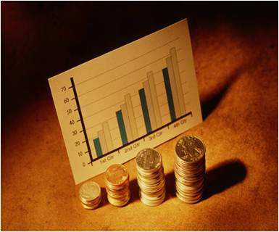
All businesses, small or large, across all industries wish to be successful. In order to be successful a good business should:
- Earn a satisfactory profit for its owners
- Use its short term and long term assets efficiently
- Be able to pay its short term debts on time
- Maintain adequate cash stocks to meet requirements
- Provide a return on investment to the owners both in income and growth of the value of the investment.
To measure this success, all organisations record their financial activities and consolidate this information in reports that convey their financial achievements over arbitrary time periods of equal length.
Accounting is often referred to as the “language of business” as it is accounting principles and terminology that provide the structure for the information system and reports that summarise financial activities.
Owners, managers and employees involved in decision making must appreciate this language so that reports on activity can be read, analysed and the information applied to enable decision making.
The tourism and travel industry encompasses a wide range of activities and types of organisations. Accounting information systems must be designed to reflect the needs not only of the industry but also of individual establishments.
From a management perspective there is a need for you to identify the range of financial information and reports required to effectively monitor business performance at a day-to-day management level.

Who is responsible for managing financial records?
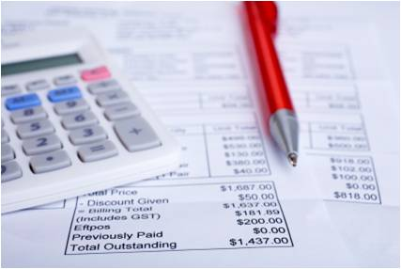
In the workplace, the function of maintaining financial records may be:
- Allocated to the administration or accounts department
- Given to one nominated management-level member
- The sole province of the business owner-operator
- Integrated with other activities and systems.


Activity 1 - Identify persons responsible for managing financial records

For a tourism organisation you are required to identify the different roles that undertaken financial transaction and management of finances.
For each role identify the types of financial activity or responsibility they undertake.

Role | Financial activity or responsibility

Importance of maintaining accurate financial records
Maintaining accurate financial records is important in business to:
- Provide information to management on which to make business decisions
- Track the performance of the operation against projections – so that remedial action can be taken where necessary
- Demonstrate business results to stakeholders such as shareholders, owners, partners, banks and various government agencies.

Definition of 'auditing'
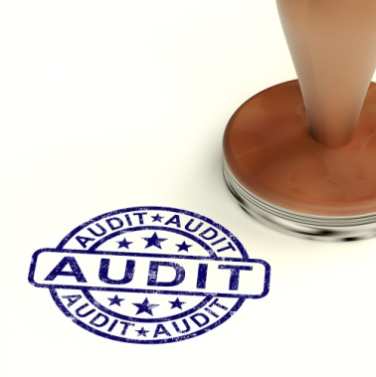
Auditing is a control procedure which is undertaken on a regular basis to ensure accuracy of financial transactions and accounts.
The transactions and records you deal with may relate to revenue streams with a tourism organisation, various expenses to sustain operations, foreign currency activities and all types of payment received or processed by the organisation in a specified period.
The audit process also identifies and rectifies discrepancies which may relate to incorrect posting, errors in accounts, computer errors and errors in source documentation. This work will impact on a number of financial systems including reports, statements, debtors control and banking procedures to name but a few.
The activities associated with an audit also relates to the preparation of reports which may relate to occupancy, sales performance, break up by department, commission earnings, supplier activity, sales returns, commercial account activity and foreign currency activities.
In summary the purpose of an audit is to:
- Make sure all accounts are accurate
- Make sure departmental charges are accurate
- Provide information on the financial activity of each department
- Provide statistics on the financial activity of the establishment
- Provide statistics on the financial activity of customers
- Allow management to assess performance in relation to operational goals.
As a result of an audit process, the management of an establishment can monitor the activity of departments on a regular basis and not have to wait until the end of a financial period.
This allows a quick response to potential problems or losses and provides accurate information on which to base business decisions.

Understand the bookkeeping and accounting cycle
The accounting cycle is the name given to the steps and procedures that are followed to ensure that all transactions are recorded correctly and included in appropriate financial reports. It can be summarised as follows:
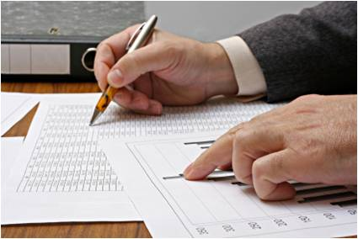
- Perform transaction analysis
- Record transactions in journals
- Post journal entries to ledger accounts
- Prepare an unadjusted trial balance
- Process adjusting entries
- Prepare a final trial balance
- Prepare financial reports

Definition of transaction
There are a set of basic procedures that are used in all accounting information systems to analyse, record and summarise the effects of activities and events in order to generate information for use by management and other stakeholders.
The term transaction is often used to collectively refer to all activities and events that are recorded in the accounting system.

Understanding transaction principles
Before we look at the different activities associated with checking transactions it is important to understand the principles that dictate how transactions are recorded.
Identifying and valuing transactions
As well as considering the appropriate category for a transaction, there are certain assumptions and guidelines that underlie the methods for identifying and valuing transactions. These have evolved as the complexity and diversity of business operations has grown over time. Particularly relevant for the tourism and hospitality industry are those associated with different types of revenue transactions and asset values.
The accounting entity

The accounting entity is one of the basic assumptions for all accounting. Each establishment records only the transactions of the business in the accounting system. The activities of the owners are entirely separate. This can become a little complex in hospitality and tourism organisations where the owners of one establishment own other businesses. For example, each hotel in the Hilton Hotel Group is considered a separate business and records transactions based on its own financial activities. The Hilton Hotel This may sound very sensible and clear to us now but can become unclear in certain circumstances.


The time period assumption
Every accounting entity must collate transactions into financial reports in a timely manner. This requires that all organisations set specific time periods of equal length for reporting and measuring financial results. Each financial report must clearly state the time period being reported, known as the accounting period.
The going concern assumption
Financial reports are prepared under the assumption that the organisation will continue to record transactions summarising operations for the foreseeable future. This has implications for some of the definitions of the elements to financial reports. Relevant details will be discussed under recognition criteria below.
Accrual basis assumption
The accounting system can reflect two methods of accounting, the cash basis and the accrual basis. Under the cash method, only those transactions where cash has been received or paid are recorded. You may find this method used in small hospitality and tourism organisations, however, this is increasingly rare as often deposits are paid for accommodation prior to guest stays and food and beverage supplies are paid for by restaurants after they are received.
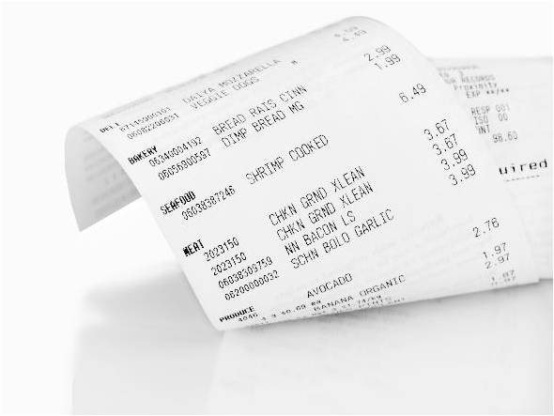
Many businesses choose to use the accrual basis method for recording transaction. In fact, if a business is required to report financial information to external users, the accrual method must be used because it is argued that the accrual basis provides the most useful information for decision making.
Under the accrual basis assumption, transactions are recorded that represent all sales that have been made and all expenses that have been incurred for the reporting period. It does not matter when cash is received or paid, simply that there is an obligation is enough to record the transaction. The matching principle and revenue recognition principle further re-enforce the accrual basis of accounting.
Matching principle
The matching principle requires that financial reports for a given accounting period should reflect only those transactions for that period. This means that revenues are included in the accounting period they are earned and expenses in the accounting period they are incurred.
For example, guests may pay a deposit for a function before the function is held. This deposit must not be included as revenue in financial reports until the function actually takes place. Employee wages for those staff who work at the function must be called expenses even though they may not be paid until the following day or week. The financial report for the accounting period in which the function is held will therefore reflect all the sales and all the expenses associated with the function. This provides management with an accurate summary of the profitability of the event.

Revenue recognition
In the tourism industry, both goods and services are sold and the transactions classified as revenue. A travel business may take its clients on a guided tour program. There is a clear distinction between a good and a service and the manner in which revenue is recognised.

When a customer pays their account, an exchange of goods (the service provided by the tour operator and payment for the services) has occurred. The accounting system records this transaction as sales and this is reported in financial statements as revenue in the accounting period the sale occurred. This is relatively straightforward and easy to understand.
Recognition of income received from providing services is more complex. In the function example described earlier, a transaction occurs when a deposit is paid by the customer to secure the function. This cannot be classified as revenue for the venue because the service has not been provided – the function has not yet been held. This must be reported differently in the financial reports.
Once the function has occurred, the service has been provided and the guest or customer pays the remainder of the charges. At this time, the accounting system can classify both this transaction and the deposit as revenue.
Businesses in the tourism industry must also be careful to recognise revenue that is earned by them. When an establishment acts as an agent, such as a travel agent, the client pays the agency for travel services such as an airline ticket. The amount received by the business includes the face value of the ticket and commission earned for the sale. However, it is only the commission earned that belongs to the business, the face value of the ticket is revenue for the airline. The transaction must be recorded by the accounting system to reflect this.
Monetary unit assumption
Transactions are measured and expressed in terms of monetary units of the currency in which the transaction takes place. Only transactions that can be expressed in terms of money are included in the accounting system.
The cost principle
This principle is particularly relevant for the tourism and hospitality industry as the value of fixed assets reported by organisations is often high compared to other industries. Fixed assets such as property and buildings must be reported at the cost price, that is the purchase price rather than the market value, which is the price you may receive if you sell the asset now. This prevents businesses from overstating the value of what they own.

Recording transactions
To record a transaction in the accounting system, the following three steps are followed:
- Analyse each transaction in terms of its effect on the ledger accounts
- Enter the transaction information in a journal
- Transfer the journal information to a ledger account.

These steps occur repeatedly, for every transaction in every business. It is important to understand each step so that you can check that transactions are processed according to workplace policies and procedures.
Double entry
All accounting information systems record transactions based on the double entry system. Each transaction is analysed to establish what types of ledger accounts are affected and whether each ledger account is increased or decreased. Every transaction affects two ledger accounts, hence the term double entry.
Ledger accounts are classified into one of the five account categories. This determines how increases and decreases are recorded. Imagine a ledger account as a blank page. For any given account, transactions that increase the account balance are recorded on one side and transactions that decrease the balance are recorded on the other side. In accounting, the left hand side is called a debit and the right hand side, a credit. You should be familiar with the abbreviations used for these terms:
DR = Debit
CR = Credit

To become comfortable with these terms, it can be helpful to think of them as meaning left or right. Neither term refers to an increase, decrease, positive or negative on its own. It is simply an instruction for recording a transaction on the correct side of the page depending on the account category.
Each of the five account categories likes to be a debit or a credit. The normal balances for each account category and the debit and credit relationship are summarised in the table.
Account category | Normal balance | Transaction increases balance | Transaction decreases balance
Assets | DEBIT | DEBIT | CREDIT
Liabilities | CREDIT | CREDIT | DEBIT
Owner’s equity | CREDIT | CREDIT | DEBIT
Revenue | CREDIT | CREDIT | DEBIT
Expenses | DEBIT | DEBIT | CREDIT
This pattern of recording debits and credits is based on a restated accounting equation:
Assets = Liabilities + Owner’s equity.
Debit = Credit
When viewed this way, it can easily be seen that for the accounting equation to be in balance, debits must equal credits. Establishments do not check this for each and every transaction but use other methods such as a trial balance to verify that debits equal credits.
This is discussed in Section 1.2 of this manual.

Categories of business transactions
The accounting system provides financial reports that summarise the financial position and the financial performance of the business for a given period of time, known as an accounting period. To facilitate this, transactions are summarised into ledger accounts that are classified into five categories for reporting:
- Assets
These are Items of value that are owned by the business and used to create sales. Examples are cash, stock, silver, glass, linen, equipment, land, buildings, and furniture.
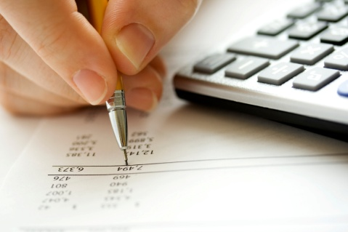
- Liabilities
Any obligation or debts the business has as a result of operations are called liabilities. Amounts owed to suppliers and bank loans are examples.
- Owners’ equity
Represents the claim the owner has on the assets of the business after liabilities are deducted.
- Revenue
Sales generated from providing goods and services in a business. Room sales, food and beverage sales and ticket sales are all examples for hospitality and tourism establishments.
- Expenses
Goods or services used in operating a business. Wages, housekeeping, inventory or stock, cleaning costs, electricity and telephone are just some examples of expenses.
Financial performance reports summarise revenue and expenses in this basic equation:
Revenue – Expenses = Net Profit / (Loss)
Financial position reports follow a calculation known as the accounting equation:
Assets – Liabilities = Owner’s equity
Note that the profit or loss for an accounting period belongs to the owners of the business and forms part of owners’ equity. In this way, the accounting equation is often considered the most basic tool of accounting. It must always remain in balance. This will become more evident as the accounting process is explored.



Activity 2 - Identify categories of business transactions

For a tourism organisation you are required to provide examples of different types of items under each category.

Category | Examples  (Minimum of three for each category)
ASSET
LIABILITY
OWNERS EQUITY
REVENUE
EXPENSES

Understand types of transactions
As part of the financial management process you will be required to check transactions made within the tourism organisation.
Following are different types of transactions that are commonly made in a tourism organisation.
Debit transactions
A debit transaction is a transaction where payment is still outstanding and includes charges for services provided by the organisation to the customer.
The following information on each and every debit transaction must be checked for accuracy:
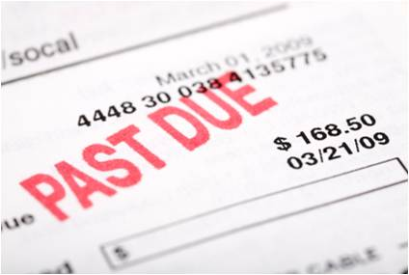
- Account personal details – name and account number
- Date
- Signature to verify receipt of goods of service (if applicable)
- Credit card limits (if applicable)
- Charge rates
- That the total for the department increases by the correct amount.
Credit transactions
A credit transaction is a transaction that has been paid on an account/folio by one means or another.
Payment may have been made by:
- Credit card

- Cash
- Electronic fund transfers (EFT)
- Traveller’s cheques
- Foreign currency
- Cheque – personal or company
- Voucher – travel agent or airline
- Direct billing. (often referred to as D’Bills)
Journals entries
This is where a 'transaction' is recorded.
Examples of journals include:
- Returns and allowances journals
- Bad debts journal
- Main/general journal
- Payroll journal.
The different types of journals will be discussed in more detail later in this section.
Cash receipts
This involves recording and updating the system when people pay their accounts.
This may include issuing a receipt depending on the common business practices of the venue

Cash payments
These include circumstances where the establishment is required to pay cash for goods or services provided to them.
It also includes instances where ‘disbursements’ are paid. These are situations where the establishment makes a cash payment on behalf of a customer, and then that money is recouped from them later
Petty cash
This involves obtaining a receipt for petty cash that is claimed, completing a petty cash voucher, distributing the required cash to the claimant and then making an appropriate entry
Sales
This involves providing invoices and receipts together with suitable entries to record the sale to the appropriate section or budget line.
This may also include making entries to adjust stock-on-hand and other similar stock control records
Refunds
These can include adjustments to previous revenue totals by recording the refund under the appropriate budget line, and adjustments to stock level figures where items have been returned
Rebates
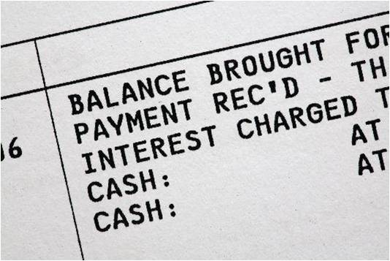
These may be entries relating to Commissions to travel agents and credit or banking suppliers and entries specifically identified as various and different discounts an establishment commonly offers
Interest expenses or interest received
Most commonly these relate to interest payable on loans or overdrafts but may relate to entries on returns obtained through investments the property has made
Purchasing of a fixed asset on credit
A fixed asset is one which will remain in the company for longer than a year. Examples of fixed assets include buildings, vehicles and major equipment.
Due to the nature of the amount required to purchase large fixed assets, normally they are not paid in cash but purchased through credit, either provided by a bank (mortgage), a finance company or an organisation or person loaning money.
Selling of a fixed asset on credit
Likewise you may sell a fixed asset to another person on credit. This means that they will owe you money which needs to be repaid, often with interest, at predetermined times.
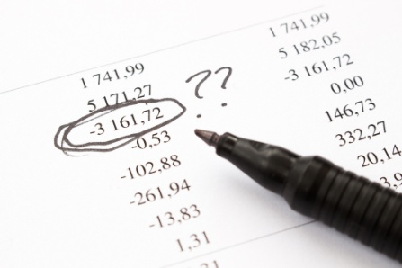
Correcting posting errors
Posting errors are quite common when recording transactions.
There are many reasons why errors occur. The different types of errors and the methods of identifying and handling errors will be explained in Section 1.6
Writing-off a bad debt
At times you may have customers or suppliers who have an account with your organisation, who is unable to repay the money owed.
In this case the debt will be 'written' off. It will be classified as an expense for the financial year.
Withdrawing of stock or assets by owner
When owners decide to take stock out of the organisation, this must be recorded. It must be reduced from their proprietorship. That means the overall amount owed to the owner will be reduced by the value of any asset taken out of the business.
Making non-cash transactions, e.g. writing off depreciation, stock losses
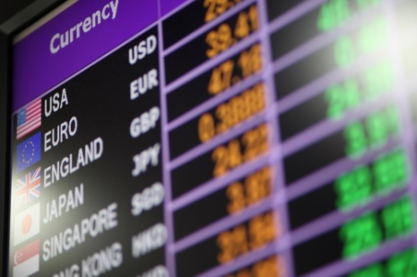
There will be a number of times, such as with 'bad debts' that outstanding debts, depreciation or losses will need to be classified as an expense for the accounting period.
Working in foreign currency amounts
In a travel and tourism organisation the use and acceptance of different currencies will be a common occurrence.
These must be handled in accordance with exchange rates and company policies and procedures.
Activities associated with checking transactions
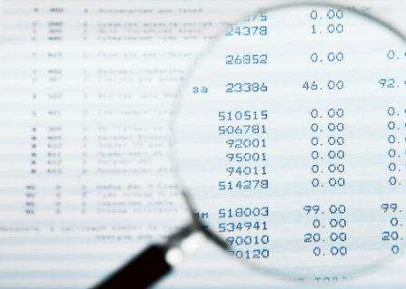
Checking transactions involves three basic activities:
- Understand types of ledger accounts
- Obtaining and checking source documents
- Checking journal entries
- Checking accuracy and completeness of transactions.

Understand types of ledger accounts
Each account in the chart of accounts is typically given a name and a unique number. Account numbers are often five or more digits in length with the digit pattern representing a division of the company, the business unit, the type of account, etc.
The first digit is commonly used to classify the account according to the accounting equation - asset, liability, equity, revenue and expenses etc. For example, if the first digit is a “1” it is an asset. If the first digit is a “5” it is an operating expense.
A gap between account numbers allows for insertion of accounts in the future. The following is a partial listing of a sample chart of accounts.

Current Assets (account numbers 10000 - 16999)
- 10400 Cash at Bank – Operation
- 10300 Cash at Bank – Payroll
- 10600 Petty Cash
- 12200 Accounts Receivable
- 12600 Provision for Doubtful Accounts
- 13200 Inventory
- 14200 Supplies
- 15400 Prepaid Insurance.
Fixed Assets (account numbers 17000 - 18999)
- 17100 Freehold Land
- 17200 Leasehold Buildings
- 17400 Furniture, Fixtures and Equipment
- 17900 Motor Vehicles
- 18200 Accumulated Depreciation – Leasehold Buildings
- 18400 Accumulated Depreciation – Furniture, Fixtures and Equipment
- 18900 Accumulated Depreciation – Motor Vehicles
Current Liabilities (account numbers 20000 - 24999)
- 20200 Notes Payable
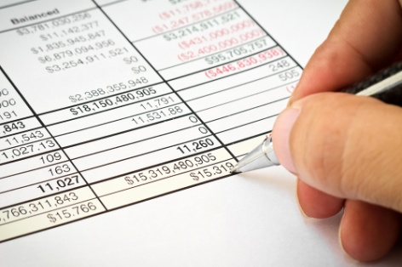
- 21100 Accounts Payable
- 22200 Wages Payable
- 23200 Interest Payable
- 24700 Unearned Revenues.

Long-term Liabilities (account numbers 25000 - 26999)
- 25300 Mortgage Payable
- 25700 Bonds Payable
- Equity (account numbers 27000 - 29999)
- 27200 Ordinary Shares
- 27600 Retained Earnings.
Operating Revenues (account numbers 30000 - 39999)
- 31012 Sales – Business Unit #A, Product AA
- 31023 Sales - Business Unit #A, Product BB
- 32016 Sales - Business Unit #B, Product CC
- 33112 Sales - Business Unit #C, Product DD.
Cost of Goods Sold (account numbers 40000 - 49999)
- 41012 COGS - Business Unit #A, Product Line AA
- 41023 COGS - Business Unit #A, Product Line BB
- 42016 COGS - Business Unit #B, Product Line CC
- 43112 COGS - Business Unit #C, Product Line DD.
Sales & Marketing Expenses (account numbers 50000 - 50999)
- 50200 Sales & Marketing Dept. Salaries
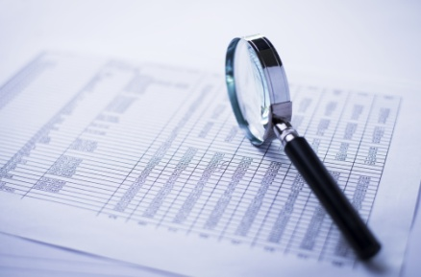
- 50250 Sales & Marketing Dept. Payroll Taxes
- 50300 Sales & Marketing Dept. Supplies
- 50800 Sales & Marketing Dept. Telephone.
Finance Dept. Expenses (account numbers 59000 - 59999)
- 59600 Finance Dept. Salaries
- 59650 Finance Dept. Payroll Taxes
- 59800 Finance Dept. Supplies
- 59900 Finance Dept. Telephone.
Other (account numbers 90000 - 99999)
- 91910 Gain on Sale of Assets
- 96230 L oss on Sale of Assets.

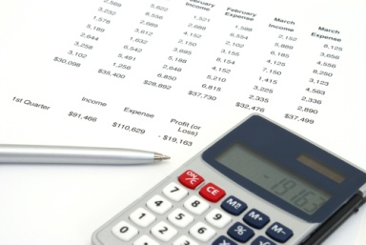

Activity 3 - Identify tourism ledger accounts

For a tourism organisation of your choice you are required to identify the ledger accounts that they use as part of their accounting system.
Current Assets
- _____________________________________________
- _____________________________________________
- _____________________________________________
- _____________________________________________
- _____________________________________________
- _____________________________________________
Fixed Assets
- _____________________________________________
- _____________________________________________
- _____________________________________________
- _____________________________________________
- _____________________________________________
- _____________________________________________
Current Liabilities
- _____________________________________________
- _____________________________________________
- _____________________________________________
- _____________________________________________
- _____________________________________________
- _____________________________________________
Long-term Liabilities
- _____________________________________________
- _____________________________________________
- _____________________________________________
- _____________________________________________
- _____________________________________________
- _____________________________________________
Operating Revenues
- _____________________________________________
- _____________________________________________
- _____________________________________________
- _____________________________________________
- _____________________________________________
- _____________________________________________
Cost of Goods Sold
- _____________________________________________
- _____________________________________________
- _____________________________________________
- _____________________________________________
- _____________________________________________
- _____________________________________________
Other operating expenses
- _____________________________________________
- _____________________________________________
- _____________________________________________
- _____________________________________________
- _____________________________________________
- _____________________________________________

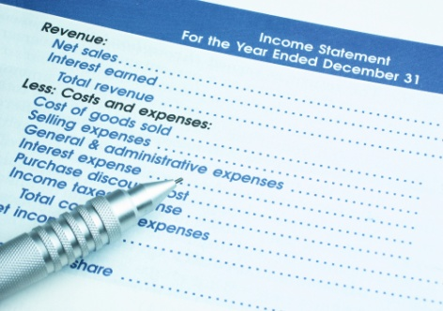
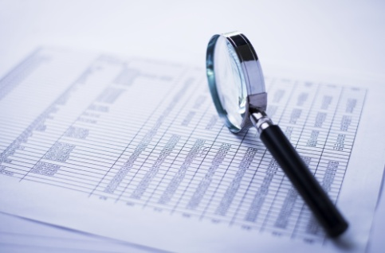

Obtaining and checking source documents
External transactions are those that occur between the organisation and outside parties such as a tour operator and a client or a restaurant and their supplier of food items.
Every external transaction should be supported by a document that details the transaction.
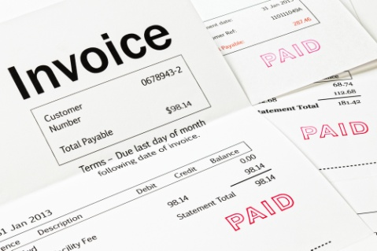
This is called a source document.
A source document is evidence of a transaction.
A source document serves two purposes.
It provides written evidence that a transaction exists and it is used by accounting personnel to support accounting records.
These are the documents on which other reports, statements and statistics are based.
They are the documents ‘first raised’ and are generated or validated by staff.
For example, a receipt is evidence that you have paid an account. Obtaining the customer's signature on an internal docket is proof they have received the products and services listed.
Every financial transaction must have a corresponding source document as evidence that the transaction actually took place.
Examples of common source documents in tourism establishments are:
- Invoices
- Receipt books
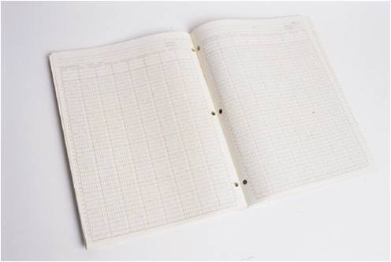
- Cash register audit tapes
- Internal vouchers and promotional vouchers which may offer special deals and discounts
- Daily takings sheets
- Credit card imprints and vouchers
- Time / wages sheets
- Purchase orders
- Receipts
- Cheques

- Deposit books
- Cheque requisitions
- Credit notes
- Expense vouchers
- Petty cash vouchers
- Bank statements.



Activity 4 - Identify source documents

You are required to identify common source documents used in tourism organisation showing evidence that transactions have taken place.

Source Document | What type of transaction does it record?

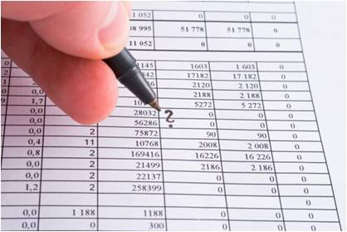
Checking journal entries
An understanding of the journals commonly used will assist in checking transactions are recorded correctly.
A journal is any internal book or record-keeping system that records entries and figures of daily financial transactions, in chronological order.
This provides a complete, chronological history of all transactions and lists the debit and credits for each transaction, amongst other details.
Journals reflect the inflows into and the outflows out of the business.
In addition, it makes the process for checking transactions straightforward and efficient because the debit and credit information is in one place. If transactions were entered directly into ledger accounts, details would be repeated and it would be necessary to search through many accounts to find the other side of a transaction to ensure the debits and credits had been allocated correctly.
At the end of an accounting period, the sum of all transactions is entered from the journals into the appropriate ledger accounts following the debit and credit rules. This is called posting to the ledger.
Journals used depend upon the variables within the business. Some of the factors involved are:
- The nature of the business
- Size of the business
- Costs associated with account keeping
- Requirements of management.
Special journals
To enter financial information into journals, similar transactions are grouped into categories according to the most common business transactions and a special journal is set up for each category. The number of journals and their design varies from one establishment to the next but generally in hospitality and tourism organisations, transactions fall into four categories.
The four special journals are:
Cash receipts journal
The Cash Receipt journal records amounts that are inflows into the bank account.
This journal is deceptive in its name, because not all inflows are cash – they may be cheque, credit card and EFTPOS as well.
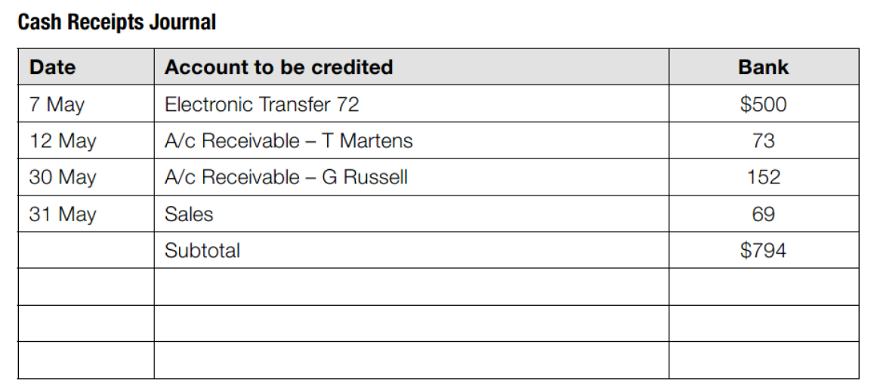

Cash payments journal
All transactions involving the payment of cash by the establishment are recorded in this journal but other things may also be included in this journal such as:
- Bank charges which appear on the bank statement
- Periodical payments – such as insurance
- Direct withdrawals or transfers – such as wage payments to staff that are taken from your account and deposited directly into their accounts.

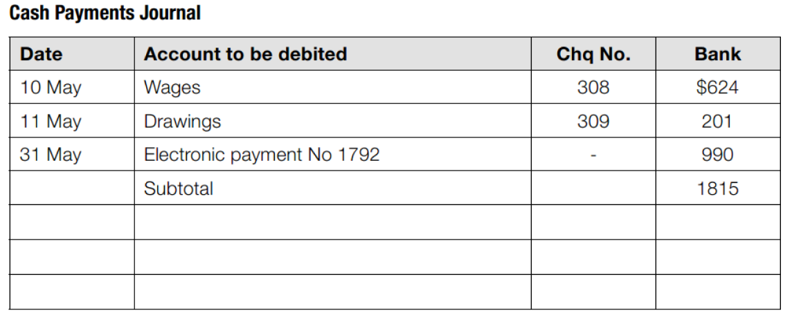
Sales journal
The Sales journal deals with sales on credit. That is, sales (inflows) that have been made but which have yet to be paid for.
Remember that this document deals only with credit sales.
Any sale that is not immediately paid for is entered into this journal.
These items are then assigned to the individual account of the person owing these amounts and they form your debtors.
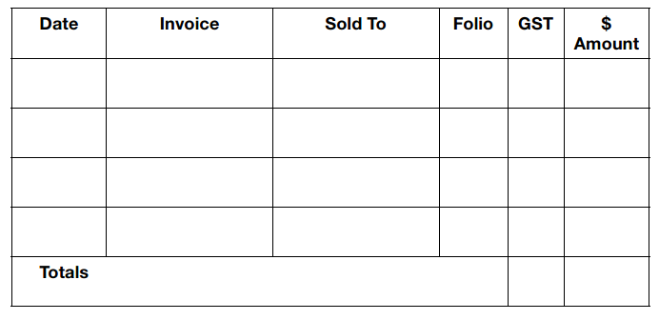

Purchases journal
This journal deals with purchases made on credit.
This means the establishment has not yet paid for them.
Anything a business buys that is not paid for on-the-spot goes into this Purchases journal.
These amounts form the ‘creditors’ or ‘Accounts Payable’ of the business.
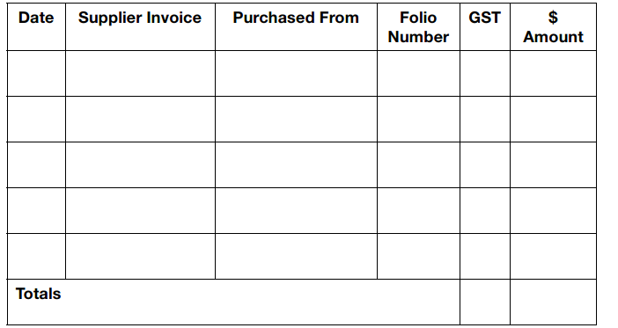
Sales Return Journal
The Sales Return journal is used to record returns made by clients - it functions as the opposite of the Sales journal.
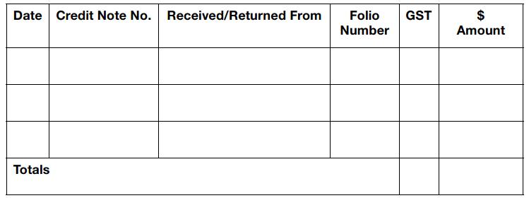

Purchases Returns Journal
The Purchases Return journal is used to record returns that we have made to our suppliers. It also functions as the opposite of the Purchases journal.
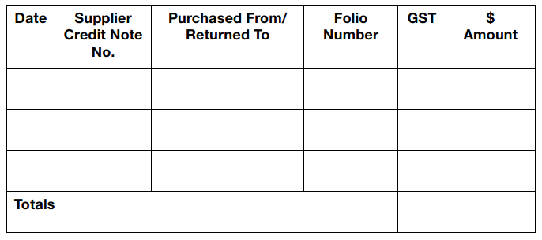
Effects of transactions in special journals
Journal | Account | Effect of transaction | Account category | DEBIT/CREDIT
Cash receipts | Cash at bank | Increases | Asset | DEBIT
Cash receipts | Sales | Increases | Revenue | CREDIT
Cash payments | Cash at bank | Decreases | Asset | CREDIT
Cash payments | Supplies | Increases | Expenses | DEBIT
Cash payments | Wages | Increases | Expenses | DEBIT
Cash payments | Other expenses | Increases | Expenses | DEBIT
Sales | Sales | Increases | Revenue | CREDIT
Sales | Accounts receivable | Increases | Asset | DEBIT
Purchases | Supplies | Increases | Expenses | DEBIT
Purchases | Accounts payable | Increases | Liability | CREDIT

General journal
The general journal is used to record transactions that are not entered into the above mentioned special journals or used when the special journals are not used.
The general journal is used for items that do not occur in the ordinary course of business. It is used to make adjustments to the general ledger.
Examples include:
- Drawing out of stock by the owner
- Corrections of errors
- Recognition of bad debts.
The general journal may look something like this:
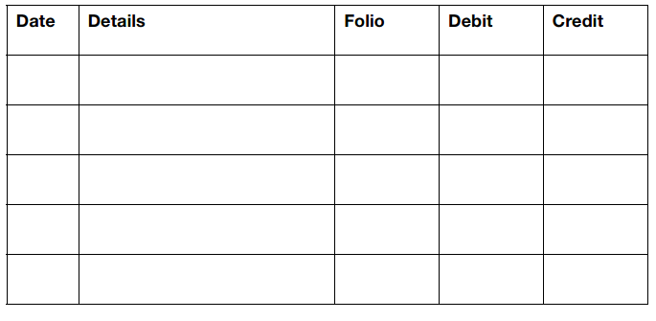

Transactions that are entered into the general journal are analysed to determine the accounts that are affected. Then, increases or decreases to these accounts are identified and the debit and credit rules applied to enter the transaction in the journal. Often, if a transaction involves cash, the effect on the cash account is determined first and the effect on the other account second. This is because it is often easier to identify the effect that a transaction has on cash.

EXAMPLE - PURCHASE OF EQUIPMENT
An example of a purchase of a fixed asset, equipment on credit for 20,000 would be entered into the general journal as follows:
- Analyse the transaction to determine the accounts affected:
Equipment
Obligation to supplier
- Identify the account category:
Equipment is an Asset
Obligation to supplier is a Liability
- Determine if the account category has increased or decreased:
Equipment is an Asset and has increased
Obligation to supplier is a Liability and has increased
- Assign debit or credit:
Equipment is an Asset and has increased so enter as a DEBIT
Obligation to supplier is a Liability and has increased – CREDIT
- Enter the transaction in the general journal
Date | Ledger account | Reference | Debit | Credit
1/1/1 | Equipment | Invoice no | 20,000
1/1/1 | Accounts Payable | Invoice no |  | 20,000
 | Purchase of equipment
At the end of an accounting period, the amounts from the general journal are entered into the appropriate ledger account.



Activity 5 - Identify ledger transactions

You are required to show the correct ledger account entries that would occur for the following transactions for the amount of 'X'.
Please identify the source documents that would show evidence of these transactions.
Cash receipts
Date | Ledger account | Reference / Source document | Debit | Credit
Cash payments
Date | Ledger account | Reference / Source document | Debit | Credit
Petty cash
Date | Ledger account | Reference / Source document | Debit | Credit

Sales
Date | Ledger account | Reference / Source document | Debit | Credit
Refunds
Date | Ledger account | Reference / Source document | Debit | Credit
Rebates
Date | Ledger account | Reference / Source document | Debit | Credit
Interest expenses or interest received
Date | Ledger account | Reference / Source document | Debit | Credit

Purchasing of a fixed asset on credit
Date | Ledger account | Reference / Source document | Debit | Credit
Selling of a fixed asset on credit
Date | Ledger account | Reference / Source document | Debit | Credit
Correcting posting errors
Date | Ledger account | Reference / Source document | Debit | Credit
Writing-off a bad debt
Date | Ledger account | Reference / Source document | Debit | Credit

Withdrawing of stock or assets by owner
Date | Ledger account | Reference / Source document | Debit | Credit
Making non-cash transactions, e.g. writing off depreciation, stock losses
Date | Ledger account | Reference / Source document | Debit | Credit
Working in foreign currency amounts
Date | Ledger account | Reference / Source document | Debit | Credit

Cross-check source documentation with entered transaction to ensure matching

Accuracy is a vital element in maintaining financial records so it is essential to cross-check source documentation with all entries to ensure there is a match between figures on the documentation and the postings that have been made.
It must be understood that an error in entries will be difficult to detect where the same error is perpetuated in the double-entry system.
For example, an incorrect (‘transposed’) debit entry of $45.00 – instead of, say, $54.00 – matched with a $45.00 credit entry will be difficult to find and will not ‘stand out’.

Checking accuracy and completeness of transactions

Now that you have examined the process for entering and processing transactions and the underlying journals and ledger accounts that they can be allocated to, you are able to check that transactions have been processed according to workplace policies and procedures. This requires that:
- Transactions are recorded accurately in respective journals
- Transactions are transferred from journals into ledger accounts correctly
- Adjustments are made to transactions that do not relate to the current accounting period.
Checking accuracy of transactions
Special journals
Checking that transactions have been entered into special journals and then ledger accounts according to workplace policies is relatively straightforward when special journals are used.
Using cash as a starting point, transactions that feature cash are entered into either the cash payments or receipts journal and those sales or purchases where no cash has changed hands yet are entered into either the sales or purchases journal.
When entering details from a source document into the journals, it will become obvious if the incorrect journal is chosen as the ledger account headings that are needed will not be in the journal.
For example, if personnel processing a cash receipt attempt to enter the transaction in the cash payments journal, they would not find a column corresponding to sales but to expenses.

This would alert them to the error before any amounts are entered and posted to ledger accounts. In this way, the use of special journals provides a check in itself. This applies to both manual and computerised accounting systems.
Also, ledger accounts will contain a small number of entries because it is only the totals for an accounting period or other period of time that are entered into the appropriate debit and credit columns. It is not difficult to check that the correct totals have been entered from the journals if needed.

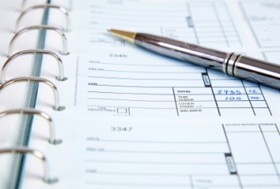
General journal
The general journal contains external transactions that occur less frequently in the business. Also, internal transactions that rely on information entered into special journals and the ledger accounts are processed in the general journal.
It is likely that general journal entries are checked more often than special journals as there is more risk of error because:
- The general journal offers no internal checking system like the special journals other than a debit and credit entry are required
- The monetary amounts of the transactions can be significant
- The transactions to be entered in the general journal can be quite complex and often require a more advanced knowledge of accounting principles and concepts than those entered into special journals.
To check if these transactions are entered correctly into the accounting system, the general journal entry is usually compared to source documentation. For the example above, this involves ensuring that the value and the description of the asset are correct and assigned to the appropriate ledger account.
The journal may also detail the name of the supplier which would also be verified. Workplace documentation will often provide guidelines on the appropriate ledger accounts to use for the different types of transactions.
Following from this it is usually clear if the debit and credit rules have been applied correctly.
Checking completeness of transactions
Completeness is an accounting term given to the process of ensuring that the accounting system includes all the information as expected. In this case, completeness refers to checking that all transactions that relate to the current reporting period are included in financial reports.
Internal controls are established to give assurance that source documents will be entered into the accounting system by accounting personnel in a timely manner. These source documents represent valid transactions. Implementing and monitoring internal controls for different transactions are discussed in Sections 1.4 & 1.5.
The matching and revenue recognition principles require a review of external transactions entered into the accounting system so that revenue and expenses that relate only to the current reporting period are included in financial reports. This may mean an adjustment to amounts already entered into ledger accounts and require internal transactions to be processed. Sometimes the accounting term, balance day adjustments or adjusting entries is used to describe this process.
Typically, all ledger accounts are summarised and reported in a trial balance so that this review can be conducted. Details of the adjusting entries that may be required are explained in Section 1.2.

Tips to assist with accuracy and correctness
Techniques to assist in ensuring accuracy and correctness include:

- Actively paying attention to what you are doing – focusing on the work and not allowing yourself to be distracted
- Visually noting figures and then verbally stating them – even if this is just to yourself and not ‘out loud’
- Doing regular and periodic checks – this involves making several entries and then stopping to check the batch you have just posted rather than doing no checks or attempting to do a check at the end of all the entries
- Double-checking totals – where individual entries have to be made, it is useful to check the totals on the source documents with the totals of the entries posted on an on-going basis
- One person makes the entries and another person cross-check or verifies them – this is a good idea but not often a practicable one. Where the same person enters and checks, there is a strong possibility they will repeat the initial mistake over and over again before they finally identify the error
- Take regular breaks or change the nature of tasks to help prevent losing focus and ‘glazing over’.


Activity 6 - Research common tourism transactions


You are required to collect evidence of financial records for a tourism organisation of your choice.
The records must show evidence of common transactions showing ledger accounts these transactions are allocated to.
You must also provide evidence of source documents commonly used in tourism establishments, as identified in Activity 3.

Activity 7 - Identify areas of focus

Based on the evidence collected in Activity 6, you are required to explain what areas you would focus on when checking transactions.
_________________________________________________________________________________________________________________________________________________________________________________________________________________________________________________________________________________________________________________________________________________________________________________________________________________________________________________________________________________________________________________________________________________________________________________________________________________________________________________________________________________

1.2 Balance transactions accurately

Introduction
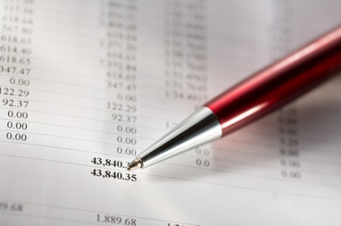
In the previous section we identified the different types of transactions that commonly take place in a tourism organisation and a list of ledger accounts that normally transactions are posted to.
After each source document has been posted to the appropriate journals, all accounts must be reconciled.
Reconciliation ensures accuracy of accounts and is also a progressive step for totalling accounts.

Use reconciliation features of computerised systems correctly to assist the reconciliation process
Where a tourism establishment utilises a computerised financial records system, staff will need to become familiar with its operation.
The basic accounting and bookkeeping concepts apply to computerised systems.
On-site training and supervision together with the relevant manuals and on-line help should show staff how to:
- Establish, open. close and modify individual accounts
- Establish, open, close and modify journals

- Make entries – debits and credits, dates, details etc.
- Calculate balances including totals and cumulative (or ‘to-date’) totals
- Amend incorrect entries
- Include narrative descriptions where required
- Cross-reference entries to the appropriate account or folio
- Perform reconciliations
- Print required documents, accounts and reports.
Staff will need to be able to use the computerised system to perform all the necessary functions, transactions and reconciliations for the organisation, and not just the most common ones.

Types of reconciliations
There are a number of reconciliations that need to be performed in a tourism organisation.
Examples of reconciliations can include:
- Creditor statements
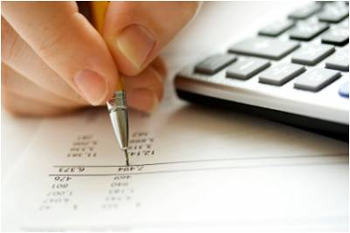
- Petty cash
- Foreign currency
- Bank reconciliations
- Guest accounts/folios
- Travel files
- Taxation.

Subsidiary ledgers
Before we look at the procedures performed when balancing transactions and accounts lets identify a number of documents that help to identify if there is a 'balance' between debit and credit transactions.
One method that enables timely and efficient checks on the balances of others is the use of subsidiary ledgers and control accounts to process of transactions.
When a large amount of detailed information about a certain ledger account must be kept, a separate ledger called a subsidiary ledger is used. The total of the balances in the subsidiary ledger should equal the balance of the related account in the general ledger. This related account is called a control account. It is important to understand that the subsidiary ledger is not part of the general ledger. It is not used in extracting the trial balance and does not need to conform to the rules of debit and credit. It serves to provide the detail that supports the control account balance in the general ledger.

Control accounts and subsidiary ledgers are used in tourism establishments for the following general ledger accounts:
- Accounts receivable
- Accounts payable
- Inventory (when applicable)
- Fixed assets.


Account summaries/balances
This document combines the balances of various selected accounts into one document.
The Account balance/summary, thus, may give you a one-stop detailed picture of the status of the full range accounts that are in operation.
Rather than having to go through numerous individual accounts, this document sets out the totals and activities for all accounts in one simple document.

Perform reconciliations
To check the balances of the subsidiary ledgers and control accounts, reconciliation is performed. There may be a standard document that needs to be completed for the reconciliation process. The balance in the control account and the total of the individual accounts in the subsidiary ledger are recorded on this document and any differences noted. These must be investigated and resolved where possible. In order to do this, it is necessary to know the source of the data in each subsidiary ledger.
This is explained below.
Account Receivable
The accounts receivable subsidiary ledger lists all the individual customers, guests or clients that have not yet paid for goods and services provided by the establishment. The accounting term sometimes used for these individual accounts is debtors. The special journals that update the subsidiary ledger are:
- Sales journal with credit sales for each individual account
- Cash receipts journal with amounts received by debtors to settle their accounts.

Checking account receivable balances also includes analysis of individual accounts and total balances. It is from the details in the subsidiary ledger that credit limits are monitored, customers are invoices and the accounts receivable ageing schedule is prepared. Also information that assists managers to monitor performance such as analysis of accounts receivable ratios are taken from the subsidiary ledger.
Accounts Payable
The accounts payable subsidiary ledger lists each supplier along with the amounts owed to them. This is sourced from the:
- Purchases journal that lists creditors that have provided goods but have not been paid
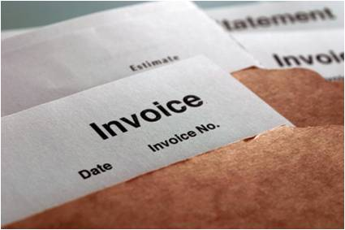
- Cash payments journal that records payments to creditors.
Once the subsidiary ledger is balanced, the information from the subsidiary ledger can be used to monitor cash flow. Managers can see total amounts that need to be paid and the corresponding due dates for each creditor. This assists with planning for future cash requirements so that the payments to creditors can be made on time or, negotiations for different settlement terms can be discussed.

Inventory
For tourism organisations that hold inventory or stock, an inventory subsidiary ledger is maintained. This includes the number and value of each item of inventory held. It is updated from the:
- Purchases journal where supplies have been received but not yet paid
- Cash payments journal that records supplies that have been received and paid.
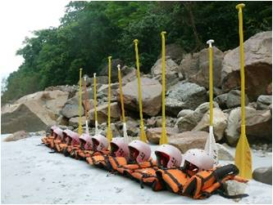
A physical count of stock called a stocktake is conducted at the end of an accounting period to verify the amounts included in the subsidiary ledger. The list of items held in the subsidiary ledger is provided to two counters and results given to accounting personnel. The number of each item is checked and any adjustments to the subsidiary ledger are processed through the general journal. This process means that not only does the subsidiary ledger and the control account reconcile but the value is verified independently by a count of actual items held.
Fixed assets
The fixed asset subsidiary ledger or the fixed asset register details the fixed assets that are owned by an organisation. Each asset is assigned a unique number and details such as the purchase price, the current value and any changes to the asset are recorded.
Changes to fixed asset balance are generally infrequent, even in tourism organisations so a formal reconciliation between the fixed asset register and the control accounts may only be performed once or twice a year.
The fixed asset register is always updated from the general journal. Sales and purchases of fixed assets are processed as and when they occur. At the end of a financial year, the depreciation expense for each asset is posted to the fixed asset register as well as any necessary adjustments to asset values.
The assets are grouped into categories such as equipment, furniture and the like that correspond to the appropriate ledger accounts. Both the depreciation and asset ledger accounts will clearly state the total amounts for the category of assets that should be included.

Make necessary adjustments

To complete the reconciliation process, any adjustments that need to be made to subsidiary ledgers are recorded in the general journal and processed before the trial balance is prepared. Documentation is filed according to workplace procedures. This is necessary as it may be needed for the next reconciliation to ensure discrepancies were resolved and also provides evidence to management or internal auditors that internal control procedures are followed.
Before the trial balance is prepared, there is one other balance that is important to reconcile – the cash at bank ledger account. This balance is verified every accounting period or as required by comparing it to the bank balance as reported by the bank. This is called the bank reconciliation.

Perform bank reconciliations
A bank reconciliation checks that the amount in the ledger account cash at bank in the accounting information system agrees to the balance in the bank account.
This is important for all organisations but especially tourism establishments where there are very often large volumes of cash handled. This represents a significant asset to the organisation that must be kept safe. Using a bank account greatly reduces the amount of cash held on the premises and enables some transactions to be conducted in a more effective manner. For example, payments can be made directly between bank accounts rather than carrying cash from one location to another.
At the end of each month or other time frame as detailed by workplace procedures a bank statement detailing the activity that has taken place in the bank account is either sent to the business or accessed from secure on-line banking arrangements. The bank statement shows the cash balance at the beginning of the month or other time, all deposits and withdrawals and the final cash balance at the end of the chosen reporting period.
It can be a little confusing when viewing a bank statement for the first time as the statement also uses the term debits and credits as column headings similar to a ledger account. This is because the bank statement is actually the bank’s ledger account that they keep for each business or individual. The debits and credits represent transactions from the bank’s perspective whereas the ledger account from the accounting system is from the businesses perspective. When there is a positive cash balance or cash in the bank account, this is an asset and therefore a debit balance in the ledger account in the accounting system. For the bank, this is a liability (the bank “owe” the cash to the business) so there will be a credit balance on the bank statement.
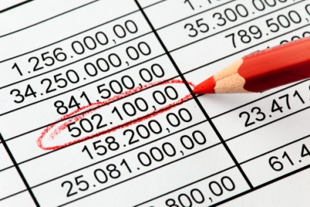
As cash transactions occur during the accounting period, the bank account balance and the accounting information system are updated with the movement of cash. Theoretically at least, the bank statement should reflect the same transactions as the cash receipts and the cash payments journals. The balance in the bank account and the ledger account should be the same. However, in practice, at any particular point in time, this rarely occurs.
Some of the possible reasons for this difference may be:
- Timing differences – there may be a delay in a payment to or from the bank account that is already recorded in the accounting system
- Errors – a clerical error may be made in recording an amount in either the cash payments or cash receipts journal
- Dishonoured payment – a guest or customer’s payment is recorded in the accounting system but not honoured or paid by the guest’s bank
- Other differences – these can occur due to a delay in recording deposits or withdrawals that originate in the bank statement.
Steps to prepare bank reconciliation
The steps to prepare bank reconciliation are:
- Gather the information as follows:
- The last bank reconciliation statement that was prepared
- Cash receipts and cash payments journal or other record of cash movements for the period to be reconciled
- The opening balance of the Cash ledger account from the accounting system
- The bank statement covering the period to be reconciled
- Standard bank reconciliation statement used in your workplace.
- Enter the balance shown on the bank statement and the balance from the ledger account into the bank reconciliation statement
- Check that previous outstanding items have been recorded on the bank statement
- Add to or subtract from the bank balance the items that are in the ledger account but not on the bank statement. This may include:
- Deposits not received by the bank yet
- Outstanding cheques
- Calculate the adjusted bank balance
- After checking that details are correct, adjust the ledger account for any items that are on the bank statement by recording the details in the general journal. These include:
- Cash receipts for direct deposits
- Cash payments made as electronic transfers
- Bank fees and charges
- Compare the adjusted bank balance and the adjusted ledger account balance and they should now agree
- Complete the bank reconciliation statement and file according to workplace procedures.

After the ledger account cash at bank has been verified and the control accounts reconciled to subsidiary ledgers, the unadjusted trial balance is prepared and adjusting entries completed.
A final trial balance is then produced that verifies that debits and credits equal after all adjusting entries are posted. Senior accounting personnel or management may review the trial balance to check balances for the last time.
Once it is confirmed that the adjusted trial balance is correct, this trial balance can be used to prepare financial reports.

Bank Reconciliation Exercise 1
You are the accountant for Harris Company and have received a Bank Statement from Community Bank for the month of May 2015. You are required to check the company records against the Bank Statement and prepare a Bank Reconciliation Statement.
Bank Reconciliation Statement for Harris Company
As at 30 April (this is the Bank Reconciliation Statement from last month)
Balance as per Bank Statement (Credit) |  | $11,540
Add Deposit not yet Credited |  | 6,000
 |  | 17,540
Less Unpresented Cheques
No 296 | 789
297 | 205
302 | 131 | 1,125
 |  | $16,415
Balance as per Cash at Bank A/c in the General Ledger (Debit) |  | $16,415

Cash Receipts Journal
Date | Account to be credited | Bank
7 May | Electronic Transfer 72 | $500
12 May | A/c Receivable – T Martens | 73
30 May | A/c Receivable – G Russell | 152
31 May | Sales | 69
 | Subtotal | $794

Cash Payments Journal
Date | Account to be debited | Chq No. | Bank
10 May | Wages | 308 | $624
11 May | Drawings | 309 | 201
31 May | Electronic payment No 1792 | - | 990
 | Subtotal |  | 1815
General Ledger: Cash at Bank Account

Date | Particulars | Debit | Credit | Balance
 |  | 16,415 |  | 16,415 Dr

Community Bank Bank Statement
Harris Company as at 31 May

Date | Particulars | Debit | Credit | Balance
1 May | Balance |  |  | 11,540 Cr
2 May | Deposit |  | 6,000 | 17,540 Cr
 | Chq #297 | 205 |  | 17,335 Cr
8 May | Deposit |  | 500 | 17,835 Cr
9 May | Chq #296 | 789 |  | 17,046 Cr
13 May | Electronic Transfer 72 |  | 73 | 17,119 Cr
14 May | Chq#308 | 624 |  | 16,495 Cr
15 May | Chq#309 | 201 |  | 16,294 Cr
 | Dishonoured Chq | 73 |  | 16,221 Cr
31 May | Deposit |  | 69 | 16,290 Cr
 | Bank Charges | 35 |  | 16,255 Cr
 | Direct Deposit – Y Thom |  | 450 | 16,705 Cr
After checking the Bank Statement against the:
- Previous month’s Bank Reconciliation Statement
- Cash Receipts Journal (against credit column of the Bank Statement)
- Cash Payments Journal. (against debit column of the Bank Statement)
It was found that the following items did not appear in the Cash Journals:
- Direct deposit from Y Thom
- Dishonoured Cheque (banked on 12 May)
- Bank Charges.
These items would now be recorded in the Journals:
Cash Receipts Journal
- Add the Direct Deposit
- Show the dishonoured cheque as a negative.
Cash Payments Journal
- Add the Bank Charges.
Both Journals are now complete and show all relevant transactions for the month.
- Total both Journals and post to the Cash at Bank A/c in the General Ledger
- Check illustration below.

Cash Receipts Journal

Date | Account to be credited | Bank
7 May | Electronic Transfer 72 | $500
12 May | A/c Receivable – T Martens | 73
30 May | A/c Receivable – G Russell | 152
31 May | Sales | 69
 | Subtotal | $794
31 May | Direct deposit – Y Thom | 450
 | Dishonoured Chq – Y Thom | (73)
 | Total | $1,171

Cash Payments Journal

Date | Account to be debited | Chq No. | Bank
10 May | Wages | 308 | $624
11 May | Drawings | 309 | 201
31 May | Electronic payment No 1792 | - | 990
 | Subtotal |  | 1,815
31 May | Bank Charges |  | 35
 | Total |  | $1,850

General Ledger
Cash at Bank Account
Date | Particulars | Debit | Credit | Balance
 |  | 16,415 |  | 16,415 Dr
31 May | Total Receipts | 1,171 |  | 17,586 Dr
 | Total Payments |  | 1,850 | 15,736 Dr

Also, it was found that the Bank Statement did not show the following transactions:
- Cheque #302 from the April Bank Reconciliation Statement still had not been cleared by the Bank
- Deposit on 30 May $152
- Electronic payment on 31 May for $990 had not been cleared through the Bank’s system.
The Bank Reconciliation Statement is used to reflect these transactions. It commences with the last balance shown on the Bank Statement and then shows what happens to the
Bank balance once these transactions go through the Bank’s system. The end result should match the last balance in the Cash at Bank A/c in the General Ledger.
Remember that from the Bank’s perspective our balance is a credit because they owe it back to us whenever we choose to withdraw it. From our perspective it is an asset and therefore has a debit balance.
Bank Reconciliation Statement
Harris Company
As at 31 May

Balance as per Bank Statement (Credit) |  | $16,705
Add Deposit not yet Credited |  | 152
 |  | 16,857
Less Unpresented Cheques/Electronic payments
No 302 | 131
Electronic payment 1792 | 990 | 1,121
 |  | $15,736
Balance as per Cash at Bank A/c in the General Ledger (Debit) |  | $15,736

Bank Reconciliation Exercise 2
Note that in this exercise the business has an overdraft balance with the bank. Therefore, from the bank’s viewpoint, our account has a debit balance – from our viewpoint, we have a credit balance. This means that in the Bank Reconciliation Statement, deposits reduce the overdraft and unpresented cheques increase the overdraft.
Using the information below compare the journals of the “Asiana Tours” with the Bank Statement received, and work through all steps to complete the Bank Reconciliation for the month of March 2015.
‘Asiana Tours
Bank Reconciliation Statement – 28 February
Balance as per Bank Statement (Debit) |  | $21,400
Less Deposit not yet Credited |  | 200
 |  | 21,200
Add Unpresented Cheques
435647 | 700 | 700
 |  | $21,900
Balance as per Cash at Bank A/c in the General Ledger (Credit) |  | $21,900
Cash Receipts Journal
Date | Account to be credited | Bank
7 Mar | Cash Sales | $550
14 Mar | Cash Sales | 2,200
17 Mar | A/c Receivable – D South | 1,900
29 Mar | A/c Receivable – J Brittle | 2,000
 | Subtotal | $6,650
Payments Journal
Date | Account to be debited | Chq No. | Bank
1 Mar | Wages | 435653 | $350
5 Mar | Cash Purchases | 435654 | 800
29 Mar | Cash Purchases | 435655 | 600
30 Mar | Wages | 435656 | 800
 | Subtotal |  | 2,550

General Ledger
Cash at Bank Account
Date | Particulars | Debit | Credit | Balance
1 Mar | Balance |  | 21,900 | 21,900 Cr

Challenge Bank
Bank Statement
‘Asiana Tours as at 31 March
Date | Particulars | Debit | Credit | Balance
1 Mar | Balance |  |  | 21,400Dr
 | Deposit |  | 200 | 21,200 Dr
6 Mar | Chq 435654 | 800 |  | 22,000 Dr
8 Mar | Deposit |  | 550 | 21,450 Dr
12 Mar | Bank Charges | 16 |  | 21,466 Dr
15 Mar | Deposit |  | 2,200 | 19,266 Dr
18 Mar | Deposit |  | 1,900 | 17,366 Dr
20 Mar | Chq 435653 | 350 |  | 17,716 Dr
25 Mar | Interest |  | 32 | 17,684 Dr
30 Mar | Chq 435655 | 600 |  | 18,284 Dr

Asiana Tours
Bank Reconciliation Statement as at 31 March
Balance as per Bank Statement (Debit or Credit*)
Less Deposit not yet Credited
Add Unpresented Cheques
Balance as per Cash at Bank A/c in the General Ledger (Debit or Credit*)

*Cross out incorrect type of balance

The trial balance
The double entry accounting system requires that for every transaction, equal amounts of debits and credits be recorded in the ledger accounts. This is verified by preparing a document called a trial balance. Some establishments will call this first trial balance an adjusted trial balance because it does not include any adjustments that may need to be made to balances. Others simply refer to this as a trial balance. You will need to know the correct terminology used in your workplace.

The trial balance lists all the ledger accounts in the following order with their current balances:
- Assets - current and non-current
- Liabilities - current and non-current
- Owners’ Equity
- Revenue
- Expenses.
The monetary amounts of accounts with a debit balance are listed in the left column and the amounts of accounts with a credit balance are listed in the right column. The totals of the two columns should be equal. When this happens, the ledger accounts are said to be “in balance.”
Note that a trial balance is always prepared at the end of an accounting period so that financial reports can be produced but can be prepared at any time to test that transactions balance accurately. An example follows.
Trial Balance
Account name | Debit | Credit
Cash at Bank | 24800
Accounts Receivable | 2950
Prepaid Rent | 3,000
Furniture | 16500
Accounts Payable |  | 13100
Capital |  | 31250
Drawings | 3200
Revenue |  | 7450
Salary expense | 950
Electricity & Gas | 400
 | 51800 | 51800

Finalise reconciliations within designated timelines
There is always an imperative in the workplace for reconciliations to be finalised by a set time.
This is to enable relevant reports to be generated and other work to be done.
Timelines
Whatever the situation you discover when performing reconciliations including identifying discrepancies, outstanding entries, keying errors, arithmetical miscalculations and so on, it is vital the reconciliation be completed by the required time.

Most organisations will set a specific time by which the reconciliation is expected to be finalised.
Where there are problems with the reconciliation, things can be flagged for future attention such as investigation, training, follow-up or re-entry activities. That said, it is important that the current reconciliation be brought to a close within the designated timelines reflecting accuracy in, and completion of, the relevant records.
This finalisation is necessary in order to produce the necessary internal and external financial reports.
Providing information
A wide variety of options exist when providing relevant information to others.
Despite the widespread use of networked computerised systems, many managers still prefer a hard copy of the information.
Distribution of the information will be limited to specified persons as determined by the venue.
Copies of this information should be provided in-keeping with standard establishment practices.
Providing information to others will be discussed in more detail in Section 2.2 of this manual.


Activity 8 - Identify 'balancing / reconciliation' activities

You are required to conduct research on the financial practices of a tourism organisation.
Please answer the following questions, providing evidence where possible to support your findings.
Identify the types of systems used to perform reconciliations.
________________________________________________________________________________________________________________________________________________________________________________________________________________________________________________________________________________________________________________________________________________________________________________________________________________________________________________________________________________________________________________________________________________________________________________________________________
Identify common areas of operation where reconciliations are required
________________________________________________________________________________________________________________________________________________________________________________________________________________________________________________________________________________________________________________________________________________________________________________________________________________________________________________________________________________________________________________________________________________________________________________________________________

Describe in detail the process used to reconcile transactions to a balance
_____________________________________________________________________________________________________________________________________________________________________________________________________________________________________________________________________________________________________________________________________________________________________________________________________________________________________________________________________________________________________________________________________________________________________________________________________________________________________________________________________________________________________________________________________________________________________________________________________________________________________________________________________________________________________________________________________________________________________________________
Describe the policies and procedures that are used for investigating and clearing outstanding entries
________________________________________________________________________________________________________________________________________________________________________________________________________________________________________________________________________________________________________________________________________________________________________________________________________________________________________________________________________________________________________________________________________________________________________________________________________
Describe the timelines that apply to finalising reconciliations
______________________________________________________________________________________________________________________________________________________________________________________________________________________________________________________________________________________________________________________________________________________________________________________________________________________________________________________

1.3 Check balances prepared by others are in accordance with enterprise procedures

Introduction
In the previous section we looked at balancing transactions yourself. In most organisations whilst you may be required to undertake balancing activities yourself, as a manager you will often be responsible for checking the balancing activities performed by staff.
This is often the case where staff are responsible for recording revenue and taking payment for an outlet, department or time period.
In addition, staff will have responsibility for managing expenses or stock, to name but a few items.
This section will explore the different considerations when checking balances performed by others.

Importance of separating areas of financial responsibility

To maintain an effective internal control system, management implement processes and procedures to safeguard the assets of the business and ensure the reliability of accounting information.
Financial controls are designed to ensure that financial information is valid, reliable, complete and accurate.
Separating the responsibility for related transactions and recording and controlling information about assets form part of these controls
Consider cash received at the end of a shift. Actual cash is forwarded to the cashier or other responsible person who deposits the amount in the bank. Documentation summarising the cash received is sent to the accounting department and the cash receipts journal updated. At the end of an accounting period or other time, the ledger account cash at bank is updated.
Other accounting personnel check that the balance deposited in the bank account is the same as the balance in the ledger account. In this way the third employee checks the balances prepared by the other personnel involved in this process. This gives management assurance that the balance reported is accurate, complete and reliable.


Activity 9 - Identify others who record transactions or undertake 'balancing' activities

You are required to identify the different persons inside a tourism organisation who either record or balance transactions.
Please answer the following questions, providing evidence where possible to support your findings.

DEPARTMENT | POSITION / PERSON | ACTIVITIES THEY PERFORM (RECORD / BALANCE) | EXAMPLES OF TRANSACTIONS RECORDED / BALANCED




Reviewing transactions recorded by others
The use of special journals to process transactions separates responsibility in this manner. Transactions are recorded and posted to the ledger account by different personnel ensuring that the balances prepared by others are checked appropriately.

As transactions are entered into special journals, details are recorded in columns that most accurately describe the activity or event that has occurred. The same employee may be responsible for one or more special journals or different personnel maintain each of the four special journals.
Whatever the structure may be, at the end of a month or other period, the totals for each column in each journal are calculated, ready for posting to the general ledger. Sometimes, one person from the accounting department will post all four special journals or this responsibility is divided amongst a number of staff.
Before the journals are posted, each journal is reviewed to ensure:
- Transactions are in the correct column
- The calculations are correct
- Any unusual amounts are confirmed by source documentation.
Once all the balances are checked and any information is verified, the journals are posted to the ledger accounts.

Activities associated with checking balances performed by others

Activities associated with checking balances may include:
- Checking accuracy of debtor account balances, e.g. Cash receipts journal, sales return journal, general journal
- Checking accuracy of creditor account balances, e.g. Cash payments journal, purchases journal, purchases returns journal, general journal
- Checking the total of the debtor's schedule equals the balance of the debtor's control account
- Checking the total of the creditor's schedule equals the balance of the creditor's control account.


Activity 10 - Identify persons responsible for checking balances prepared by others

You are required to identify the different persons responsible for checking the balances prepared by others.
POSITION / PERSON RESPONSIBLE FOR CHECKING BALANCES OF OTHERS | AREAS / DEPARTMENTS/ DOCUMENTS THEY CHECK

Activity 11 - Identify procedures performed when checking balances prepared by others

You are required to identify the different procedures that would be performed when checking the balances performed by others.
This includes:
Checking accuracy of debtor account balances
(E.g. Cash receipts journal, sales return journal, general journal)

_______________________________________________________________________________________________________________________________________________________________________________________________________________________________________________________________________________________________________________________________________________________________________________________________________________________________________________________________________________________________________________________________

Checking accuracy of creditor account balances
(E.g. Cash payments journal, purchases journal, purchases returns journal, general journal)
_______________________________________________________________________________________________________________________________________________________________________________________________________________________________________________________________________________________________________________________________________________________________________________________________________________________________________________________________________________________________________________________________
Checking the total of the debtor's schedule equals the balance of the debtor's control account
_______________________________________________________________________________________________________________________________________________________________________________________________________________________________________________________________________________________________________________________________________________________________________________________________________________________________________________________________________________________________________________________________
Checking the total of the creditor's schedule equals the balance of the creditor's control account

___________________________________________________________________________________________________________________________________________________________________________________________________________________________________________________________________________________________________________________________________________________________________________________________________________________________________________________________________________________________________________________________________________________

Investigate and clear outstanding entries
At times there are bound to be entries that can be described as ‘outstanding entries’.
These are simply accounts that cannot be resolved in terms of what they are, where they should go or whether or not they will be paid.
Where balances are performed by others these outstanding entries must be identified and followed up with those responsible.
Outstanding accounts
Outstanding accounts may include a charge that has been made to a customer account, but there is no definitive proof as to which actual customer it applies to or as to whose the signature is.

You may have made all the necessary enquiries and checks but find there is no way this charge can, in all conscience, be correctly allocated with any degree of certainty.
You just cannot identify or prove whose charge it is.
In most cases this charge will be ‘written off’ and lodged as a ‘bad debt’, thereby resolving the issue and clearing the outstanding entry.
The larger the amount involved, the less likely the establishment will be willing to do this.
An outstanding account may also be created when you have taken delivery from a supplier and are not happy with what has been provided.
You may have discussed this with the supplier and they may have agreed to make some form of compensation to you but a supporting credit note is still yet to be raised by them.
In this case you may contact them, state that you wish to clear the account and request they issue a credit as soon as possible to facilitate your payment.
In other cases, where the amount is low, the owner may simply decide to pay the account to get it out of the way, and never deal with that supplier again.
The purpose of investigating these outstanding entries is to prevent issues dragging on, and to enable the records to present an accurate and current picture of the state of the business.
Where an outstanding entry is allowed to remain unresolved it has the potential to adversely alter the position represented by the records.
Action taken in regard to these investigations is usually restricted to nominated management level personnel, management or to the dedicated accounting staff.
Discussing with appropriate colleagues
The appropriate colleague is initially the person who was responsible for raising the source document.
They are the best person able to clarify details and shed light on the issue.
Where this person is unable to help:
- Seek advice from management
- Follow in-house standard operating procedures.
In Section 1.6 we will discuss in more detail the process of identifying and resolving discrepancies that may take place during the reconciliation process.


Activity 12 - Identify types of outstanding accounts

You are required to identify the different types of common outstanding accounts that may lead to an 'unbalance' of accounts.

TYPE OF OUTSTANDING ACCOUNT | REASON FOR OUTSTANDING ACCOUNT | ACTION TO BE TAKEN TO 'BALANCE' ACCOUNT

1.4 Implement and control financial systems in accordance with enterprise procedures

Introduction
The accounting or financial system involves the collection of source documents, records, procedures, management policies and data processing methods used to transform data from activities and events into financial information that can be relied upon for management decision-making.
Financial reports will also meet the needs of other stakeholders such as government departments, financial institutions and any parties interested in the profitability, strategy or operations of the business.

Operational areas requiring financial systems
Each travel and tourism establishment will have different structures to meet the needs of their operations and the types of products and services they provide to their customers.
Regardless of the organisational structure established, it is essential that financial information is captured and assessed in relation to every unit within the business.
Segments of an organisation

Financial systems are required to record and monitor the actions all business units. Logical element or segment of a company is called:
- Business units
- Departments
- Divisions
- Cost centres.
Each unit has its specific company functions. The summation of the financial statements of all business units should add up to the financial statements of the company.
Types of business units
Examples of such business units may be related to:
- Outlets
- Geographical offices
- Specific sales related areas

- Types of customers / market segments
- Accounting
- Production
- Marketing
- Research & development
- Human resources
- Sales and marketing.

Activity 13 - Identify business units


You are required to identify the different business units / areas of responsibility in a typical travel and tourism organisation.
You are also required to identify the financial responsibilities of that business units / areas of responsibility.

BUSINESS UNIT/ AREA OF RESPONSIBILITY | FINANCIAL RESPONSIBILITIES
E.g. - Travel consultants | E.g. - Sell tours

Focus of financial systems
Whilst each tourism organisation will have their own operational areas requiring monitoring and controlling, financial systems should relate to:
- Sales and sales returns
- Purchases and purchase returns

- Cash receipts
- Cash payments
- Asset acquisition
- Stock control
- Debtor control
- Creditor control
- Petty cash
- Banking procedures
- Cash control, e.g. Security, floats.
How these different aspects can be included in a financial system will be discussed later in this section.

Structure of financial systems
Financial systems can take many forms, from simple manual systems to sophisticated computerised systems. The operation of all systems has three basic steps or phases:
- Inputs
- Processing
- Outputs.
Data or perhaps a clearer term to use is facts, are entered into the financial system based on activities or events that have occurred in the business. These facts are summarised into journals and processed into the appropriate ledgers, ultimately ending in the general ledger, which represents the permanent record of assets, liabilities, equity, revenue and expenses.

Financial reports are the output from the system and are prepared for stakeholders both inside and outside the business.
To adequately satisfy these three phases, a financial system must be dependable. Sometimes the financial system is designed in-house by accounting and technical staff or is adapted to the needs of the organisation by these staff as it has been developed by an outside source such as an accounting firm.
Alternatively, as is the case in many smaller tourism organisations, a commercially developed accounting software package may be purchased. As the organisation grows and needs change, the financial system must be revised, sometimes to accommodate a larger number of transactions or transactions of a different kind.
Whether in the initial development or revision phase, the development of a financial system follows a three-step process, systems analysis, systems design and system implementation and review.
Systems analysis
This first step of the process requires a study of the organisation to gather facts that will provide a thorough understanding of the organisation’s information requirements and sources of information.
The different functions of the organisation are analysed to determine the best or optimal combination of people, forms, records, procedures and equipment for the accounting system. For existing systems, this information is usually part of the policies and procedures manual. It is any deficiencies or suggestions for improvement that are identified in this phase.
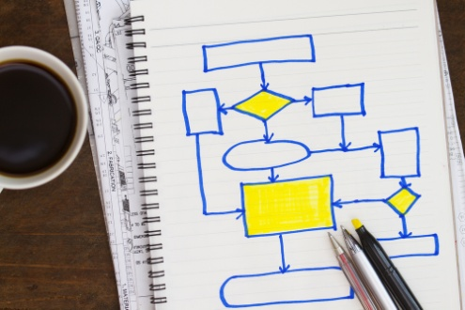
Systems design
Based on the facts gathered during the analysis phase, the new system is designed or improvements made to the existing system. This can range from a minor change such as an updated form for customers to complete to a conversion from a manual to computerised process. There is often a team of relevant personnel involved depending on the nature and scope of the new system. Systems design should always take care to consider:
- Personnel and their job descriptions that required to operate the new or changed system
- Source documents to record transactions
- Accounting records and procedures to process data
- Reports to be prepared
- Any automated features of the system.
The basic concern of the systems design phase is to ensure that the flow of information through the accounting system is efficient and reliable internal controls are developed.
Systems implementation and review
This is the final step in the development or revision of a financial system. Policy and procedure manuals are updated as a formal description of the procedures required for the new system or new process. The personnel needed to operate the system are trained and supervised closely to ensure they understand the new or revised functions. Any new documents, records or equipment are also purchased or the designs released.
When revising a system or process, usually the new and the old systems operate together until management are sure the new system is reliable.

Key considerations when developing a financial system
Cost versus benefits
There are a number of important considerations for management when developing a financial system. The first of these is cost versus benefits.
The value of the benefits of any new or revised financial system usually comes from the output of the system. This can be measured by the timely, reliable and relevant information provided for management decisions, the capacity to report to owners and to meet regulatory or government reporting requirements. The costs of design, analysis and implementation must be balanced appropriately with these benefits.
Compatibility
All financial system must be compatible with the particular characteristics of the business. This includes:
- Size and nature of the business
- Qualifications and competencies of staff
- Location such as local, regional, national and international.
To ensure appropriate compatibility, it is necessary to have a thorough understanding of the business and the industry. Some unique characteristics of the tourism industry are explored under the internal control sections.
Flexibility and Adaptability
No business is static and over time, the size, scope and nature of organisations change. New products or services are offered, the internal structure of the business changed such as new departments added or removed or aspects of the business sold. The financial system must be developed to adapt to these changes.
Internal control

Every financial system must have adequate controls built in to the system. This means that the system must protect the inputs – the data, process the data through timely, reliable and accurate procedures and provide output that meets the needs of decision makers, also in a timely, accurate and reliable manner. Such as system is called a system of internal control and is discussed fully below.

Internal control systems
One of the most important functions of management is to efficiently use and protect the assets of the business. In a smaller business, such as an independent tourism operator, the owner is usually always present and performs this function themselves. In larger establishments, this becomes impractical and the owner must rely on others to help manage and control operations. The system designed to help managers is an internal control system.
The Internal control system can be defined as a system of procedures and forms established in a business to safeguard its assets and ensure the reliability of accounting information. It consists of all the measures used by a business to:

Safeguard its assets

This objective focuses on the protection of assets from theft and inefficiencies. For example, cash is kept in secure storage. Fixed assets should be maintained so that they are in good working order.
Promote efficient operations
Efficiency is maximised by ensuring that policies from staff recruitment through to technology to support business functions are reviewed and new efficient methods adopted as appropriate.
Maintain accurate and reliable accounting records
Financial data must be carefully recorded and processed so that the reports produced by the system are relied upon for accuracy and completeness to assist external and internal users of reports monitor and evaluate business performance.
Encourage and promote compliance with business policies and government regulations
This objective is an important characteristic of an internal control system and is monitored by regular internal and external reviews. These reviews are called audits and assess the extent to which internal control procedures are followed. In doing so, they also provide an independent verification of the financial records.
Management responsibilities

It is the responsibility of management to ensure that the internal control system meets any legal requirements set down by government bodies. These may cover requirements for the preparation of financial statements or require owners to give an opinion in the annual report.
The need for controls
Because the flow of information in a business is constant, different departments of different people will need to access the same information. Controls must be in place to ensure that the information remains secure and accurate.

Structure of the internal control system
An internal control system includes the control environment, the information system and internal control policies and procedures. It is important to highlight that this relates to the entire organisation. The system can be classified into two main types being administrative controls and accounting controls.
Administrative controls
These are systems and procedures that are established to encourage and promote adherence to policies and provide efficiencies in operation. One of the foundations of an effective internal control system that falls under this category is an organisation chart. This shows the structure of a business and establishes levels of authority, responsibility and lines of communication. Generally, the larger the tourism establishment, the more complex the organisation chart.
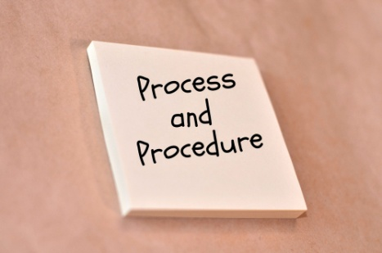
Examples of other administrative controls are:
- Written procedures for recruitment and hiring staff
- A system of authorisation and responsibility
- General operational policy and procedure guidelines
- Manuals identifying sales and purchases procedures
- Details of performance reports from employees.


Activity 14 - Identify organisational chart

You are required to collect or prepare an organisational chart for a tourism organisation of your choice.
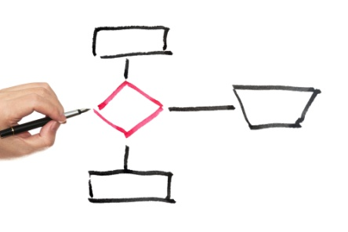
Accounting controls
Accounting or financial controls refer to procedures put in place to meet the following objectives and are the focus of this unit of study. It is necessary in an effective internal control system that accounting controls are designed to provide reasonable assurance that these objectives are met.
Objective | Description
Financial records are complete | All transactions are recorded and any omissions are prevented
Financial records are valid | All recorded transactions are “real” and properly authorised
Financial records are accurate | Transactions are properly valued, errors are minimised and records are classified correctly and kept in a timely manner
Adequate safeguards | Ensure that all assets are properly safeguarded against loss, theft and are maintained appropriately
Accountability | Ensure all staff are assigned clear responsibility through clearly defined job descriptions and duties

Principles of internal control systems
To ensure adequate levels of administrative and financial controls and therefore an effective internal control system, there are some basic principles that to consider. The actual control measures implemented are affected by the size and nature of the business and management’s view on the combination of controls that are most appropriate.
Following are some of the more important principles and is followed by the application of these principles to establishments in the hospitality and tourism industries.
Establish clear lines of responsibility and supervision
In some capacity in all organisations, individuals carry out business transactions, record the transactions and manage the assets resulting from activities and events. An important aspect of an effective internal control system is to employ or hire competent, trustworthy people. This begins with good procedures for screening and selecting appropriate people. Responsibilities of the position should match the ability and authority of the person employed. For example, when hiring managers, people with appropriate management skills should be selected and employed.
It is also necessary for employees to have a clear understanding of the responsibilities of their role. This begins with the organisation chart. It then extends to specific tasks or duties such as receiving food supplies, counting cash at the end of a shift or accepting payment for an accommodation bill.
Responsibilities should be assigned so that there are no overlapping or undefined tasks. Imagine a cash register where two members of staff are responsible for the cash contents. If there are problems, it is difficult to determine the error and therefore take corrective action. The internal control system is better when a task is restricted to one employee at one time.
Policies and procedures for training also support employees to understand and perform the responsibilities of their role appropriately. This covers training when staff are first employed, both in organisational policies and in specific tasks as well continuing development of skills and evaluation. Training can be occur within or external to the establishment.
Part of the internal control system is also management supervision. Management must continually observe operations as no internal control system can always safeguard against the likelihood of theft, fraud or ineffective operational practices.
Responsibilities and duties should also be rotated amongst employees, wherever possible and for appropriate periods. This gives employees the opportunity to be familiar with the entire system and gain a better understanding of the relationships between inputs, processing and outputs. It also encourages employees to carry out tasks according to policies and procedures since they know someone else will soon be taking over and possibly reviewing their activities.
Separate or divide the responsibility for related transactions

To minimise the possibility of errors, theft or fraud, responsibility for related transactions should be separate so as the work of one employee is verified or acts as a check on the work of another. This is not two employees carrying out the same task but two different employees carrying out two different control functions. This ensures that no single person has too much control over the assets of the business.
One common example in a tourism establishment that illustrates this point is the responsibility for ordering goods, receiving goods and paying for the goods received. This responsibility sits in the purchasing area. Separating these tasks to individual employees minimises the opportunity for any one employee to order and receive goods for their own use but authorise the business to make payment.
Separate record keeping and control of assets
One of the more important principles of internal control is to separate the functions of recording information about assets and the actual control of the assets. For example, when a cashier is responsible for a sales register and therefore cash sales in the department for their shift, they should not be responsible for entering the transactions in the cash receipts journals in the accounting system. This minimises theft and contributes to ensuring that financial records are valid, accurate and complete.
Storeroom personnel may control other assets such as food and beverage inventories but different employees maintain the record of what is actually in the storeroom in the accounting system.
The number of employees who have access to assets should also be limited. This requires management to balance access requirements that do not hinder efficient operations but that minimise the risk of theft or fraud. Too many employees with access increase the chance of rick or fraud but too little can affect customer service and quality. For example, if only one employee has access to cash reserves in a larger establishment yet two or more areas need to provide notes and coins to customers or guests for change, there may be a delay in getting that change to the appropriate register and the customer or guest must wait.

Surprise checks or reviews for both the recording and actual control of assets are carried out as part of an effective control system. There are two aspects to consider when conducting spot checks. The first is that the employee conducting the spot check should be independent or not part of the operation checked. For example, if supplies are checked, this person should not be involved in recording or counting supplies. The second is that spot checks should be frequent but not scheduled in a predictable pattern such as once a week on the same day.
One further control procedure for employees with control of assets is to impose a mandatory holiday break. This discourages dishonest activity, as employees know that someone will take over their responsibilities while they are away. This can also highlight any weaknesses or changes in control procedures that may have been evident before.

Activity 15 - Identify importance of 'separation'

You are required to explain the importance for having 'separation' mechanisms in a financial system.
________________________________________________________________________________________________________________________________________________________________________________________________________________________________________________________________________________________________________________________________________________________________________________________________________________________________________________________________________________________________________________________________________________________________________________________________________
Prepare written procedures
Once procedures have been established in all areas of an organisation and for each job or role where control is needed, these procedures should be documented. This is particularly important in the hospitality industry where employee turnover is high. Employees should always be able to access these documents so that they know what the policies and procedures are.
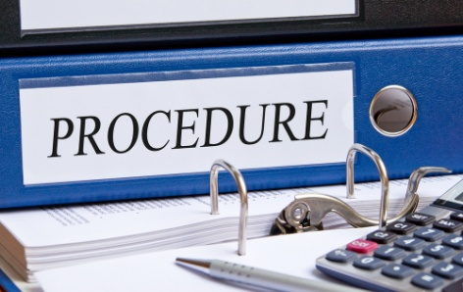
It is very difficult to establish a set of procedures that will fit every possible situation in the hospitality and tourism industry because there are such a wide variety of types, sizes and styles of establishments. Even in two establishments that appear similar, management policy, the type of customer or other reasons means the procedures for any particular control area differs.

Documentation procedures

Documents provide the basis for determining activities and events that have occurred throughout an organisation. Tickets for tours must be numbered. These documents and others that are similar should be pre-numbered whenever possible. In this way, individual documents can be tracked and prevents the same document form being used more than once. When pre-numbered documents are used, the employee receiving the document should sign it to acknowledge responsibility and accountability.
Forms and reports also form part of the documentation of in an organisation. They are often used to provide management with information about different aspects of the business so that performance can be reviewed, evaluated and revised when necessary. Usually the accounting department or personnel are responsible for designing forms and reports in consultation with appropriate management.
The accounting department or person is also responsible for designing, ordering, storing and issuing all pre-numbered and other documents. This is to ensure that documents are used appropriately. The sequence of all numbered documents is checked regularly to ensure none are missing.

Activity 16 - Identify procedures used in a financial system

You are required to identify three procedures that exist or you would implement as part of a financial system for a tourism organisation.
TYPE OF PROCEDURE | EXPLANATION

Set standards and evaluate results

Another important principle for an effective internal control system is to have a reporting system that indicates whether all aspects of the business are operating properly. As part of the written guidelines given to employees about how to perform specific tasks in their role, standards of performance should also be established.
A common standard of performance in the tourism industry relating to revenue is sales and regarding costs is gross and net cost percentages.
By setting a standard, manager’s performance and the performance of the establishment are evaluated against that standard.

Activity 17 - Identify standards used in a financial system

You are required to identify categories and examples of standards within these categories that exist or you would implement as part of a financial system for a tourism organisation.
Some examples have been added to guide your responses.
CATEGORY OF STANDARD | EXAMPLES OF STANDARDS
Revenue | Tour sales  Merchandise sales
Expenses
Productivity

Mechanical and electronic devices
In order to protect assets and maintain the accuracy and efficiency of the accounting process, mechanical and electronic devices should be used wherever possible. These can be physical controls such as:
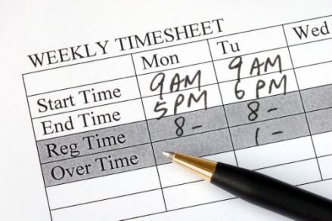
- A safe or vault for cash and secure document storage
- Cash registers
- Passwords, cards or combinations locks restricting access to buildings or areas in the organisation
- Point of sale (POS) systems
- Electronic time-keeping for employee shifts that records the number of hours worked.
There are also computer programming controls built in to a computerised accounting system. These include:
- Confirmation that data has been processed in the correct sequence
- Proof of accounting and mathematical integrity
- Limits to monetary amounts that can be processed
- Password access to authorised users
- Anti-virus and other software that identifies unauthorised interference.

Activity 18 - Identify devised used in a financial system

You are required to identify three different devices, either mechanical or electrical that can be used as part of a financial system

DEVICE | PURPOSE OF DEVICE

Maintain adequate insurance
Insurance is a guarantee that is purchased to provide monetary compensation for loss, damage or theft of an organisation's assets. If assets are fully insured, they can be recovered or replaced and continue to contribute to the profit making capabilities of the business. Insurance can also cover a loss of profits if there is a delay in replacing assets.
Internal audits
The purpose for internal audits is to continually review and study the internal control system of an organisation. Sometimes, there is an internal audit department depending on the size of the business and in other circumstances; the owner or most senior manager is assigned this responsibility as part of their role.
During the year, various record keeping systems and administrative processes are reviewed to ensure that operations are conducted effectively and documented procedures are being followed. If a procedure, form or report is not used for its intended purpose or is not needed anymore then the internal audit should address this and recommend a change. One of the reasons why this is important is that employees may begin to adjust procedures for fraudulent purposes and if this is not noticed, they will know the internal control system is not working and continue this practice.
An audit trail exists in every good internal control system that documents each transaction from the time it was initiated through to final recording in the accounting system. Internal auditors follow and verify this audit trail to ensure it is maintained. A simple example of an audit trail may be as follows:
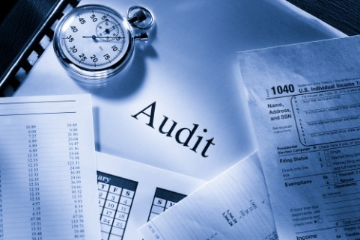
- Sale of tours is recorded on a pre-numbered sales document
- The customer presents the pre-numbered document for payment
- Payment is processed through the point of sale system using the pre-numbered document as a reference
- The pre-numbered document and the cash are stored in the cash register
Almost all organisations, regardless of size also undergo external audits. Objective, external parties such as an accounting firm conduct these audits.

Activity 19 - Identify importance of internal audits

You are required to identify the purpose and importance of having internal audit mechanisms as part of a financial system.
____________________________________________________________________________________________________________________________________________________________________________________________________________________________________________________________________________________________________
Explain the reasons
The final principle of an internal control system that encompasses all others is to ensure that all employees understand the implications for internal control that apply to their position. The importance of minimising loss, theft and fraud in the context of the operations performed should be clearly explained. It should also be clear to an employee how the specific internal control procedures they are asked to perform fit into the internal control system of the entire establishment.

Limitations of internal control systems
All systems of internal control should provide a high level of assurance that assets are safeguarded and the accounting records meet the objectives of reliability, validity, accuracy and completeness.

However there are limitations, including the following:
- The cost of implementing a system where absolute assurance is met far exceeds the benefits an organisation would expect to derive
- For smaller organisations, there is always a compromise it is not possible to implement some internal control principles due to cost and or capability
- Employee attitudes influence the effectiveness of an internal control system. Tired, bored and disinterested employees can be careless resulting in a less effective system
- Even though duties are separated, internal control systems cannot negate the chance that employees may work together to act dishonestly. This is called collusion.

Internal control challenges in the tourism industry
For businesses in the tourism industry, internal control systems are many and varied. All systems adhere to the objective, structures and principles that have been introduced so far.
However, there are challenges that are unique to the industry that will require a certain focus on and combination of actual internal control measures to ensure an effective internal control system is maintained.
Business size
The size of the tourism business influences the nature of the internal control system. Many establishments are not considered large organisations, even if they are part of a greater company or franchise so it is more difficult to implement a comprehensive internal control system.
This places responsibility for many internal control functions with senior managers or owners. The limitations this places on the procedures that can be performed must be acknowledged and considered.

Cash transactions
One of the key characteristics of the tourism industry is the high level of cash transactions that are conducted every day. Cash is defined as a method of payment and includes notes and coins, cheques, credit card payments, vouchers, electronic transfers and any other legal form of payment. It is the asset most susceptible to theft. Cash can be readily transferred into another asset, it is easy to transport and conceal, it is difficult to distinguish cash that belongs to the establishment from cash the employee may already have on hand and is very desirable.

Typically, revenue is earned or generated in the tourism industry from activities that require the use of cash. The accounting system must appropriately record this cash so that all revenue earned by the business is recognised and profits, for each area or department and the establishment as a whole can be calculated accurately.
It is therefore very important that appropriate internal control procedures are established to protect cash held on the premises as well as handling cash that is received by the business (cash receipts) and cash that is paid out from the business (cash payments).
Whilst all the principles of a good internal control system apply to cash transactions, of particular importance are the following:
- The separation of responsibility for receiving cash, banking cash and maintaining accounting records for cash
- Cash receipts for each day should be banked the same day where possible
- An automated summary of cash receipts from the POS system should be printed out by an employee other than the cashier and used as a basis for updating accounting records
- All payments should be made by cheque or electronic transfer with appropriate authorisation by designated personnel.
Labour intensive implications
One of the defining features of the tourism industry is that it is labour intensive. This means that people rather than machines carry out the activities required for organisations to operate.
This has two main implications for internal control systems.

Payroll costs, that are the amount paid to all employees for the services they provided, are often the single largest expense, especially in tourism establishments. It is always a balance between providing quality customer service and efficient operations with wages and salaries paid and scheduling employee hours. This justifies particular attention with respect to internal control procedures.
Furthermore, the tourism industry experiences a much higher employee turnover rate than other industries. The turnover rate is the percentage of employees that leave and need to be replaced compared to total employees for a given period.
This has implications for training, skill development and knowledge of operations, all which must be considered by the internal control system.
The principles that will ensure proper control is exercised over payroll may include the following:
- Clear policies regarding the screening and selection of new employees
- Training of new employees to be cost efficient and appropriate to the position

- Separation of responsibilities from hiring new staff, approval of pay rates and processing of payroll
- Mechanical or electronic capture of hours worked if appropriate otherwise forms should be designed that must be completed for hours to be recognised and processed
- Pre-numbered documents such as identification number for each employee, processing documents are used
- Spot checks are conducted on payroll sheets to verify accuracy of calculations
- A separate bank account is maintained for payroll to provide more accurate means of verifying and reconciling payments to employees.
Inventory
Even though the assets of inventory in tourism establishments in particular may only be a small proportion of total assets, the value of many individual products can be quite high. Consider expensive equipment supplies. Internal controls need to ensure that these items are not lost or stolen by dishonest employees.
Limiting physical access may control these items. They are stored in a secure area accessed only by lock and key, combination lock, swipe card or similar. Periodic spot checks by independent employees would also be part of the internal controls implemented.
Sales volatility
The tourism industry is very susceptible to the highs and lows of the economic cycle. In a strong economy, household income is high and spending in the hospitality and tourism sector increases. In a weak economy, household income is low and spending decreases. Accurately predicting these fluctuations and adjusting operations to the changes in demand are necessary to remain successful in the industry.
The standards of performance set as part of the internal control system are often utilised for such predictions as managers ensure that these standards are not compromised by changes to operations.
E-commerce
Many tourism and hospitality organisations conduct business over the internet. Reservations are made directly or indirectly through booking agents, deposits paid and entire holiday and accommodation packages are arranged, paid and confirmed on-line.
This creates new risks for internal control as unauthorised users can gain access to confidential details. To convince customers, guests or clients that it is safe to use on-line facilities, the establishment must ensure that data is secure.
Two standard techniques that should be part of any internal control system that operates on-line are firewalls and encryption. Firewalls limit access to a local computer system or network but allow local users to access the internet. Encryption scrambles words by a mathematical process and can only be read by a system that knows the process.

Implementing internal controls
With the principles and objectives of internal controls in mind as well as the particular challenges for businesses in the hospitality and tourism industry, processes should be developed for both the financial and administrative functions of the business that satisfy internal control requirements.
Administrative controls refer to the organisational structure, authorisation, performance standards and employee policies and procedures. It is beyond the scope of this unit of study for you to explore each of these in detail.
Financial or accounting controls
Financial or accounting controls refer to the internal control processes that ensure both internal and external financial statements and reports provide users with information about the business that is valid, accurate, reliable, timely and complete.
To effectively and efficiently process and produce reports or the outputs from the financial system, those responsible must have access to records of all transactions within the business. A fully integrated accounting system describes a financial system where all transactions recorded by all the different functions in the business are stored in one system. This can apply to both manual and computerised systems. Most software packages, PMS or manual options available to the hospitality and tourism industry are considered to be fully integrated systems.
This diagram illustrates the structure of a fully integrated financial system.
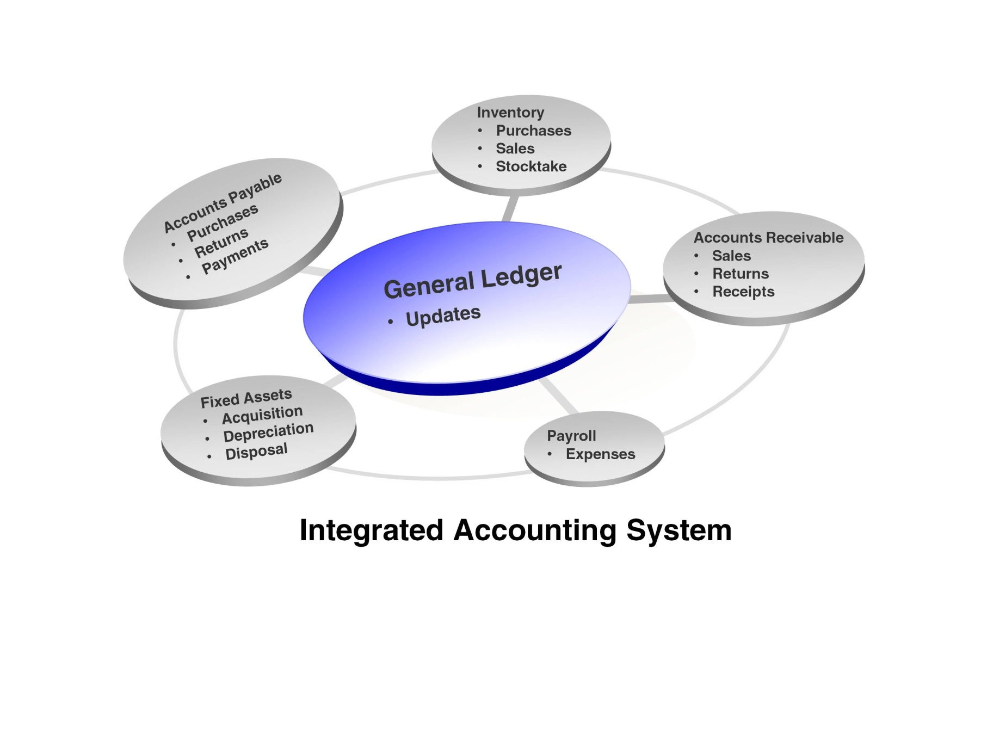
Financial sub-systems
Supporting the accounting system depicted above is a range of subsystems that are integrated into the whole system. The operation of each system has three basic steps or phases, input, processing and outputs that are unique to that system. Each sub-system collects processes and reports transactions relating to similar business activities and events. The most common found in most accounting systems, manual or computerised in the hospitality and tourism industry are:

- Cash
- Sales
- Fixed Assets
- Payroll
- Purchases
- Accounts receivable
- Accounts payable
- Inventories.
The subsystems vary according to the size, structure and complexity of the operating activities of the business. It is useful to consider internal control requirements in terms of these sub-systems as there are different processes that will have to be implemented to ensure the objectives of internal control are met.

Control of cash
The cash sub-system records all receipts and payments within the organisation. Remember that cash is defined as any legal form of payment such as notes and coins, credit card payments, cheques, direct deposits and other electronic transfers. Cash is the asset most at risk of theft and fraud in any hospitality and tourism establishment. It is therefore important to establish effective internal controls for handling cash and recording cash transactions. Three particularly important principles for cash that were introduced earlier are the separation of responsibilities, appropriate documentations procedures and secure payment processes. These principles are applied to the control of cash receipts, cash payments and petty cash. An additional control feature regarding planning or cash management is also considered.
The bank account
An essential element of the internal control of cash is the requirement that each day’s cash receipts are deposited into a bank account. In addition, all major payments are made by cheques or electronic transfers from a bank account. Internal control is strengthened because the bank record of deposits received, cheques paid and transfers made provides and independent cross check on the internal records of the business. Establishments may use more than one bank account to carry out these functions, depending on the size of the business, management policies or other internal or external requirements. For example, travel agencies may be required to help client deposits in a separate bank account from their normal operations account until the service is provided.

Control of cash receipts
Internal control over cash receipts ensures that all cash receipts are deposited in the bank and recorded in the accounting system. Given the high volume of cash transactions in the hospitality and tourism industry and that these cash receipts can represent a significant portion of revenue it is very important that internal control procedures are developed for the different sources of cash receipts.

Cash receipts from cash sales
Cash is received in tourism business as payment for goods and services such as tours and travel services in several areas of the establishment at the same time. Each area will have a point of sale terminal or cash register depending on the equipment available. The process for recording the sale is as follows:
- Each sale is entered or rung up on the cash register or terminal
- The register or point of sale terminal is located in a position that allows the customer to see the amount recorded.
- Each sale is recorded on the locked-in tape inside the register or terminal.
- The customer, guest or client receives a receipt printed from the register or terminal that summarises their transaction
- The cash drawer opens only after the sale is recorded by the register or terminal and at the end of the day by a supervisor or other authorised personnel.
At the end of the day’s trading or shift, the supervisor collects and counts the cash in the register or terminal drawer and enters the information in a pre-printed form sent to the accounting department or personnel. The register tape that summarises the cash sales for the day or shift is attached to the form. The contents of the cash drawer are then forwarded to the cashier for deposit into the bank account.

This procedure clearly separates the responsibility of handling cash, both during the shift and at the end of the day from the responsibility of updating the accounting records. Neither the cashier or supervisors have access to the accounting records nor do accounting personnel have access to cash.
Some businesses may use pre-numbered sales dockets for cash receipts as an additional internal control feature. Often larger accommodation venues use this feature so that the sales docket can be attached to the guest’s bill or the details of the sale updated manually on the guest’s bill.
The sale is recorded on a register or terminal as above as well as recorded on a sales docket. The customer is given one copy and the duplicate is retained and stored in the register or terminal. At the end of the day or shift, a supervisor or other independent employee adds the total of the sales dockets to ensure none are missing. The total is compared to the total sales recorded on the register tape.
Cash short and over
In spite of internal control measures, errors still occur when cash sales are recorded at the point of sale terminal. As a result, a cash shortage or cash surplus (too much cash) is discovered. A cash shortage occurs when the total sales on the cash register tape are greater than the cash counted from the cash drawer. When cash from the cash drawer is greater than the recorded balance on the cash register tape, a cash-over situation has occurred. The accounting system records cash shorts and overs and it is expected that these will cancel each other out over time. However, if this does not happen, there may be a problem with cash being lost or stolen. In this way, monitoring shorts and overs becomes an effective internal control technique, especially when employees know that shorts and overs are reviewed.
Cash receipts by mail
The amount of cash receipts by mail varies greatly for establishments in the tourism and hospitality industry. Sometimes charges in accommodation venues are not paid on checkout and payment is forwarded by post at a later date. Sometimes a deposit is sent by mail to reserve a room or place on tour for example. Generally, forms of payment other than notes and coins are sent by mail as if the payment goes missing, cheques or vouchers can be cancelled and replaced but notes and coins cannot!
Internal control procedures for cash received by mail include:
- Designated personnel open mail and the cash received recorded on a pre-printed form. This employee is separate from the cashier and the accounting function
- One copy of the form is sent to the cashier for banking along with the cash amounts and will added to the banking for that day or shift
- Another copy of the form is sent to the accounting department or personnel to update the accounting records.
This ensures that the person opening the mail and the cashier cannot access the accounting records and accounting personnel have no access to cash.
Cash receipts by direct deposit
Many customers, guests or clients may also make payment directly into the bank account of the hospitality and tourism establishment instead of sending payment by mail. This practice enhances internal control as cash is never required to be handled on the premises. Notification confirming the direct deposit is usually sent on or around the day of the deposit to accounting personnel so that accounting records can record the cash receipt. The bank reconciliation ensures that the accounting system will record this cash receipt even if notification is delayed or forgotten.


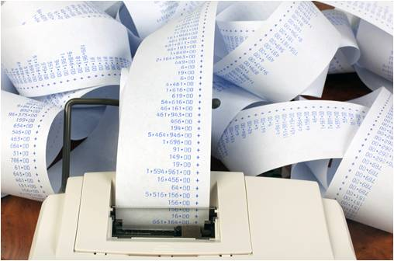
Activity 20 - Control receipts

You are required to identify common ways a tourism organisation receives money and ways to ensure that each of these methods can be controlled and safeguarded.

COMMON METHODS TO RECEIVE MONEY | METHODS TO CONTROL AND SAFEGUARD MONEY RECEIVED

Control of cash payments

Cash payments are made to cover a wide variety of obligations for tourism businesses. Examples are:
- Cash purchases
- Payments to suppliers for goods and services received
- Payroll
- Other expenses
- Repay loans
- Purchase fixed assets.
These obligations can be separated into payments made for external purchases or obligations and payroll, an internal function. Internal control processes for payroll will be reviewed in a later section. The focus for now is determining appropriate procedures for the authorisation of cash payments, the approval of cash payments, additional internal controls for cheques and the issue of notes and coins for minor cash disbursements.
Approval of cash payments documentation
Before a cash payment can be made, there must always be appropriate documentation to support the payment. This documentation can be part of the inventory purchasing process for a service outlet, it can detail the fixed assets bought by the establishment or summarises services that have subsequently been provided to customers such as airplane fares. The common term used for such documentation is an invoice.
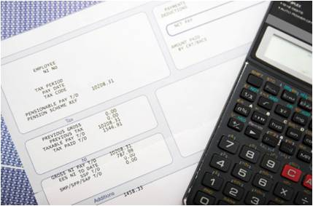
It is very important that the responsibility for approving invoices is separate from the purchasing and receiving functions as well as separate from employees designated to prepare cheques and electronic transfers. To approve an invoice, it must be verified that goods and services were properly ordered and received as expected. Documentation such as purchase orders and receiving orders provide evidence of this. Often an approval stamp is used to indicate this.
In some establishments, the accounting department or personnel will collate all supporting documentation. It will be checked for accuracy and then forwarded to appropriate personnel for approval. In smaller organisations, this may not be possible.
Some larger service establishments use a voucher system to further strengthen internal controls over cash payments. When a document such as an invoice is approved for payment, a pre-numbered voucher (used in sequence) is prepared. This details the information from all other documents that support the payment and provides a space for recording the date of payment and cheque details. All of the supporting documents are attached to the voucher and given to the person who prepares the cheque payment. The cheque is then attached to the voucher. Final approval can be given as the voucher verifies that the transaction is valid and authentic.
Authorisation of cash payments
Once invoices have been approved for payment, they are sent to designated personnel who authorise payment. This is an important separation of duties in the cash payment process as different personnel approve invoices, process payments and authorise payments. Even smaller hospitality and tourism venues attempt to separate these responsibilities as much as possible.
Once invoices have been approved, they are sent for payment. Payment can be made by cheque or electronic transfer. Generally, the following steps are followed:
- Personnel responsible for cash payments check all invoices for appropriate approval and sort into payment type, either cheque or electronic transfer
- Cheques are printed and electronic transfer data completed
- Authorisation is given for payment depending on the payment method and invoices are marked as paid
- Payment is distributed to suppliers, to employees for payroll or other relevant parties according to the cash payment processed.
There are unique internal control procedures for each payment method and these are explored below.

Approved invoices, copies of cheques and approved electronic transfers are sent to the accounting department where entries are made into the accounting system to reflect the transactions that have occurred. Once again, personnel entering this information must be separate from those approving, processing and authorising cash payments.
Controls over payment by cheque
Payment by cheque is in itself an important control over cash payments. Firstly, cheques are a pre-numbered document so they can be tracked. They should be used sequentially so that any missing numbers are easily noticed. Secondly, to be valid, a cheque must be signed by authorised personnel who are often senior management and have been approved by the bank or financial institution. It is their responsibility to study the evidence supporting the payment before it is approved. It is common practice to require two cheque signatories.
When cheques are used for payments, they must be treated like notes and coins and stored securely. This is usually in a safe with access limited to employees who prepare cheques for payment and not employees who are authorised to sign cheques. Any cheques that cannot be used must be voided and kept.
Some organisation can utilise functions in the computerised accounting system or use another mechanical form that can print details on cheques such as the name of the recipient and the amount. This is an internal control procedure in itself as this generally prevents anyone from altering the amount to be paid.
Access to this automated process will be limited to those employees who prepare cheques and are usually by password or other security measure such as a key that allows a machine to operate. Furthermore, cheques are usually printed in a secure environment to reduce the risk of error.
Once cheques have been signed, they should be sent out promptly to minimise any chance that they could be lost or otherwise missing. Usually a list is created to monitor the cheques that have been printed, sent for approval, returned and sent.
Controls over payments by electronic transfer
Electronic transfers sends cash directly from the bank account of the business to the bank account of the party with whom the obligation to pay lies such as suppliers or employees in the case of payroll. When an invoice is approved for payment, a pro-forma document, either within the accounting system or printed manually is created and the details of all the cash payments to be made by electronic transfer are entered.
The name of the party to be paid, the payment amount and a code relating to that party’s bank details are included on this form.
This pro-forma document is then authorised by senior personnel to indicate that payment is authorised. If the form is manual, signatures are required similar to a cheque. If the document were part of the accounting system, a password or code would be required to indicate that payments are authorised. This list is sent electronically or delivered to the bank and the cash payments are made.
The internal control system must ensure that authorisation passwords, codes relating to confidential information and delivery to the bank are all surrounded by sound security measures.



Activity 21 - Control payments

You are required to identify common ways a tourism organisation pays money and ways to ensure that each of these methods can be controlled and safeguarded.

COMMON METHODS TO PAY MONEY | METHODS TO CONTROL AND SAFEGUARD MONEY PAID

Control of petty cash payments
To make minor cash payments or cash disbursements, businesses keep a small amount of notes and coins on hand. This is called a petty cash fund. Many tourism organisations feature a well-used petty cash fund, as there are often many minor expenses that are incurred. For example, a customer may not have enough local currency on hand to pay a transport fare such as a taxi. The organisation, in the interests of quality service, uses the notes and coins from the petty cash fund to pay the fare. The charge may be added to the customer's account or perhaps waived entirely depending on policies and procedures. Sometimes on a tour a tour guide may purchase an item on behalf of a customer. The tour guide may purchase the item and re-imbursed from the petty cash fund.
It is important to note that even though the amounts paid from the petty cash fund may be small, over time the total amount of expenses paid in this way may grow quite large.

Therefore, internal control procedures such as these must be established:
- The responsibility for administering the petty cash rests with one employee
- A specific amount of notes and coins is kept on hand; sometimes this is enough to cover one month’s transactions but may be any other appropriate measure. This is called the fund limit
- All payments from the petty cash fund must be supported by a petty cash slip or voucher
- The petty cash fund is replenished to the fund limit at least monthly so that the accounting records can accurately state the expenses incurred by the business.
A petty cash voucher is prepared for every payment made from the petty cash fund. It shows the amount paid, the purpose of the payment and the date paid. It requires two signatures, one from the person receiving the payment and one from the employee responsible for the petty cash fund. Attached to the petty cash slip or voucher will be an original proof for payment of the expense. In the example above, a receipt for the transport fare will have been provided. This receipt is attached to the petty cash voucher to verify the validity of the payment.
At suitable intervals, personnel that are not responsible for the petty cash fund record expenses from petty cash vouchers in the accounting system. Sometimes a petty cash book is used that summarises like expenses in columns and it is simply the totals of each column that are shown in accounting records. For other systems, all petty cash transactions are recorded. This separation of responsibilities serves to further strengthen the internal control of cash.

Activity 22 - Control petty cash

You are required to identify the different reasons why petty cash may be used by a travel organisation and methods to control petty cash usage.

REASONS WHY PETTY CASH IS USED IN A TOURISM ORGANISATION
- _________________________________________________________
- _________________________________________________________
- _________________________________________________________
- _________________________________________________________
- _________________________________________________________

METHODS TO CONTROL PETTY CASH USAGE
- _________________________________________________________
- _________________________________________________________
- _________________________________________________________

Control of cash budgets
So far, the focus on internal controls for cash has been establishing procedures within the recording process. However, an important aspect of control over cash is planning cash that will come into the business (cash inflow) and cash that will be paid out (cash outflows). A cash budget helps a business to manage cash by expressing these plans for a given future period. It will show whether or not there are sufficient cash inflows, to make future payments to suppliers, to employees and for other expenses. This is particularly important for hospitality and tourism organisations who not only experience seasonal and economic volatility in sales but because a high portion of these sales are in cash, need to carefully consider and plan cash inflows so that cash outflows can also be managed and adjusted as required.
Estimating the amount of cash expected from cash sales, and the amount of cash required for cash payments and any other outlays creates cash budgets. The difference between these two amounts is added to or subtracted from the existing cash balance in the bank account so that a forecast for cash needs is established. Managers or owners can act on this information appropriately. For example, if for a given period, there appears to be insufficient cash, a request can be made to the bank for short term financing. If there is excess cash, management may choose to purchase fixed assets or upgrade existing fixed assets.
It is for these reasons that the cash budget along with internal controls over the recording of cash that are the priority of internal control systems for organisations in the hospitality and tourism industry.

Control of accounts receivable
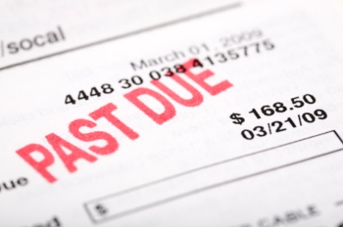
Accounts receivable are amounts owed to a business by customers, clients, guests and any other outside party for goods and services that have been provided but where payment was not made. These are called credit sales. Until payment is made, they are considered debtors to the business. Collectively they are called accounts receivable. In fact, it is common for larger organisations such as accommodation venues and resorts to use the term accounts receivable and smaller tourism and hospitality businesses use the term debtors.
The accounts receivable sub-system manages individual debtor accounts by issuing invoices for payment and credit notes, recording and processes payments received and issuing receipts to debtors to acknowledge a payment has been accepted. Reports or outputs from the system include summaries of all outstanding amounts, summaries of payments received and any other activities that have occurred that are needed by management.
Most larger organisations establish a credit department to manage and control the accounts receivable sub-system and in smaller organisations, the most senior personnel usually assume these responsibilities.
As is the case with cash, internal control procedures must be established for accounts receivable to safeguard this asset. The main issues in controlling receivables are the management of credit policies, the recording of adjustments to debtor accounts, the separation of cash handling and cash accounting duties and the separation of responsibilities that surround the verification of final debtor balances.

Control of credit policies
The common phrase for the practice of permitting customers or clients to receive goods and services but make payment later, is to say that credit has been granted or extended to these parties. When a sale has been made, this represents revenue for the business.
For that revenue to contribute to profit and the success of the business, it must be received by the business, even at a later date when credit has been granted. It is therefore important that there are clear management policies to determine:
- Which customers will be granted credit
- What the terms for payment will be
- How the terms and conditions are communicated to customers
- Satisfactory collection of amounts owing
- Methods to encourage payment on time
- Methods used to follow up outstanding amounts.
In the case of an accommodation venue, clear policies are also required to:
- Set a limit on the value a guest’s individual account can reach for their stay
- Advise employees on course of action should the limit be reached.
These written procedures form part of the internal control system as they set a plan of action for the operation of this function. Examples that are adopted across tourism and hospitality organisations are:
- Obtaining a credit report from an external source that summarises the credit history of individuals or businesses. This is often called a credit check
- In the case of an accommodation venue, a credit card imprint or authorisation is taken at check-in and the house limit temporarily processed. The guest has not made a payment but the establishment has confirmation that if the account reaches the house limit, funds are available for the guest to honour the payment
- Clear communication of credit policies on invoices, documentation that surrounds payment locations and in all appropriate correspondence
- Regular timely reports provided from the accounts receivable sub-system and provided to employees responsible for following up the collection of amounts owing
- Debtor accounts that have been outstanding for a period of time are reviewed by senior managers of the business who will determine appropriate action
- In some accommodation venues where guests stay for longer periods, the guest is provided with a copy of their bill at least once a week.
Managers can determine the success or otherwise of credit policies by monitoring the amounts collected over time. If these gradually rise, adjustments may need to be made. This is explored further in Section 1.5.


Activity 23 - Identify credit policies

You are required to identify the different types of customers or clients you may extend a line of credit to. Explain why you would grant them lines of credit.
________________________________________________________________________________________________________________________________________________________________________________________________________________________________________________________________________________________________________________________________________________________________________________________________________________________________________________________________________________________________________________________________________________________________________________________________________
You will also need to identify policies you would have in place to ensure outstanding payments are monitored and repaid.
________________________________________________________________________________________________________________________________________________________________________________________________________________________________________________________________________________________________________________________________________________________________________________________________________________________________________________________________________________________________________________________________________________________________________________________________________

Adjustments to debtor accounts
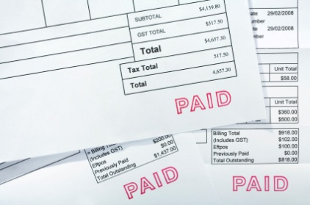
Debtors are created in the accounts receivable sub-system from sales invoices that are provided by the relevant area of operations where the sale was made. In the case of an accommodation venue, when the guest checks out, a copy of the approved bill is sent to accounts receivable personnel. Depending on the computerised accounting system and the nature of the business, a debtor account may already exist. Accounts receivable personnel check for accuracy and prepare and send an invoice to request payment. For example, accommodation venues transfer guest details from an in-house account to a city ledger account automatically when amounts for goods and services that have been provided may not have been settled on departure. The city ledger account forms part of the accounts receivable sub-system.
Sometimes the amounts on the sales invoices or city ledger account are incorrect or have been disputed by clients or guests. This may occur before or after the request for payment has been made. It is an important feature of internal control that only accounts receivable personnel are authorised to adjust amounts on debtor accounts. Adjustments are supported by appropriate documentation and will always be authorised by senior, designated personnel. Employees who handle the cash received from debtors and process sales invoices must never adjust debtor accounts as this puts the asset at risk.
Separation of cash handling and cash accounting duties
For there to be strong internal controls in the accounts receivable sub-system, it is critical that employees in the credit department or who perform these duties have no access to cash. For example, the cash received from client or guest could be stolen, the debtor’s account marked “uncollectable” to indicate that the debtor will not pay, the establishment will stop attempting to collect payment and adjustments to profit made to recognise that the amount will not be received.
To minimise or prevent this occurrence, cash receipts are collected as detailed in the section above, controlling cash receipts received by mail. Documentation is sent to accounts receivable personnel so that the accounting records can be updated with the debtor’s payment. In this way, cash and the debtor records are separate.
Separation of responsibilities for managing final balances
Internal controls surrounding the accounts receivable function are further strengthened by review and verification procedures. As part of collection procedures, monthly statements that summarise the amounts owed by debtors are prepared. These statements should be verified, and sent out to debtors by personnel other than those responsible for accounts receivable. Another independent check should be made to ensure that the statements sent to customers agree to accounts receivable records.

Control of purchases
The purchasing function in any organisation is responsible for ensuring that supplies, services and equipment are available for use to either sell as goods and services to customers, clients or guests or in the case of equipment, support the sale of goods and services. The purchasing sub-system is in the accounting or financial system records, co-ordinates, processes and reports these activities.
Internal control of purchases is required to ensure that purchases are made only for goods and services required by the business, to assign responsibility for who orders what type of goods and services, to check receipt of goods and services and to approve invoices.

To achieve strong internal controls over purchasing the following four principles are particularly important:
- Establish responsibility and supervision
- Forms and documents
- Separation of responsibilities
- Prepare written procedures.
Establish responsibility
Generally, establishments in the tourism industry will assign responsibility for purchasing to a number of employees who become the purchasing department or to one or two employees depending on the size and nature of the business.
The organisation chart along with clear job descriptions informs personnel of their responsibilities. For example, in a large accommodation venue, one person is responsible for ordering food and beverage supplies and another person in the purchasing department is responsible for ordering room amenities supplies. For a travel business, one person may be assigned to ordering services from airlines and another from accommodation venues. This minimises duplication of orders, mistakes and opportunities for dishonest practices.
Prepare written procedures
Written procedures that detail the tasks required for each of the different responsibilities in the purchasing function also need to be determined as part of the internal control system.
These procedures provide clear instructions for employees to follow and are particularly important for the hospitality and tourism industry where employee turnover can be high. The areas of purchasing to be covered are highlighted in the forms and documents section that follows.
Separation of responsibilities for transactions
All significant aspects of the purchasing process are recorded on forms or documents. These serve to record purchasing activities and divide responsibilities across several individuals or departments, depending on the establishment. The four basic documents that should feature in most hospitality and tourism organisations are:
- Purchase requisition
- Purchase order
- Invoice
- Receiving report.
Purchase requisition
Department managers or in smaller organisations, employees with overall responsibility for a function, are responsible for ensuring there are adequate supplies of goods and services. Since control of purchasing is co-ordinated by the purchasing department or a small number of personnel, departments cannot deal directly with suppliers. Instead, a pre-numbered, pro-forma document called a purchase requisition form is prepared with a description of the supplies required, the amount needed and the desired date of delivery. A signature authorises the request. There are often three copies of the purchase requisition, the department or person requesting the supplies retains one and the original and one copy are sent to purchasing.
The role of purchasing personnel is to confirm that the request can be met at the right price and within the desired time frame. Part of the responsibilities of this position is to authorise such requests, usually to a certain monetary limit. More senior personnel are required to approve purchases that may be beyond such limits however the basic process is still the same.
Purchase order
Once the purchase is authorised, a purchase order is prepared by purchasing personnel. Again, this is a pre-numbered, pro-forma document. Purchase orders are used in number order or sequentially and typically, four copies are produced and distributed as follows:
- Sent to the supplier to request goods or services
- Forwarded to the department initiating the purchase to confirm the order has been made
- Retained by the purchasing department
- Forwarded to the accounting department with the purchase requisition attached so that accounting records can be updated
It is common practice to ensure that the purchase requisition number is recorded on the purchase order and the purchase order number recorded on the requisition to further strengthen internal controls.
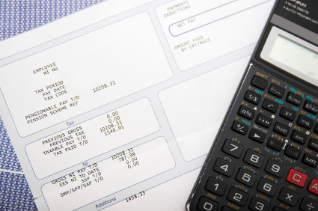
It is important to note that many establishments in the tourism and hospitality industry modify this process as it can become quite cumbersome, especially for food supplies that are ordered every day. Instead, agreements are established with approved suppliers and a particular purchase order form is used. The ordering department must complete this form and are authorised to send the request directly to suppliers. Procedures usually ensure that the purchasing and accounts department receive prompt notification of this. The use of computerised systems supports this process.
Supplier’s invoice
An invoice prepared by the supplier is an itemised listing of the goods and services provided and indicate the monetary amount owing. It usually accompanies the goods and services that have been delivered. The supplier may also send a copy of the same invoice to the accounts department.
The supplier usually includes the purchase order number and perhaps the purchase requisition number on the invoice to assist the accounting department in verifying the purchase.
Receiving report
An employee in the department or function that requested the goods completes the receiving report. It is used to verify that the goods requested have been received and should be checked item by item against the supplier’s invoice. If any items need to be returned or are missing, this is noted and verification by a third party, such as the delivery driver’s signature acknowledges the missing goods or the returned items. A copy of the receiving report accompanies the returned goods where necessary.
When the receipt of goods is finalised, the completed receiving report and the accompanying invoice are forwarded to the accounting department or personnel.
Final approval
When the accounting department receive the documentation confirming that goods or services have been received, this is matched to the original purchase requisition and purchase order. The following information should be compared and verified:
- Purchase requisition, purchase order and invoice numbers match
- Invoice prices compared to purchase order quotes

- Quantities compared to purchase order and receiving report
- The invoice is arithmetically correct.
Once verified, the invoice is approved. A stamp or voucher system as described in the cash payments section confirms this approval. The invoice and all the accompanying details are sent to cash payments to be processed.
The use of documentation in the purchasing process clearly defines responsibilities and the duties that need to be separated. Even if modifications are made to the process, the basic separation of tasks should still be maintained to ensure an effective internal control system.

Control of payroll
The internal control procedures reviewed for cash payments are intended to control payments made externally by tourism organisations. Since the cost of labour can be such a proportion of operating costs for establishments in the industry, it requires particular attention with respect to the implementation of internal controls. The main objectives for internal control of the payroll sub-system focus on ensuring that transactions are:
- Valid – employees exist
- Complete - all hours worked are paid
- Accurate – correct hours and pay rates are used
- Accountable – responsibility for tasks is clearly defined.

Procedures and processes specifically address the following internal control principles:
- Establish responsibility
- Separate or divide the responsibility for related transactions
- Documentation procedures
- Use of mechanical and electronic equipment
- Internal review.
Confidentiality and privacy
The payroll sub-system holds private and personal details of all employees of a tourism and organisation. Family information, contact details, medical history and details of remuneration and conditions of employment are all examples of information stored.
There are ethical and even legal requirements an establishment must follow to ensure that this documentation remains confidential and only accessed by personnel with appropriate authority. Paper copies of documents are usually kept in a form of secure storage and computerised records are only accessed with the relevant password or other security measure.
Processing and distributing payroll
For effective internal controls in the payroll sub-system, different people or departments depending on the size of the business carry out authorising employment and pay rates and verifying hours worked.
It is also necessary to ensure that internal control measures segregate the duties of preparing the payroll, authorising payroll to be processed and distributing pay to employees.

Preparing payroll
Documentation supporting hours worked is forwarded to appropriate payroll personnel by supervisors and managers in departments or functional areas within the establishment. The size and nature of the organisation usually determines how many personnel are required to process payroll and it is usually part of the accounting department or back office in an accommodation venue.

Processing payroll
To process payroll, documentation summarising hours worked is reviewed. From time to time, an independent accounting office employee will spot check payroll sheets to verify that hours worked, pay rates and calculations are accurate. In either a manual or computerised system, payments for all employees are prepared. These payments are then authorised by either a senior payroll employee or other manager charged with this task.
Once authorised has been granted, payroll can be processed. Payments are generally made to employees from one of the following options:
- Cash
- Cheque
- Electronic transfer.

Some organisations will offer both options to employees and some, depending on size and management policies, will just use one payment method. The internal controls surrounding cheque and electronic payments are the same as other cash disbursements discussed earlier.
Wherever possible, organisations should avoid making payroll payments in cash. However, this is sometimes unavoidable for hospitality and tourism organisations because often people are hired as needed. For example, if a number of guests check-in to an accommodation venue without prior reservations, housekeeping may need to call on additional staff to service rooms more quickly than planned. It would be unfair to ask these employees to wait for their wages until the next pay period which could be a week or two away.
In cases like this, establishments use a pre-prepared cash payment form that details hours worked, pay rate and employee details. This form is authorised by the supervisor and manager and forwarded to the employee assigned with cash disbursement duties such as the cashier. It is important that the authorisation and payment duties remain separate.
Distributing payroll
Internal control measures should always require the duties of payroll processing and payroll distribution to be carried out by different personnel. This minimises the opportunity for fraudulent activity such as a pay cheque being written to a fictitious employee but cashed by another genuine employee.

When payroll cheques are prepared, cheques should be handed to employees or mailed to their home address. Any cheques that cannot be delivered should be given to senior accounting personnel or the general manager who have no responsibility preparing the payroll cheques. If electronic transfers are made, a pay slip is prepared summarising the monetary amount and bank account details for each employee. This should be distributed under the same guidelines as cheques.
In smaller tourism establishments, employees may pick up their pay cheque or slip from the payroll office. In larger operations, department managers may distribute them. Usually, in these cases, the payroll office or managers know each employee. Sometimes, pay cheques and slips are issued only when photo identification or a signature that matches the original job application is shown.
To take this internal control measure one step further, this responsibility is assumed by a member of the accounting department that has no other involvement with the payroll function.


Activity 24 - Control payroll


You are required to identify different ways you can control payroll costs and the actual payment of wages themselves.

Explain measures you can put into place to control payroll costs.
________________________________________________________________________________________________________________________________________________________________________________________________________________________________________________________________________________________________________________________________________________________________________________________________________________________________________________________________________________________________________________________________________________________________________________________________________
Explain measures you can put into place to control the actual payment of wages to staff.
________________________________________________________________________________________________________________________________________________________________________________________________________________________________________________________________________________________________________________________________________________________________________________________________________________________________________________________________________________________________________________________________________________________________________________________________________

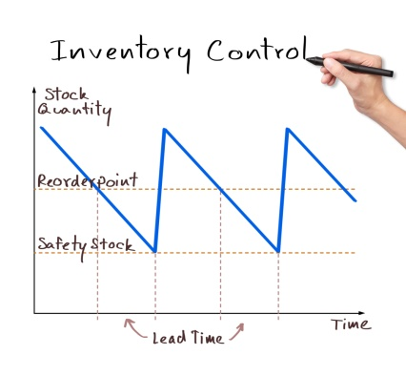
Control of inventory
The nature, size and scope of tourism businesses are many and varied. Whilst all organisations receive and pay cash, make purchases and incur payroll costs, not all businesses purchase and hold inventory or at least if they do, the value of this asset can be vastly different.
A visitor centre in the middle of a city that offers guidance to tourists or tours is providing a service and does not require the same level or type of supplies.
Good internal control systems include:
- A physical count of inventory at least once a year – the higher the value of inventory held, the more frequent the physical counts should be. Two accounting office employees should conduct this count
- Storing inventory is stored securely to prevent theft, damage and spoilage or waste
- Limiting access to inventory to personnel responsible such as storekeepers or similar person in a department
- Keeping formal inventory records in the accounting department who have no access to storage facilities and ensuring that store personnel have no access to accounting records for inventory
- Perpetual inventory cards that include the quantities received and issued for each separate item in stock so there is always a running balance of stock
- Keeping enough inventory on hand to prevent shortages which could mean lost sales
- Purchasing inventory in quantities that take advantage of cost savings.

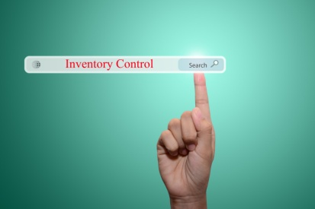
Activity 25 - Control inventory

You are required to identify the main types of inventory commonly found in a tourism organisation and methods you would implement to control them.

TYPES OF INVENTORY | CONTROL METHOD

Control of fixed assets
One of the unique characteristics of the tourism industry is the value and amount of fixed assets held by organisations as a percentage of total assets compared to other industries. Consider the value of aircraft owned by airlines or the value of the land and buildings for a large multi-national accommodation venue. Even a smaller operation requires significant investment in fixed assets such as furniture and fittings.
Internal control for the purchase of fixed assets follows the purchasing controls discussed earlier. However, because the value of these purchases is high, they usually originate and are authorised by the most senior personnel in the organisation.
An effective internal control system will feature a fixed assets register. This provides a record of all the fixed assets that are owned by an organisation and details information such as:

- Unique identification details
- Location
- Purchase details
- Depreciation methods
- Current value
- Disposal details.
Personnel in the accounting department are usually assigned responsibility for maintaining the fixed assets register. At the end of a financial year or other time as directed by management, accounting personnel, other than those responsible for the register, perform a physical count of fixed assets to ensure that the register remains valid and complete. Fixed asset values are also reviewed at least once a year, by accounting staff that are not responsible for maintaining the fixed asset register.

Activity 26 - Control fixed assets

You are required to identify the main types of fixed assets commonly found in a tourism organisation and methods you would implement to control them.

TYPES OF FIXED ASSETS | CONTROL METHOD

Setting standard costs
One of the requirements of an effective internal control system is not only controlling the visible items such as cash and inventory but also implementing a reporting system that indicates whether the establishment is operating properly and at the standard expected by management.
There are many techniques available for management to implement across tourism organisations. An example common to all establishments is a standard for payroll costs. Using industry benchmarks often provided by external financial organisations combined with the size and scope of the business, a standard payroll cost percentage can be set.
When periodic reports on operations are prepared, accounting personnel use the payroll reports provided to them to calculate the payroll cost percentage for that reporting period. This percentage may be reported for each department or functional area as well as the organisation as a whole.
Management compare the actual payroll cost with the standard and any significant variations (usually above a minimum percentage) will be investigated. If there have been more employee hours worked than planned or the pay rate is different to what was expected, department managers or supervisors will need to provide an explanation. This type of monitoring for operations significantly strengthens the internal control system.
Other examples of control techniques applicable in the industry depending on the goods and services provided are:

- Cost percentage
- Gross profit margin
- Productivity calculations
- Other operating expense percentages
- Cost of sales percentage.

Establish financial performance evaluation mechanisms
One of the most important features of a financial system that needs to be established is methods you will use to accurately assess the performance of a tourism operation based on the financial data compiled in the financial system.
Interpretation of financial information is required to measure the success or otherwise of trade for the period in question and to plan future action.

Financial analysis is also referred to as:
- Financial statement analysis
- Accounting analysis
- Analysis of finance.
It refers to an assessment of a company’s, business unit’s or project’s viability, stability and profitability.
Financial analysis is usually performed by professionals who prepare reports using ratios calculated using the information extracted from financial statements and other reports.
Financial analysis assists managers in making business decisions.

Why analyse financial information?
Interpretation and analysis of financial information is required to:
- Measure the success or otherwise of operations for the period in question
- Plan future action.
The only way to identify errors and discrepancies with reports, records and financial statements is to read, analyse and interpret them. Some reports will highlight ‘red flags’ certain situations requiring attention, but you still need to read the documents to identify them.
The key in interpreting and then analysing financial information is to be able to explain what is happening and to understand why it has happened: if the actual results are not as expected, your analysis must be directed at:
- Identifying income and expenditure trends – it is important to identify trends as opposed to single, one-off events: Trends are worthy of attention whereas one-off events are usually not
- Rationalising actual-to-budget variance analysis – this means understanding the fundamental reasons why such a variance has occurred and what needs to be done, if anything, to retrieve the situation. Perhaps the initial ‘budget’ figures were just too optimistic and need to be realistically revised
- Rationalising period-to-period variance analysis – this means determining why such a variance has taken place. Perhaps there has been unforeseeable economic, weather, environmental, competitive or legislated conditions that were not expected and which caused the variance. Once more, where appropriate, this understanding has to be used as the basis of determining what needs to be done to exploit a good situation and limit the adverse effects of a bad one.

- Understanding historical data comparisons – this involves evaluating how the business has performed compared to previous performances. Commonly used comparisons are:
- Same week last year
- YTD last year
- Specific ‘times’ of the year – such as ‘Christmas’, a nominated holiday period. This general type of comparison is useful where there are movable holidays that don’t fall on the same dates each year or a regular event.

Objectives of financial analysis
The major objectives of financial analysis are as follows:
Past | Current | Future
Evaluate past performance | Assessment of current position | Prediction of future business position and strategies
Past performance provides indicator of future performance. | Current position of the company is assessed in terms of the types of assets and liabilities. | Future viability of the business can be predicted.
Trend of past sales, cost of goods sold, operating expenses, net profit, cash flows and return on investment provide indicators to creditors and investors on the company’s future performance to help make them make decisions. | Assessing and predicting the earning prospects and growth rates helps investors to compare and make investment decisions. | Assessing and predicting bankruptcy and probability of business failure is key to future of the business.

In addition to the above, financial analysis helps to assess the operational efficiency of the management of the company by comparing the actual performance against:

- Budget
- Forecast
- Industry leaders
- Industry average.

Measuring the financial position
To monitor actual and planned financial results for a given time period, department manager, general managers and owners depending on the size of the organisation will be provided with appropriate reports from the financial system that summarise both the actual and planned financial information. For example, a payroll cost report enables each manager to monitor the daily payroll costs for their department and would show the actual and planned hours worked and total costs.
Managers are then able to calculate the difference between actual and planned results. These are called variances and can be expressed as monetary values or as percentages. Variance analysis is the term given to the process of calculating and analysing the different variances.
Variances are considered favourable if the actual result is an improvement on the budget (higher revenue or lower expenses) and unfavourable when actual results do not meet budget expectations (lower revenue and higher expenses).
Travel and tourism establishments must take particular care to note that labelling variances as favourable and unfavourable should not be interpreted as good or bad, respectively. This judgement can only be made when the cause of the variance has been investigated. For example, for a food service outlet, actual food costs may be higher than budgeted as shown by an unfavourable variance. However, if food revenue is also higher than budget (prices have not changed), it seems reasonable to assume that this increase in food sold would also mean an increase in food used. Therefore, the increase in food cost is acceptable.
The steps are commonly associated with financial analysis. They are:
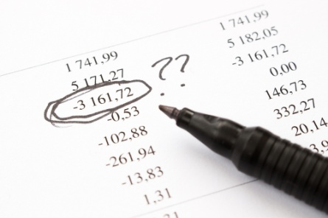
- Select financial analysis method
- Conduct financial analysis
- Identify significant variances
- Determine the cause of significant variances
- Take corrective action as required.

Select financial analysis method
Financial statement information is used by both external and internal users. In order to make good business decisions, users must analyse the information. Understanding financial statements is a pre-requisite to analysis. Several methods of performing financial statement analysis exist.
The 3 common analysis methods are as follows:
- Horizontal
- Vertical
- Ratio
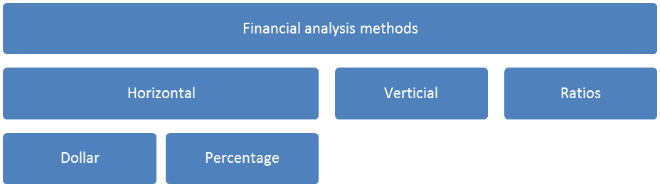

Horizontal Analysis
Methods of financial statement analysis generally involve comparing certain information:
- Across periods
- Across companies
- Against benchmarks.
The horizontal analysis compares items in the financial statements over a period of time. For example:
- Accounts receivable may be compared over 3 months
- Expenses may be compared over a period of 2 years.
To put it simply, comparison of two or more year's financial statements is known as horizontal analysis, or trend analysis.
Basically, horizontal financial analysis compares the financial information in the financial statements of a company over a defined period within a calendar year.
For example, revenue generated over different months of a year can be compared to analyse the overall performance of a company or a particular project.
The following 2 methods below are used to conduct a horizontal financial analysis:
Dollar analysis
Amounts in absolute dollars of items in the financial statements are compared over different time frame. This type of analysis helps to evaluate trend of such items.

Percentage analysis
Analysis is made by calculating percentage of changes for specific items over period of time or across companies. Percentages expressed number as a fraction of 100.

Vertical analysis
Vertical analysis is most often used in tourism organisations to monitor and control expenses that appear on an income or profit and loss statement, both at department level and for the entire establishment. The amount of each expense is divided by total revenue and converted to a percentage. Operational cost and labour cost percentages are examples of this calculation.
The analysis reveals which costs absorb the most revenue for the reporting period. When compared to pre-determined standards and industry benchmarks, managers can assess whether the expenditure is in line with operating expectations or if action needs to be taken.
Comparing the percentages over time also reveals trends that further provide managers with information to effectively monitor and control costs. For example if the operational cost percentage increases over time, managers of an outlet may choose to investigate sourcing products from other suppliers or changing offerings to control costs.
Vertical analysis involves preparing and presenting common size financial statements.
In the following example, we noted the following:
- Sales in Year 2 is better than Year 1
- Expenses in Year 2 is higher than Year 1
- Profit in Year 2 is higher than Year 1.

WAI Pte Ltd
Profit and Loss Statements
For the year ending

 | Year 2 | Year 2 | Year 1 | Year 1
Revenue | 15,000 | 100% | 10,000 | 100%
Expenses | 8,000 | 53% | 4,000 | 40%
Profit | 7,000 | 47% | 6,000 | 60%

Question: Is Year 2 doing better than year 2012?
If we are to express sales as a base for both years, the following points are noted:
- Out of $100 sales made in Year 2, $53 is spent leaving a profit of $47
- Out of $100 sales made in Year 2, $40 is spent leaving a profit of $60.
The size of the financial statements in the above example has been made to be of common size for meaningful comparison.

Balance sheet can be analysed using vertical financial analysis. Each item of the balance sheet can be compared to the total assets calculated.
WAI Pte Ltd
Balance Sheet
As at 31 December

 | Year 2 | Year 2 | Year 1 | Year 1
 | $’000 | % | $’000 | %
Assets
Fixed Assets
Land and Building | 100 | 56 | 100 | 40
Current Assets
Cash | 20 | 11 | 50 | 20
Debtors | 10 | 5 | 80 | 32
Inventory | 50 | 28 | 20 | 8
Total assets | 180 | 100 | 250 | 100
Liabilities
Current liabilities
Creditors | 60 | 33 | 100 | 40
Short term bank | 20 | 11 | 50 | 20
Total liabilities | 80 | 44 | 150 | 60
Equity
Capital | 100 | 56 | 100 | 40
Total liabilities & equity | 180 | 100 | 250 | 100
Vertical analysis is useful for answering the queries relating to company’s assets, liabilities and equity. Vertical analysis is also referred to as common-size analysis.
The main advantage of using vertical analysis is that profit and loss statements and balance sheets of companies of different sizes can be compared. Comparison of absolute amounts does not provide useful conclusions.
Usually the vertical analysis is performed for one reporting period to see the relative comparisons of different account balances. But it is also useful to perform vertical analysis over few reporting periods to identify changes in trends over time.
It can help to identify unusual changes in the behaviour of accounts. For example, if the cost of sales has been consistently 30% in the past, then a 60% should attract attention and alert investigations. After which, measures should be taken to bring this percentage back to its normal level or a new benchmark is established.

Ratio Analysis
Ratio is a mathematical way of expressing one number in terms of another. A ratio is regarded as a statistical yardstick. Relationship between two or various figures can be compared or measured using ratio.
Accounting ratios used this statistical yardstick in financial statement analysis.
Financial ratio refers to ratios used in analysis of financial numbers. It is a way of assessing a company's performance. Standard set of items in the company's financial statements are compared rather than an absolute reading of the figures in the financial statements.
For example, one common ratio used is the current ratio. This is calculated as such:
Total Current Assets
Total Current Liabilities
The result indicates the company's ability to cover current liabilities with its current assets. A margin of safety or buffer to cover a possible reduction in current assets can be deduced from the ratio as well.
Reading financial ratios
Several aspects of financial indicators are expressed in dollar terms requiring comparison of one dollar amount to another, and drawing relevant conclusions.
Dollars are used to indicate things such as sales, expenses, revenue per staff member, average spends received, commissions, and income by department.
Alternatively indicators may be expressed in the form of ratios.
Ratio analysis is the technique of manipulating information contained in financial reports to produce measures of performance.
Ratio analysis uses a number of different measuring devices:

- Ratios – such as ‘working capital ratio of 2:1’, or ‘the ratio of FITs (Fully Independent Travellers) to group tour guests is 4.5:1’
- Rates – such as ‘debtors turnover is 6.8 times per year’
- Percentages – such as ‘the gross profit margin for the department is 37%’.
All the above are common examples of industry ratios used to describe the financial situation, and performance of, the business.
Hence, in order to read financial ratios, the following steps are required:
- What two items in the ratio compares
- The definition of those two items
- What the definition really means
- What the trend is in the company
- How the ratio compares to other similar companies.

Importance of financial ratios
Understanding and interpreting financial ratios is a key business skill for users of the financial statements. Financial ratios illustrate the company’s strengths and weaknesses.
Over time, unusual fluctuations in financial ratios can be noted.
Besides using historical financial figures in financial statements to calculate ratios, ratios can be calculated using forecasted or budgeted figures from forecast and budget. Such forecasted or budgeted ratios become specific goals for management to easily track progress toward financial goals.
There are many financial ratios available. Some are generic to all companies and some are industry-specific. Too many ratios used may cause confusion. It is even more unproductive when numerous ratios are just calculated without interpretation and analysis. Hence, it is important to choose financial ratios that best serve the company’s purposes.
Information provided in the financial records should be used as the basis for making operating decisions for the business.
To obtain the full benefit from financial records there is a need to analyse the data they contain so a full understanding of the information they contain is achieved.

Liquidity (short term stability) ratios
These ratios show us whether or not we can meet our short term debts and how speedily we can pay them. Obviously, if we can’t pay our bills on a day to day basis, this will negatively impact on the running of our business.
The most frequently ratios used are:
Current ratio = current assets
current liabilities

Quick asset ratio = current assets–(stock + prepaid expenses)
current liabilities
In addition to these ratios, it is desirable to calculate the Working Capital of the organisation.
Working capital = Current Assets – Current Liabilities
For the business to be in a sound financial position there needs to be a reasonable surplus of current assets over current liabilities. The aim should be for the business to achieve sufficient liquidity to remain solvent and be able to pay its debts as and when they become due.

Activity ratios

These ratios demonstrate how efficiently we manage our asset or how good we are at getting the best out of our assets.
Asset turnover ratio
This ratio tells us how efficiently we use our assets to provide us with income. When interpreting this ratio we try to see a trend emerging. We want our ratio to be steadily increasing. This would mean that we are getting better at what we do.
Asset turnover ratio: total sales
total assets
The result of this calculation shows us the number of times per annum the assets are “turned over”.
Average Inventories Turnover (Stock Turnover)
These calculations shows how long it takes to “turnover” or sell the inventory of the organisation. The longer it takes, the less efficient the organisation.
To calculate the stock turnover, follow these steps:
- Step 1: Calculate the Average* Stock (previous year Closing Stock plus current year Closing Stock divided by 2).
- Step 2: Divide Cost of Goods Sold (COGS) by the average stock.
- Step 3: Divide the number of days in the year by the solution to step 2.

Debtors turnover ratio = Average Debtors
Average daily credit sales
This ratio tells us how skilful we are at collecting our debtors. It shows the number of days it takes to collect in monies from our customers.
Debtors Turnover:
This calculation is best undertaken as a 2 step process:
- Step 1 – calculate the average daily credit sales (credit sales for the year divided by 365 days)
- Step 2: divide the above result into the debtors balance.
Most retail organisations operate a 30 day credit cycle with an expectation that they will receive payment within 45 days. However in travel and tourism credit is usually desirable at 7-14 days. The establishment is within normal commercial range, but does not collect outstanding monies within the industry averages, it is however improving.

Profitability ratios
Note: These ratios are usually calculated as percentages.
These ratios tell us about our profit margins and how profitable our business is. Changes in ratios for a business over several years can indicate favourable or unfavourable trends.
Comparison can also be made with other similar organisations. Most industries have averages that have been recognised as desirable in order for a business to be “healthy”.
Calculating the ratios is only the first step in examining an organisation’s profitability. We need also to establish the reasons why change has occurred, what it means and if the trend is likely to continue.
Gross profit ratio demonstrates the direct relationship between Sales and the Cost of Goods Sold. If the mark up on stock is not high enough, then the business will not be profitable. Obviously, the higher the gross profit margin, the better. Some industries, including the tourism industry, require a very high Gross Profit ratio in order to cover all expenses.
Gross Profit ratio
Gross Profit x 100
Net Sales
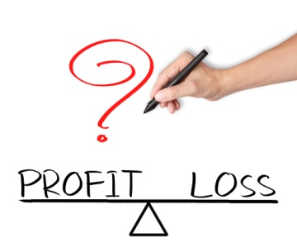
Net Profit ratio
This shows how much of each sales dollar becomes profit. A high ratio means high profits. A low ratio means low profits - if a term deposit in a bank earns 5%, why bother staying in business for less than that? Other factors must also be considered when making decisions regarding the viability of staying in business.
Net profit ratio:
Net profit after tax* x 100
Net Sales
Note that the Net Profit after tax is often referred to as the “bottom line”
Return on Investment (ROI)
It is necessary that management makes the most efficient use of the resources available to them. They must make assets work hard to produce sales revenue, as well as maximise profit percentages from sales revenue.
ROI indicates the efficiency of management’s decisions regarding the purchase and use of assets. Operating profit has tax and interest added back to enable the business to compare its results with other organisations.


Return on Investments:
(Net operating profit + tax + interest) x 100
Average total assets
- Step 1: add back tax and interest to Net operating profit
- Step 2: calculate average total assets. Note that as we do not have a previous year value, we use the Year 1 value of total assets
- Step 3: calculate as per formula.
This ratio shows us how much our assets are earning. The higher this ratio is, the more desirable the business is as an investment for the owners. In this instance, the establishment has significantly improved their return on investment for the owners.
Long Term Solvency Ratios
Leverage (Gearing) ratios
These ratios test an entity’s financial stability from a longer term point of view. They tells us how much of the funds in our organisation come from debt and borrowing, and how much is contributed by owners or shareholders. The gearing ratios measure the reliance on funds from outside sources (borrowings) compared to internal sources of funds (proprietorship or shareholders).

Two formulas used are:
Debt to equity ratio
Total Liabilities x 100
Total Assets
Proprietorship ratio
Owners’ Equity (Shareholders Funds) x 100
Total Funds or Total Assets
The Proprietorship ratio shows the percentage of assets that have been funded by the owners of the business.
It is important not to look at the ratios in isolation. To get a true picture of how a company is performing you need to examine the:
- Combined effects of the ratios
- Trends found by comparing several years ratios and percentages (a minimum of three consecutive years is desirable)
- Comparisons across an industry.
By considering the significance of all of these factors, you will be able to reach a correct diagnosis that will be of assistance in interpreting the financial stability, liquidity and profitability of the business.

Exercise 3 - Prepare financial reports
- Prepare financial reports for Lucky Charm Travel Agency for years 1 & 2
- Use Excel spread sheet if possible and round to one decimal place (handwritten spread sheets are acceptable).
- Calculate the following ratios for each year (show your workings):
- Gross profit percentage
- Net profit percentage
- Payroll expense percentage
- Current ratio
- Working capital
- Quick asset ratio
- Debtors turnover
- Proprietorship ratio
- Return on Investment
- Note: the value of stock at beginning of Year 1 is $18 000.
- Credit sales for Year 1 are 20% of total sales and for Year 2 are 25% of total sales.
- Debtors at beginning of Year 1 are $22 000.

Lucky Charm Travel Agency
Statement of Financial Position (Balance Sheet)
Current Assets | Year 1 | Year 2
Cash on Hand | 300 | 250
Cash in Bank | 10 000 | 5 100
Debtors | 42 000 | 38 000
Stock | 25 500 | 20 000
Total Current Assets | 117 800 | 109 350
Non-Current Assets
Land | 110 000 | 110 000
Buildings | 85 000 | 85 000
Less Accumulated Depreciation on Buildings | (8 500) | (10 200)
Furniture & Equipment | 62 000 | 62 000
Less Accumulated Depreciation on Furniture & Equipment | (15 000) | (21 000)
Total Non-Current Assets | 261 500 | 253 800
Total Assets | 379 300 | 363 150
Current Liabilities
Creditors | 18 000 | 8 000
Accruals | 5 600 | 3 200
Total Current Liabilities | 23 600 | 11 200
Non-Current Liabilities
Mortgage on Buildings | 80 000 | 75 000
Total Non-Current Liabilities | 80 000 | 75 000
Total Liabilities | 103 600 | 86 200
Owners’ Equity
Capital | 140,700 | 140 700
Accumulated Profits | 55 000 | 135 000
Profit Current Year | 80 000 | 1 250
Total Owners Equity | 275 700 | 276 950
Total Equities | 379 300 | 363 150

Lucky Charm Travel Agency
Statement of Financial Performance (Profit & Loss)

 | Year 1 | Year 2
Sales: | 1 135 000 | 925 000
Total Sales | 1 135 000 | 925 000
Less Cost of Sales | 474 750 | 478 250
Total Cost of Sales | 474 750 | 478 250
GROSS PROFIT | 660 250 | 446 750
Less Controllable Expense
Payroll | 317 800 | 323 750
Direct operating | 155 000 | 32 000
Administrative | 66 850 | 66 850
Promotion | 18 500 | 2 500
Total Controllable Expenses | 558 150 | 425 100
Profit before Uncontrollable Expenses | 102 100 | 21 650
Less Uncontrollable Expenses
Interest | 13 600 | 12 700
Depreciation | 8 500 | 7 700
Total Uncontrollable Expenses | 22 100 | 20 400
NET PROFIT BEFORE TAX | 80 000 | 1 250

.

1.5 Monitor financial systems and provide input on possible improvements to appropriate personnel

Introduction
In the previous section we have identified, in sufficient detail, the various considerations that go into select an appropriate and complete financial system for a tourism organisation.

In this section, we will take this one step further and focus on the need to monitor the financial systems themselves to ensure that not only do the systems in place provide accurate data but the information produced is able to meet the needs and requirements of both internal and external stakeholders.
It is important to note, that this section does not focus on monitoring and evaluating financial information contained within budgets. The different evaluation methods were discussed in the previous section.
As mentioned, this section will focus on monitoring the entire financial system itself.

Responsibilities in managing financial systems
Part of the responsibilities of managers and owners in maintaining financial systems is to ensure that:
- Transactions are processed in accordance with management policies
- Transactions are recorded in a manner that reflects appropriate accounting policies

- Financial reports can be prepared based on appropriately recorded transactions.
- Access to assets is appropriately authorised
- Recorded assets are compared to existing assets at regular intervals and the values monitored.

Importance of monitoring financial systems
To meet that responsibility, it is essential that the financial system be constantly monitored to ensure that best practices are maintained, procedures are adapted to reflect changes and corrective action is taken where necessary.
This includes:
- All the internal control measures used by a business to safeguard its assets and ensure the reliability of accounting information
- The inputs to the system – the transactions summarising the activities and events that have occurred
- Processing transactions that result in appropriate categories for classification to meet reporting requirements
- The outputs of the system – the financial reports required to meet internal and external requirements.

Generally, organisations will agree on particular cyclical periods to conduct formal monitoring such as monthly, quarterly, bi-annually and annually. This is usually directed towards the internal control system and the outputs of the financial system and depends on the size and scope of the business. These two aspects are discussed in this section.
There are also procedures that management implement as part of day-to-day operations that enable constant supervision and review of financial data when it is entered and processed into the financial system.

Stakeholders involved in managing financial systems

Financial or accounting systems transform data from activities and events that have occurred in an organisation into financial information that can be relied upon internally by managers and owners to evaluate operational performance and make decisions.
Also external parties such as government departments or financial institutions or any other parties interested in the profitability, strategy or operations of the business can rely on the financial information the system provides.
Therefore it is important to involve all relevant stakeholders in the monitoring and evaluation process.

Activity 27 - Identify stakeholders

You are required to identify the stakeholders you would involve in monitoring the financial system for a tourism organisation.
These stakeholders may be internal or external to the company.
You are required to identify what expertise or information you seek from each stakeholder as part of the monitoring process.
INTERNAL / EXTERNAL STAKEHOLDER | EXPERTISE / INFORMATION SOUGHT

Conducting internal audits
An internal audit provides a review of the operating and accounting controls within an establishment to ensure that internal control procedures are being followed and assets are adequately safeguarded.
This assists managers to monitor the financial system by verifying that forms, records and reports are reliable or may reveal that improvements to tasks or procedures should be made.
In smaller tourism organisations, internal audits are the responsibility of the general manager. In larger establishments, accounting personnel conduct internal audits. Sometimes larger organisations will have an internal audit department, generally based in one location, which travel to all owned establishments and conduct the internal audit.
The size and scope of the business and the internal control measures usually determines the frequency in which internal audits are conducted, with at least once a year being the minimum policy. For example, in smaller organisations, the owner is often present and carries out many of the financial activities.
Very few internal controls are probably required and therefore an internal audit to monitor them would be infrequent. However, in larger establishments that feature multiple services such as a resort, operations are organised into departments and internal controls are extensive. Internal audits would be frequent and perhaps scheduled to rotate through the functional areas twice or three times per year. Each workplace will detail their own internal audit policy that you would be expected to know.
The process of an internal audit can be broken down into five key steps that are applicable for all organisations. These are discussed briefly below.
Management meeting
Management and internal auditor personnel meet to confirm the scope, timelines and other requirements for the audit. Any particular area of operations or procedures within any area of operations that may be of concern to management for any reason are discussed and included in the tasks for the audit. Any changes to the operation of the financial system such as a change to procedures within the cash sub-system are also highlighted in this meeting.
Identify internal controls
As part of planning the internal audit, audit personnel refer to the policy and procedures manual that details all the internal control measures management have implemented. Any changes since the last internal audit will be documented as part of this manual. The systems and procedures that are to be evaluated are reviewed, discussed and the audit plan finalised.
For example these areas may be subject to audit each time an internal audit is conducted due to the frequency of transactions:
- Daily sales, allowances, cash and credit transactions, including pricing and commissions

- Purchasing, ordering and receiving goods and services
- Payroll and labour costs.
- Compliance with external regulations
- Computer system controls
- Controls over fixed asset expenditure.

Evaluate internal controls
Once the audit plan is established and agreed, auditors can begin the task of evaluating the internal controls. An audit trail exists in every internal control system that documents each transaction through the stages or phases of the financial system - input, processing and output.
Internal auditors follow the trail, checking that procedures are followed and forms, reports or other documents are used as intended. It is important to note that internal auditors test a sample of transactions to evaluate the internal control procedure. This will usually represent a proportion of the total transactions that management believe will verify that the system is reliable.
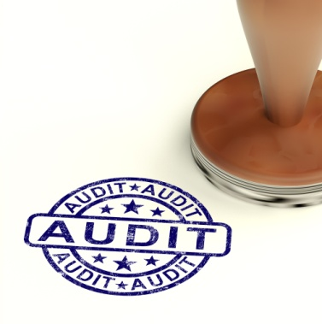
Assess outcomes
If the auditors find that a procedure is not followed or documents are not used as detailed in the procedures manual, a record of the transaction and the details are noted. This requires internal auditors to assess the impact on internal controls of the deviation and note this for management. It might appear to employees from one department that a particular task can be carried out differently but may not realise that this has a detrimental impact on another part of the system. Internal auditors would be expected to note an example such as this.
When a significant deviation from procedures is found, internal auditors may expand the number of transactions reviewed to check if the incident is isolated or indicative of a potential internal control issue. This occurs if it is thought that the deviation threatens the reliability of accounting information or the safeguarding of assets.
Final evaluation
At the completion of the internal audit, an audit report is prepared for management. This outlines the strengths, weaknesses, actions and follows up procedures from the internal audit. This is an important document for managers as it serves to provide evidence that they are fulfilling the responsibility of ensuring the reliability of financial information.
Any actions that recommend changes to internal controls are discussed carefully between managers and auditors. As appropriate, input from those employees who perform the tasks is also sought. When changes are agreed, the policy and procedure manual is adjusted to reflect the new procedure, any forms or reports altered and the internal audit report updated.


Activity 28 - Identify internal audit requirements

You are required to identify the different aspects of a financial system that you would wish to audit as for a tourism organisation.

ASPECT TO BE AUDITED | KEY OBJECTIVE OF AUDITING ASPECT | WHO IS TO AUDIT THIS ASPECT?




1.6 Identify and resolve discrepancies or errors according to level of responsibility and in consultation with designated persons

Introduction
All financial discrepancies must be identified and investigated as soon as possible.
Not only do discrepancies mean that there are gaps in financial performance monitoring and reporting but more importantly can lead to great financial waste and loss.
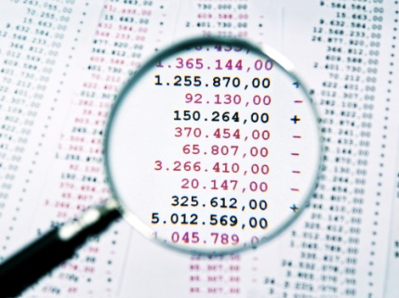
Always remember that every discrepancy should be investigated, and a suitable resolution found.
Failing to identify and resolve these issues compromises the entire system and reduces its effectiveness in generating data that can be used for financial decision making or performance tracking.
The reality is that ignoring or turning a blind eye to one discrepancy makes it that much easier to ignore the next one, and then the next and so on.
Where an on-going issue is detected, the person involved must be trained or the system or procedure must be addressed to fixing the problem.
This section will explore some of the common financial discrepancies and also strategies to resolve them in a timely manner, taking into account levels of authority.

Involving designated persons
In many cases, whilst discrepancies can be identified in financial reports, it is often vital that key designated persons are consulted to not only confirm the discrepancies themselves but also to provide background information or reasons for the discrepancy or any action taken to date.
Whilst the nature of the discrepancy will dictate which persons may be contacted as part of the discrepancy resolution process, designated persons may include:
- Supervisor

- Bank personnel
- Authorised department persons
- Line management
- Statutory body personnel.

Common causes of discrepancies
Many of the discrepancies or errors that occur as transactions flow through the accounting cycle are addressed throughout this manual. They can be summarised by the three basic steps or phases of all accounting system:
- Inputs
- Processing
- Outputs.
It is important to note that action taken for errors and discrepancies should be document where appropriate.
This provides management, other personnel, internal auditors and any other interested parties with explanations for transactions in the accounting system and evidence that financial information is valid and reliable.

Inputs

Examples of errors or discrepancies that can occur when transactions are entered into the accounting system are:
- Data entry
- Calculation mistakes
- Clerical errors
- Transposition of numbers and words
- Omitting transactions
- Processing the same transaction twice
- Omitting information from the journals
- Incomplete information received from other areas of operations.

Processing
Computerised accounting systems greatly reduce the amount of errors that can occur when transactions are posted from journals to ledger accounts or otherwise processed by the accounting system. Most errors or discrepancies arise from:
- Transactions classified incorrectly

- Journals posted to incorrect ledger accounts
- Omitting a journal
- Posting the same journal more than once
- Clerical errors
- Calculation errors
- Data entry mistakes.

Outputs

Reports produced from the financial system rely on the correct balances in the accounting system. Errors or discrepancies in reports are usually as a result of input or processing problems. However, the following may occur:
- Transposition errors
- Calculation mistakes
- Clerical errors
- Choosing incorrect parameters when creating reports in a computerised system
- Using an incorrect report format.
Wherever possible, errors or discrepancies should be resolved with a minimum of fuss and disruption to the normal course of business operations. It is always wise when informing supervisors or managers of a problem that you also have suggested solutions.
Workplace policies and procedures will always detail the process you must follow for reporting errors or discrepancies and the appropriate personnel to manage the particular issue. You must be aware of this in your workplace.

Possible actions to resolve discrepancies
You may be required to:
- Re-visit various source documents and verify their content, figures and calculations
- Double-check calculations
- Seek out additional information, data and documents
- Check figures with suppliers, clients and revenue centres
- Undertake a physical stock take
- Check and re-price stock-on-hand
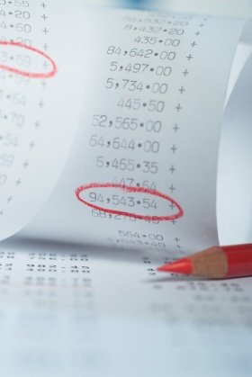
- Verify and upgrade internal reporting and recording procedures, practices and documentation for incomes and expenditures
- Develop ancillary systems and reports to support emerging operational and financial requirements.
Once a reason for the initial discrepancy has been determined it must be reported back in order to maintain the integrity of a transparent and accountable record-keeping system.
It is sound practice to build a review of the practices involved in the maintenance of the financial records of the business into the overall annual review of an organisation.

Checking irregularities with source documents
Examples of irregularities will depend on whether the document is for a sale we have made, or whether it relates to a purchase we have made. They may include:
Documents with the incorrect date
For example, it is common for documents at the start of a new year to be dated the previous year.
It is also common for people to make mistakes at the end of each month, being confused about how many days there are in the month. For instance, it is common to find documents dated 31st April etc.
Resolution of the irregularity involves altering the date to the correct one.
Lack of required signatures or actual documentation for goods purchased
The nature of the tourism where the need for quick responses by suppliers to our requests often means that orders are processed over the phone and there is insufficient documentation to support those orders.
It is not that we haven’t received the goods; it’s just that there is no supporting documentation to ‘prove’ we received it, and no authorising signature to validate the purchase.
Resolution involves raising supporting documentation ‘after the event’ in order to complete the required records, and obtaining the necessary signatures ‘after the event’.
An internal sale has been made but the customer has left before the charge can be processed

Even with electronic systems there are instances where a customer leaves before the charge has been posted to their account.
Where the guest has paid by credit card, resolution usually involves adding the charges to their account after their departure, without their signature. Note, however, that the customer also has the right to query and challenge these charges but where they are definitely legitimate charges they are usually paid without question.
Arithmetic errors
These are relatively common despite the use of pre-programmed numbers of registers.
Resolution involves substituting the proper figure and re-calculating the entire document ensuring that flow-on calculations such as discounts, taxes, rebates and commissions etc. so that the correct total is obtained.

Use of incorrect figures when calculating the document
In some cases a supplier may have presented us with a document that charges us the wrong price for a given item or service.
In other cases, we may have failed to provide a nominated discount to a regular customer, or charged them for 3 persons instead of 2 persons.
Resolution involves inserting the correct figure and re-working the document.
Where necessary, a refund must be issued to customers who have been over-charged.
Individual organisational policy will determine whether or not an account is sent out for items etc. that have been under-charged and for what amount.

Incomplete documentation
A very common irregularity is for source documentation to be forwarded to you in an incomplete form.
This may mean that a signature is missing but is more likely to mean that essential pieces of information such as quantities, prices, full and accurate product descriptions and department names are absent from the document.
Resolution involves visiting the department or talking to the person involved to complete the missing information, or to clarify the ambiguous areas.
Illegible documents
In some cases the documents that you are required to deal with can be accurate, complete and authorised as required, but illegible!
This can increase when people are from non-English speaking backgrounds, but it is relatively common amongst all staff, and is especially the case where they are under pressure or are writing out these documents at the end of a shift.
Resolution is to speak to those involved and ask them what they meant. As many will have gone home when you receive their paperwork, use of the telephone is common in these situations.

Identifying and correcting errors

It should never be assumed that balances in the ledger accounts are accurate simply because the debit and the credit column in the trial balance equal. An entry may have been made and posted to the wrong account or two accounts could be correctly identified with the wrong amount in both cases. Also, a transaction may have been omitted entirely or not journalised.
Some errors are discovered by chance or during normal operations. For example, if an accounts receivable amount is incorrect a customer will usually point this out when an invoice is sent. Other errors are identified through procedures designed to check the accuracy of ledger accounts such as a bank reconciliation which verifies the balance of the cash ledger account.

The trial balance should always be reviewed to ensure that the ledger account names that appear with balances make sense for the business. This is particularly important in computerised accounting systems where default ledger account settings are used. If the debit and credit amounts do not equal when a transaction is processed, the difference is posted to a default account. Default accounts should always be documented so you will know if this account appears on a trial balance, a transaction may be processed incorrectly. In a manual system, experience, knowledge of the business and comparisons with prior period trial balances serve to inform this review.
When a trial balance does not balance, there are either errors in the accounts, errors in preparing the trial balance or both. It can be helpful to adopt a systematic approach as follows:
- Recalculate the totals for both debit and credit columns

- Calculate the difference between the debit and credit totals and compare to the ledger accounts listed. It may be that an amount is in the wrong column, has been listed twice or a ledger account is omitted
- Ensure that all ledger accounts are listed in the trial balance
- Recalculate the ledger account balances
- Verify the debit and credit entries in each ledger account. This may require a review of one or more journals.
Any errors that are found must be corrected. The general journal is used to record any adjustments that may need to be made to ledger accounts; otherwise the trial balance is simply prepared again to correct any mathematical errors.

Adjusting entries
Under the cash method of accounting, there is no need for adjusting entries or adjustments to the accounts because only the cash transactions for the reporting period would have been recorded. However, hospitality and tourism organisations generally operate under the accrual method of accounting.
At the end of an accounting or operating period, adjustments are made to ledger account balances that assign revenues to the period in which they were earned and expenses to the period in which they are incurred. Also, related asset and liability account balances are brought to their correct accrual-basis amounts.
For tourism establishments, some of the common adjusting entries are:

- Unearned revenue – a form of cash is received but the service has not yet been provided
- Prepayments - expenses that have been paid in advance
- Accrued expenses – expenses that have been incurred but not yet paid
- Depreciation expense

Unearned revenue
An adjustment for unearned revenue is required when cash is received from customers, guests or clients before the goods or services are provided. This creates a liability for the establishment which is recognised in a ledger account called unearned revenue.
In order to process the correct adjustment, it is necessary to understand how the initial transaction was processed in the accounting system. Consider a deposit for an amount of 450 is included as revenue in the trial balance of the example company but the service has not been provided.
The effect of the initial transaction on the ledger account is:
DR Cash at Bank 450
CR Sales Revenue 450
Then the adjusting entry in the general journal is:
DR Sales revenue 450
CR Unearned revenue 450
For the next month, when the service is provided, the adjusting entry is:
DR Unearned Revenue 450
CR Sales Revenue 450
Prepayments
When expenses are paid in advance, the most common for hospitality and tourism being rent and insurance, a ledger account called Prepayments records the total amount of the expense paid in advance. This is categorised as an asset because a benefit will be received in future accounting periods. An adjustment is made to record the amount of the expense that has been used in the current reporting period, one month for example.
In the trial balance for the example company above, the balance for prepaid rent is an amount of 3,000. This is for three months’ rent. The accounting period is one month so the monthly rent expense is an amount of 1,000. The adjusting entry in the general journal is:
DR Rent expense 1,000
CR Prepaid Rent 1,000
Accrued expenses
The most common accrued expense in tourism organisations is wages and salaries. Payroll is rarely processed on the last day of an accounting period so the payroll costs in the unadjusted trial balance will not include amounts owed to employees. An adjustment is required to match this cost to the correct accounting period. The general journal entry if 150 is owed to employees for wages appears as:
DR Wages expense 150
CR Payroll payable 150

Depreciation
Depreciation is the portion of an asset’s cost assigned to an expense for the current reporting period to recognise that the asset has contributed to producing revenue. It is an internal transaction processed by the establishment that does not involve cash.
There are many calculations that can be used to calculate depreciation which will be documented in workplace policies and procedures. The journal entry for adjusting for depreciation is the same, whatever method is used. If depreciation on the asset furniture has been calculated at an amount of 780, the adjusting entry is:
DR Depreciation expense – Furniture 780
CR Accumulated depreciation – Furniture 780
Accumulated depreciation is called a contra-asset account and reduces the balance of the asset account. It is used because the value of assets in the accounting system must be recorded at cost according to accounting principles.

The worksheet
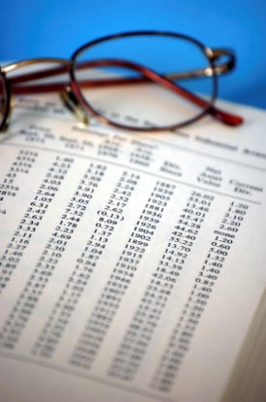
In practice, adjusting entries are only made in ledger accounts at the end of a financial year, for both manual and computerised accounting systems. However, tourism establishments prepare reports for management use for different accounting periods during the year. It is common for a worksheet to be prepared, either manually or electronically from which balances can be checked and financial reports prepared.
The basic format of the worksheet contains the unadjusted trial balance, a set of debit and credit columns for recording adjusting entries and a set of debit and credit columns to calculate final ledger account balances. Financial reports are prepared based on the balances in the worksheet.


Activity 29 - Identify common discrepancies

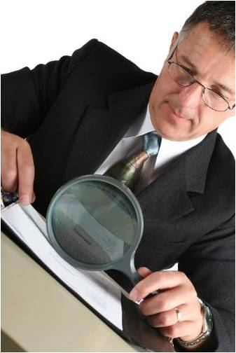
You are required to identify:
- Three common discrepancies that commonly appear in financial systems for a tourism organisation
- Methods to identify discrepancy
- Cause of the discrepancy
- Action taken to resolve discrepancy.

COMMON DISCREPANCY | METHOD TO IDENTIFY DISCREPANCY | CAUSE OF THE DISCREPANCY | ACTION TO RESOLVE DISCREPANCY

Work Projects
It is a requirement of this Unit you complete Work Projects as advised by your Trainer. You must submit documentation, suitable evidence or other relevant proof of completion of the project to your Trainer by the agreed date.
1.1 Please complete the following activities relating to this Performance Criteria:
- Activities 1,2,3,4,5,6,7
1.2 Please complete the following activities relating to this Performance Criteria:
- Activity 8
1.3 Please complete the following activities relating to this Performance Criteria:
- Activities 9,10,11,12
1.4 Please complete the following activities relating to this Performance Criteria:
- Activities 13,14,15,16,17,18,19,20,21,22,23,24,25,26
1.5 Please complete the following activities relating to this Performance Criteria:
- Activities 27,28
1.6 Please complete the following activities relating to this Performance Criteria:
- Activity 29

Summary

Monitor financial procedures
Check transactions accord with enterprise procedures
- Who is responsible for managing financial records
- Importance of maintaining accurate financial records
- Definition of 'auditing'
- Understand the bookkeeping and accounting cycle
- Definition of transaction
- Understanding transaction principles
- Categories of business transactions
- Understand types of transactions
- Activities associated with checking transactions
- Understand types of ledger accounts
- Obtaining and checking source documents
- Checking journal entries
- Cross-check source documentation with entered transaction to ensure matching
- Checking accuracy and completeness of transactions
Balance transactions accurately
- Use reconciliation features of computerised systems correctly to assist the reconciliation process
- Types of reconciliations
- Subsidiary ledgers
- Account summaries/balances
- Perform reconciliations
- Make necessary adjustments
- Perform bank reconciliations
- The trial balance
- Finalise reconciliations within designated timelines
Check balances prepared by others are in accordance with enterprise procedures
- Importance of separating areas of financial responsibility
- Reviewing transactions recorded by others
- Activities associated with checking balances performed by others
- Investigate and clear outstanding entries

Implement and control financial systems in accordance with enterprise procedures
- Operational areas requiring financial systems
- Focus of financial systems
- Structure of financial systems
- Key considerations when developing a financial system
- Internal control systems
- Structure of the internal control system
- Principles of internal control systems
- Limitations of internal control systems
- Internal control challenges in the tourism industry
- Implementing internal controls
- Control of cash
- Control of cash receipts
- Control of cash payments
- Control of petty cash payments
- Control of cash budgets
- Control of accounts receivable
- Control of credit policies
- Control of purchases
- Control of payroll
- Control of inventory
- Control of fixed assets
- Setting standard costs
- Establish financial performance evaluation mechanisms
- Why analyse financial information?
- Objectives of financial analysis
- Measuring the financial position
- Select financial analysis method
- Horizontal Analysis
- Vertical analysis
- Ratio Analysis
- Liquidity (short term stability) ratios
- Activity and profitability ratios
- Long Term Solvency Ratios

Monitor financial systems and provide input on possible improvements to appropriate personnel
- Responsibilities in managing financial systems
- Importance of monitoring financial systems
- Stakeholders involved in managing financial systems
- Conducting internal audits
Identify and resolve discrepancies or errors according to level of responsibility and in consultation with designated persons
- Involving designated persons
- Common causes of discrepancies
- Inputs
- Processing
- Outputs
- Possible actions to resolve discrepancies
- Checking irregularities with source documents
- Identifying and correcting errors
- Adjusting entries
- The worksheet

Element 2:
Complete financial reports

2.1 Accurately complete routine financial/statistical reports within designated timelines

Introduction
Every accounting entity must collate transactions into financial reports in a timely manner.
This requires that all organisations set specific time periods of equal length for reporting and measuring financial results. Each financial report must clearly state the time period being reported, known as the accounting period.

For most organisations, large or small, the accounting system encompasses all the business’s activities as it reflects common elements across all aspects of the business, costs and profit.
Financial reports or statements should reflect the different needs of managers and owners as well as adhering to external requirements. This means that it is the nature, scope and format of reports that is important and also the frequency in which decision makers require the information.
Managers in all hospitality and tourism organisations use information from the accounting system to support, inform and monitor the results of the decisions they make. To be successful, managers wish to ensure that the business should:
- Earn a satisfactory profit for its owners
- Use its short term and long term assets efficiently
- Be able to pay its short term debts on time
- Maintain adequate cash stocks to meet requirements
- Provide a return on investment to the owners both in income and growth of the value of the investment.
You may be required to prepare and distribute regular financial information and reports.
When doing so it is important to:
- Adhere to designated timelines for their preparation and distribution
- Use the standard format as accepted in the business
- Distribute reports only to designated persons
- Maintain the confidentiality of the information and the reports.

The need for reports
Financial reports can be seen as providing:
- A communication link between the operation of the business and management – in an organisation where the business operates 24 hours per day, 7 days each week it is impossible for management to be there at all times. No–one can be there all the time, so these reports provide one way of making sure they get vital information in a timely manner
- A historical database which builds into a useful management tool to help future predictions and decisions by recording what has taken place in the past
- Data to managers which can inform and assess operational performance against budgets

- Indicators to potentially problematic areas – such as slow-payers, build-up of excessive stock-on-hand, bad debts and bounced cheques
- An essential tool to provide an overview of the performance of the business and its liquidity
- In essence, the analysis and interpretation of reports and information is undertaken in order to allow for planning and control of the operation and direction of the business.

The accounting period
The accounting period is the period with reference to which accounting books of any company are prepared. It is the period for which accounting books are:
- Closed
- Balanced
- Financial statements are prepared.
Depending on the needs of the users of the financial statements, generally, the accounting period can be:

- Daily
- Weekly
- Monthly
- Quarterly
- Half-yearly
- Annually.
The period of time that the statement covers is decided by the company and it will vary from company to company. The following type of companies usually prepares financial statements on yearly basis:
- Smaller companies with limited resources
- Companies with little transactions.
Large companies usually prepare financial statements on monthly basis while listed companies are required to disclose their financial statements to public on a quarterly basis.
Title | Meaning
For the 3 months ended 31 March | Sum results from January to March
For the quarter ended 30 September | Sum results from July to September
For the half year ended 31 December | Sum results from July to December

Impacts on frequency of statements and reports
Above, we have looked at some examples of how often financial reports may need to be prepared. Following are factors that will impact on the frequency of both financial accounting and managerial accounting reports.
Ownership requirements
Ownership of organisations in the tourism and travel industry varies greatly. We are going to consider this in terms of private and public ownership as it is this distinction that impacts on the nature and frequency with which financial statements need to be produced.
Private ownership
These are small to medium size organisations with perhaps one or more owners that usually operate in one country or region and perhaps in just one or a number of locations. These businesses are commonly called sole traders and partnerships but may also be called companies.
Public ownership

Public ownership means that the general public own the organisation by purchasing shares that are traded through a stock exchange. This type of organisation is always called a company and there are many examples in the tourism and hospitality industry of such companies. Generally, airlines, larger travel chains that may or may not be multi-national, even tour group agencies are either public companies themselves or wholly owned by public companies.
Financial Accounting reports
Financial accounting reports focus on the financial position and performance of the entire organisation for a given period of time.
With details of ownership in mind, there are both internal and external requirements that specify the frequency in which financial reports must be produced.
For this purpose, external requirements mean those imposed by bodies outside the ownership of the company and internal requirements refers to reports that are required by owners and managers within the business or organisation only.
External requirements
Publicly owned companies must produce financial accounting reports as required by financial regulatory authorities in the country where the shares are listed on the stock exchange.

For example, if an organisation is listed on the Indonesian stock exchange then the Financial Services Authority (Indonesia) will issue guidelines for the frequency in which financial accounting reports must be produced.
Generally, authorities at least require all four financial accounting reports annually. Some authorities also require all four reports every six months and some a condensed cash flow and statement of owners’ equity but a complete profit and loss statement and balance sheet. It may also be the case that a condensed profit and loss statement and cash flow statement are required to be submitted to regulatory authorities every three months (quarterly).
It is very important that organisations are aware of the requirements set by regulatory authorities as failure to produce financial accounting reports at the frequency that is required can result in penalties such as fines or even orders to cease trading.
Government authorities may also require financial accounting reports to be produced for the purposes of taxation or calculating other government charges. The frequency of these reports will be governed by the particular authority but will be at least annually.
Larger companies in the tourism industry that are owned by organisations based in another country or region may have additional considerations regarding financial accounting reporting.
Financial regulatory authorities decide their own time period for which reports on activities are to be included. For example, some authorities require annual financial accounting reports to report on activities from January 1 to December 31 each year. Other countries prepare reports from July 1 to June 30.
This means that publicly owned companies may find themselves producing financial accounting reports to meet the requirements of their “home” financial authorities but also the financial authorities of their head office. Hence an accounting department may find themselves producing financial accounting reports for external bodies at least once every quarter.
Internal requirements
Financial accounting reports prepared for external requirements are used by owners and managers within the business to monitor performance and assist with decision making. However, the purpose of the accounting information system must be to support internal decision making and control responsibilities. Often reports prepared for external requirements can lack the detail managers and owners require.
Preparing financial accounting reports, even as frequently as quarterly, may not meet the needs of managers and owners who wish to appreciate the financial impact of activities as and when they occur.

Hence, most organisations, whether publicly or privately owned, produce a profit and loss statement and cash flow statement daily, weekly and monthly or some variation of these. These reports may differ in format from the statements prepared for external purposes. For example, a profit and loss statement is often prepared daily so that different departments can monitor their performance. The accounting department will monitor cash flow to ensure there are funds available to meet the needs of the business.

A balance sheet and statement of owner’s equity is often prepared just on a monthly or even quarterly basis for internal purposes as fluctuations in balances of assets and liabilities are less frequent. Some organisations simply require a report if balances change by a minimum threshold such as 5 per cent.
Each establishment will have their own guidelines regarding the frequency of financial accounting reports for internal purposes for which you must be aware.
Management accounting reports
Internal requirements
The provision of information to managers and owners that is designed to assist with decision-making and control of the business falls within the scope of management accounting.
It is important that management accounting reports address the issues required to effectively manage the business in a timely manner.
The nature and size of the organisation influences the frequency in which management reports are produced. Managers of a large establishment may require information about activities differently to those managers of a small establishment.
Generally, though, both large and small businesses produce management reports that capture daily revenue and daily costs.
Larger organisations will format this by department revenue and costs and smaller organisations by revenue and cost categories only.
In busy seasons and in establishments with varied activities, the number of transactions captured by the accounting information system can be very high. Reporting in those times or environment can be very frequent to ensure managers stay informed of costs and revenues.
Most accounting information systems have the ability to produce management reports daily based on the previous day’s activities. Reports can also be produced weekly, monthly, quarterly, every six months and annually. Ultimately it is at the discretion of management and owners to request reports as frequently as is necessary to effectively manage the business.
Listed in the table below are the most common time frames within which the three management reports covered by this unit are produced.
External requirements
There are generally little or no requirements to produce management accounting reports for distribution to external bodies. However, you should always check with local financial and other government authorities and in policy and procedure documentation to confirm requirements for your workplace.
It is also worth mentioning that many authorities throughout the Asia-Pacific region such as Indonesia are considering or have already implemented, as in the case of Thailand, reporting requirements for non-financial performance indicators that may be monitored and consolidated by the accounting information system.
Some measures such as carbon emissions directly impact some tourism organisations whereas for others, such as corporate governance, the impact is less onerous. Once again policies and procedures in your workplace will offer guidance.



Activity 30 - Identify frequency of financial statement and reports

You are required to identify an example of financial statements or reports to be completed for each of these timelines.

FREQUENCY | REPORT / STATEMENT | PURPOSE / CONTENTS OF REPORT / STATEMENT
Daily
Weekly
Monthly
Quarterly
Half-yearly
Annually
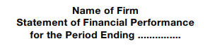

Users of financial information
When financial documents are to be prepared, it is vital that they are constructed with the end user in mind.
Financial statements provide useful information to many users. These users use the information for different purposes.
Managers

With power and authority delegated to manage the affairs of the company, managers would need to constantly make important business decisions. Hence, assessing and evaluating the financial information is very important for managers to make informed and best decisions for the company.
Managers may be assisted with analysis performed by accountants to better understand the financial figures. However, most managers are expected to equip with basic knowledge of financial statements.
Shareholders or current investors
Shareholders invested their money with the objectives of having returns more than their initial investment. They need to constantly use financial statements to assess the:
- Risks
- Returns.
Shareholders need to make the following decisions on their investment in the company at different point in time:
- Increase
- Reduce

- Withdraw.
To make such decisions, shareholders analyse the financial statements and make predictions. Predictions made by shareholders affect the investment decisions. Shareholders who have influence on the operations of the company also use financial statements to steer important business decisions.
Potential investors
Before deciding if they should invest in a company, they assess the viability of investment by studying financial statements of the companies. Investors aim to receive returns in the form of dividends. They will predict future dividends based earnings trends reported in the financial statements. Dividends are distributions from the company out of earnings to shareholders. Earning ability of the company determines the frequency and amount of such distributions.

While potential investors are concerned with returns, they need to weigh the returns with the risks when making investment decisions. There is an inverse relationship between risks and returns. The company may make lower than anticipated profits or experience loss by taking safe strategies. Such situation is known as business risk. Business risk is influenced by many factors:

- Unit price
- Costs
- Sales volume
- Competition
- Economic environment
- Government regulations.
Besides business risks, the company faces other risks like:
- Financial risks
- Liquidity risks
- Systematic risks
- Exchange-rate risks and
- Country-specific risks.
Most of the time, potential investors rely on financial analysis prepared by financial analysts who are professional in these areas.
Financial institutions
Before financial institutions like banks and lending companies make their lending decisions, they will assess the financial statements of the company. Lending decisions may include decisions to:
- Lend with collaterals
- Lend without collaterals

- Provide fresh working capital
- Extend existing loans / credit.
In assessing the financial statements of the company, financial institutions evaluate financial health of a company to determine the probability its loan becoming bad. Any decision by the financial institutions to lend must be supported by:
- Strong asset base
- Liquidity.

Suppliers
The credit worthiness of a company determines if supply of goods and services can be made on credit terms. It does not make business sense for suppliers to supply goods and services and not get paid. After evaluating the financial health of the company, the suppliers will decide the extent of the credit in terms of:

- How much
- How long.
If the company is evaluated to be not credit worthy, suppliers may only supply goods and services on:
- Cash terms
- Shorter credit periods
- Smaller credit amounts.
In some cases, prepayment or deposits may be required before the supply of goods or services by creditors.
Customers

Key concerns to the customers are:
- Steady supply
- Continuous provision from the company.
They use financial statements to assess whether the above will be available in the future.
This is especially important when a customer is dependent on the company for:
- A specific component or parts to complete its product cycle
- Maintenance or support for its operating and financial systems.
Potential Employees
Potential employees use financial statements to assess the company's profitability to evaluate:

- Future remuneration
- Future career path
- Job security.
Company with strong financial standing tend to
- Be able to attract talent better
- Have aggressive expansion plans.
Potential employees tend to see strong financial standing as opportunities of career growth in the company.

Existing Employees
Based on their analysis of the financial statements, existing employees may discuss the following with their supervisors:
- Compensation

- Promotion
- Rankings.
Some companies designed their variable wage schemes to vary with the financial results.
Variable wages may include:
- Bonus
- Commission
- Incentives.
These variable wage schemes act as carrots for employees to work towards meeting the financial goals or budget of the company.
Union of employees also need these reports to negotiate collective bargaining agreements with the management. As the union represents a huge number of employees, it carries heavy responsibility to ensure their members’ interests are safeguarded and maximum benefits obtained.
Competitors
To be on the winning edge and improve the competitiveness, competitors take the following actions on their strategies after comparing their performance with the company’s performance:
- Learn
- Develop
- Amend.
At times, the financial results of the company especially for those who are viewed as market leader in the industry may be used as the benchmark.
General Public
They may be interested in the effects of a company on a macro level:
- Economy
- Environment
- Country.
Public forming the majority of the shareholders of public listed company used the financial statements in the same manner like current or potential investor mentioned above.
Media are also interested in financial statements for financial news reporting purposes.
Government
They require financial statements to ensure correct taxes and duties are declared in the tax returns and paid to the government. Government also keeps track of country’s economic progress by analysing financial statements of companies from different sectors.

Activity 31 - Identify financial information prepared by personnel

You are required to identify the different types of financial information, statements or reports prepared by the following personnel in the travel and tourism industry.
PERSONNEL | INFORMATION / REPORT / STATEMENT
Accounting staff
Staff members
Managers & supervisors
Head office
Providers, suppliers and carriers



Financial report topics
The type and exact nature of reports will vary from establishment to establishment, and will depend on management requirements and preferences.
There is no established or ‘required’ suite of reports despite the existence of many commonly used ones.
Different managers put different emphasis on different reports and some managers may rely heavily on certain information or reports that other managers never look at.
In addition, the computerised system being used at one establishment may generate some information and reports not generated under a manual system.
In some cases, generation of reports will require you to extract and manipulate figures in-line with basic accounting concepts and standards, whilst in other cases, it will be as easy as pushing the right button.
Some reports may stand alone or be seen as supporting documentation for other reports.
Financial or statistical reports may relate to:
- Daily, weekly, monthly transactions and reports

- Break up by department
- Sales performance
- Commission earnings
- Sales returns
- Commercial account activity
- Foreign currency activities
- All types of payment.

Summary of reports prepared in the tourism organisations
Area of operations from business cycle | Report | Frequency | Data that is reported
Complete cycle | Profit and loss statement | Daily, Weekly  Monthly, Annually | Total revenue and total costs for the entire establishment
Complete cycle | Balance sheet | Monthly, Annually | Assets, liabilities and owner’s equity
Complete cycle | Statement of cash flows | Daily, Weekly  Monthly, Annually | Cash inflows, cash outflows, available funds
Complete cycle | Department operating schedule | Daily, Weekly  Monthly | Revenue and expense for each department
Complete cycle | Fixed asset schedule | Annually (or as requested) | Lists all fixed assets by location and description
Complete cycle | Exception reports (by department and for establishment) | Daily, Weekly  Monthly | Differences between actual and budgeted results
Cash | Cash flow summary | Daily, Weekly  Monthly | Actual cash flows compared to budget
Cash | Cash budget | Daily, Weekly  Monthly | Plans for future cash inflows and outflows
Cash | Bank reconciliation statement | Monthly (or daily) | Cash balance in the bank account and the ledger account
Production of goods and services | Payroll cost report | Daily | Labour cost by department
Production of goods and services | Other operating cost summaries | Daily, Monthly | Details any other operating costs management wish to monitor
Production of goods and services | Purchase order reports | Daily | Summarises the supplies ordered by department
Production of goods and services | Goods received reports | Daily. Weekly | Records the stock received for the period of time required
Production of goods and services | Wastage report | Daily, Weekly | Lists stock that could not be resold to customers
Production of goods and services | Accounts payable schedules | Weekly Monthly | Detail the amounts owed to creditors and the due dates
Production of goods and services | Inventory or stock sheets | Daily, Monthly  Annually | Lists item by item the stock or inventory held on the premises
Sales of goods and services | Daily revenue report | Daily | Details revenue by department
Sales of goods and services | Sales analysis reports:  Occupancy reports | Daily, Weekly Monthly | Includes statistical data to analyse specific nature and timing of sales
Accounts receivable or Cash | Daily Takings report | Daily | Summarises cash movements at each point of sale for each shift or day
Accounts receivable or Cash | Daily Cash received reports | Daily | All cash received for the day identifying daily takings and accounts receivable amounts separately
Accounts receivable or Cash | City ledger report (accommodation venues) | Daily | All guest accounts that have not settled their account the previous day
Accounts receivable or Cash | Accounts receivable aging schedule | Monthly (or as needed) | Accounts receivable amounts by days outstanding
Accounts receivable or Cash | Accounts receivable schedule | Daily, Weekly Monthly | Lists all individual accounts receivable details

Many of these reports have been mentioned throughout this manual in relation to implementing and monitoring internal controls and checking the recording and processing of transactions. The format and nature of information reports is specific to the day-to-day operations of hospitality and tourism establishments. It is impractical to provide detailed procedures for the preparation of each and every report. Instead, the most common management reports will be discussed in detail. These can be adapted to reflect the circumstances of different workplace operations.

Statement of Financial Performance / Profit and Loss Statement
Purpose
Statement of comprehensive income or profit & loss statement is a financial statement that measures a company's financial performance over an accounting period
Financial performance provides information on the financial results of the company for a period of time. All companies aims to perform with profit for the reporting period.

Profit | = | Revenue | > | Expenses
Loss | = | Revenue | < | Expenses

Format
The exact format and presentation for profit and loss statements is dictated by the needs of managers and users of financial reports in the tourism and hospitality industry. The profit and loss statement for one smaller accommodation venue may be completely different from another and other branches of the industry such as resort, restaurants and theme parks will likely be very different from each other because each statement is prepared to reflect the operating results for that business. The profit and loss statement may also be called an income statement, a Statement of financial performance or a schedule of department results.
Preparing the profit and loss statement
The profit and loss statement has two main sections, revenue and expenses. The trial balance summarises the general ledger balances for revenue and expenses for the accounting period. These balances may be recorded in a worksheet from which the profit and loss statement is prepared.
Revenue

A tourism organisation earns revenue by selling goods or services to guests, customers or clients. Sales are recorded in general ledger accounts that usually specify the nature of the sale. For example, a tourism establishment may have a sales general ledger account called Tour ticket sales.
When preparing a profit and loss statement, the format required must be very clear. This determines the level of detail required for each category of revenue.
Whichever format is used, amounts from the sales accounts in the general ledger are entered into the profit and loss report. It is necessary when reporting revenue for individual departments to ensure that it is only those revenue items that belong to that department that are included. This could create confidentiality issues, especially if department managers receive a bonus based on the financial performance of their department.
When all sales accounts have been recorded on the profit and loss statement, total revenue is calculated and recorded.
The second section of the profit and loss statement is expenses. This section has a number of sub-categories depending on the nature of the business.
Cost of goods sold or Cost of sales
The cost of goods sold or cost of sales expense represents the cost of the goods or products that have been removed from inventory and delivered to customers during the reporting period.
Examples from the tourism industry include tour packages and airline tickets that are sold by retail travel operators.
The format and calculation of cost of goods sold or cost of sales is:
- Opening stock
- Add: Purchases
- Subtract: Closing stock
- Total cost of goods sold.
Note that closing stock is sourced from the results of a stock count that verifies the actual physical inventory held on the premises.
It is not always possible or practical to include a cost of goods or cost of sales calculation in a profit and loss statement as stock counts are only performed periodically during a reporting period. Occasionally, estimates are used or the purchases account balance is included under departmental or selling expenses depending on the format chosen.

Gross profit
Gross profit is the difference between revenue and cost of goods sold or cost of sales. It represents the profit made just from buying and selling products and services. When the profit and loss statement classifies expenses as departmental and fixed, the term gross profit can also be used to describe the profit calculated by deducting departmental expenses from departmental revenue. The remaining profit contributes to the fixed expenses of the business.
Expenses

It is at this stage in a profit and loss statement that all the expenses (apart from purchases if cost of goods sold calculated) are transcribed into the report. Before this occurs, expenses may need to be classified by nature or function. This may require the details of particular ledger account balances to be analysed and may even require a review of the cash payments or purchases journal for additional information. Some accounting systems, the CP3 system is an example mentioned earlier, choose to add to expenses all supplies that have been ordered as well as received. Whatever procedures are used, there will be workplace guidelines to follow.
Whenever an account balance is analysed and amounts separated for reporting purposes, it is necessary to ensure that the general ledger account balances. It is for this reason, as well as for future reference, that a document is completed that tracks the movements in the general ledger account balances.
When all expenses have been included in the report, the totals for each sub category are calculated and recorded.
The final step to preparing the report is to determine the profit or loss over the reporting period. Expenses are either deducted from revenue or gross profit and the final Net profit or loss is calculated.
In summary, a properly prepared profit and loss statement:
- Clearly identifies the business or department whose revenues and expenses are being summarised
- States the accounting period for which the statement has been prepared
- Includes an informative summary of all the revenue generated by the business during the accounting period
- Summarises all the expenses utilised by the business to generate the reported revenue
- Classifies expenses logically and consistently
- Clearly states the profit or loss for the accounting period.

Format of profit and loss statement

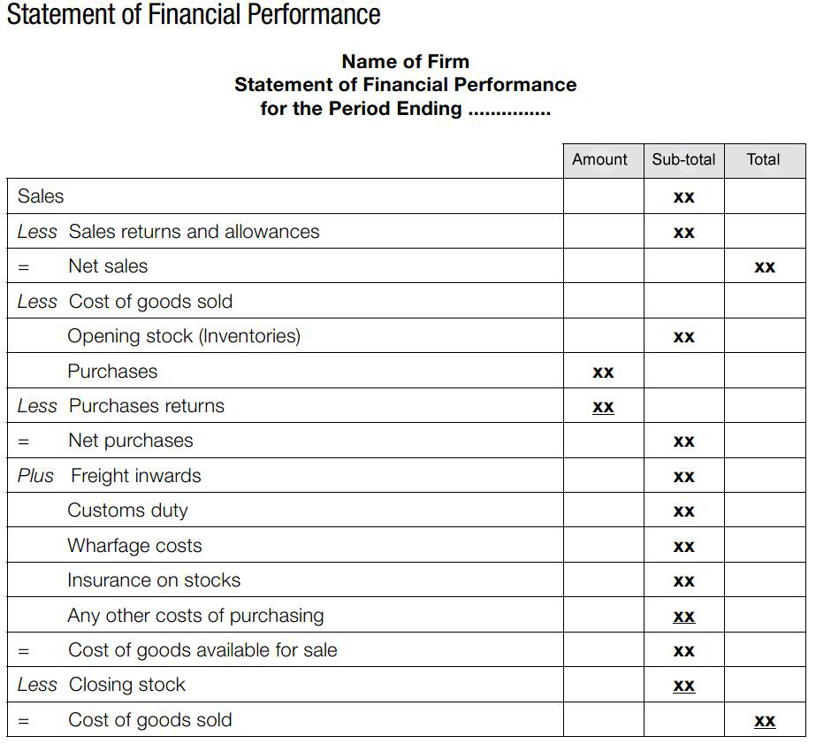

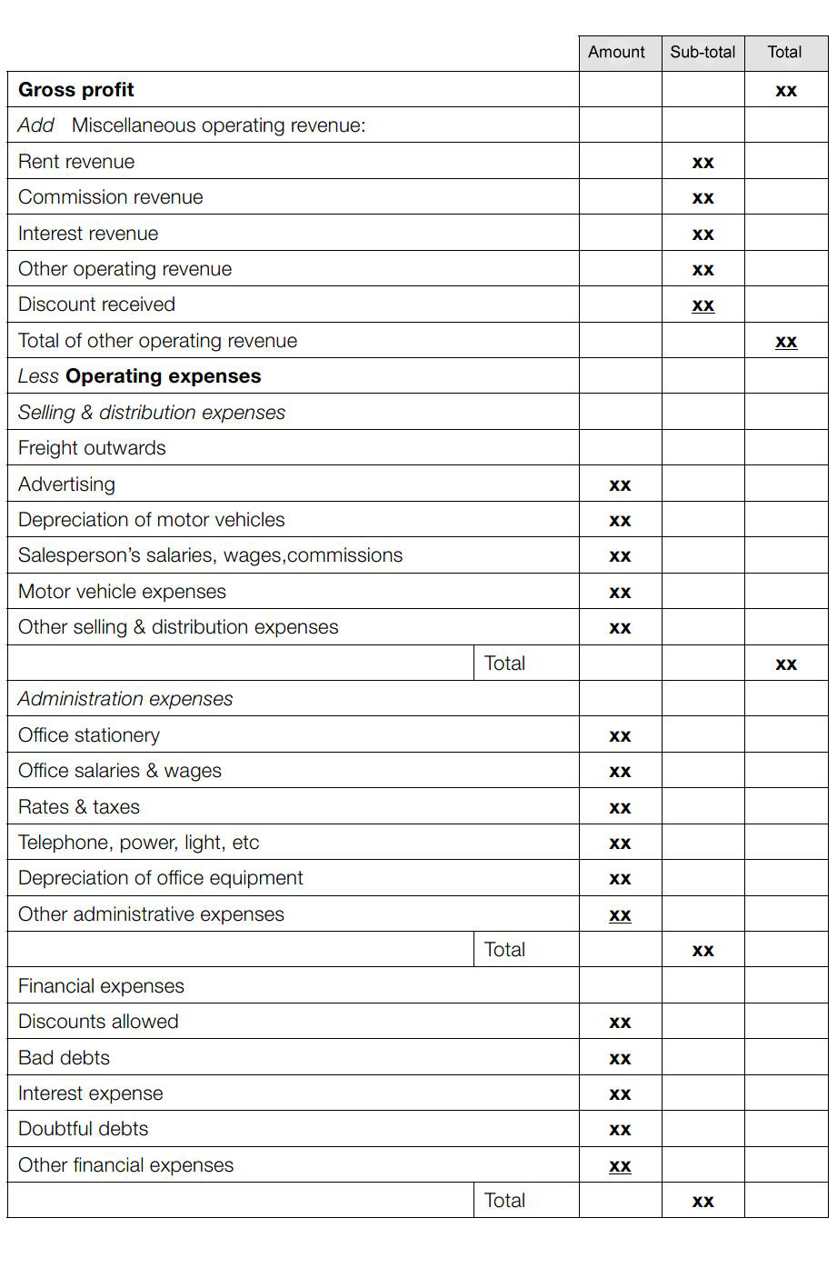

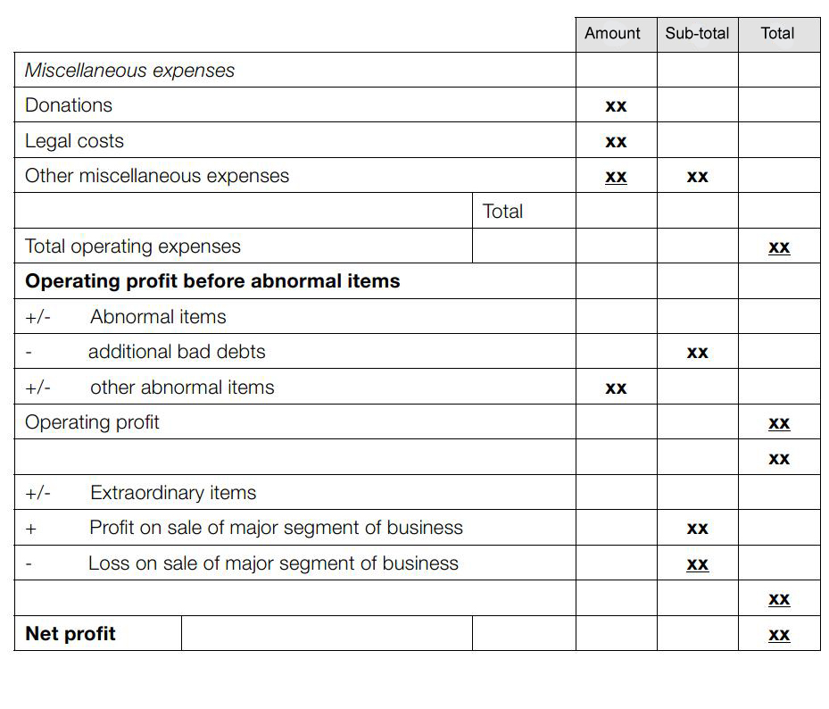

Statement of Financial Position / Balance Sheet
Purpose
A balance sheet is a financial statement that summarises at a specific point of time a company's:
- Assets
- Liabilities
- Equity.
These three balance sheet segments give readers an idea as to what the company:
- Owns
- Owes.
It is called a balance sheet because the total of the two sides of the report must be balanced or equal. The balance sheet presents a "snapshot" of the company's financial position
- At a particular time
- At a point of time
- At a moment of time
- An instant in time.

The balance sheet informs the users of the financial statements what a company owns as well as what it owes to other parties as of the date indicated in the header of the balance sheet.
The balance sheet contains valuable information to the users of the financial statements. Each of these users has different needs and uses the balance sheet for different purposes
Format
There are two accepted formats for a balance sheet called the account and narrative or descriptive format. The account format lists the elements of the balance sheet in two columns. This can often be the format chosen when the balance sheet is produced internally for use by managers. The left hand column lists assets and the right hand column liabilities and equity. This highlights what is owned and how the assets were acquired, either sourced from borrowings (liability) or from owners (equity).
Preparing the balance sheet
The balance sheet is divided into three main sections, assets, liabilities and equity which are further breakdown into several important sub-categories. These sub-categories enable the evaluation of financial data and are arranged so that important relationships are shown. Generally for both narrative and account formats, balances for assets are entered into the balance sheet first, then liabilities and finally equity.
The balance sheet must follow the following universal accounting formula:

Assets | = | Liabilities | + | Equity
What the company owns |  | What the company owes to outsiders |  | What the company owes to shareholders

Assets
Assets are separated into two sub-categories, current and non-current. The sub category of current assets is listed first. Current assets are cash and other types of assets that can be easily converted to cash within 12 months of the current reporting period. The most common accounts found under this sub-category are (in order of liquidity):
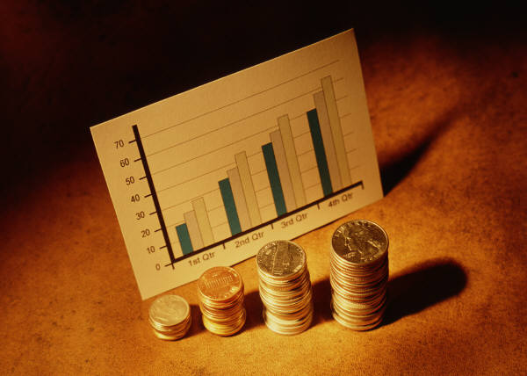
- Cash at bank
- Accounts receivable or trade debtors
- Inventory or stock
- Prepayments (or Pre-paid expenses).
Each account name is listed in one column and the account balance written next to it. The total for the sub category is calculated.
Non-current assets are listed next and are those assets that are held for specific long term purposes. In practice for hospitality and tourism businesses, long term means greater than one year. It is important to be aware that many non-current assets must be depreciated. The sum of the depreciation expense that has been calculated for each asset is called Accumulated depreciation and is reported underneath each fixed asset to which it applies. Because the book value of the asset is reduced by the amount of Accumulated depreciation, this is shown in brackets as follows:
Furniture 40,000
Accumulated depreciation – Furniture (5,000)
There are also non-current assets that are intangible. Intangible means the asset is not a physical substance. An example is the franchise licences issued by multi-national fast food companies. These licences are issued to the outlet owners but are ultimately owned by the company. Because such licences generally bring financial success to the outlet owners, they are considered to be of value and can therefore be classified as a non-current asset by the issuing company.
When all assets are entered, Total assets are calculated and entered into the balance sheet.
Liabilities

The next category to be completed is liabilities which are also separated into current and non-current sub-categories. Current liabilities are debts or obligations that an organisation expects to settle or are due to be settled within the next financial year. Accounts payable and deposits that have been receive from guests or clients but the goods or services have yet to be provided are common current liabilities in the tourism and hospitality industry.
Other liabilities are:
- Accrued Expenses
- Taxes.
There is no agreed uniform presentation for this category. One approach is to list accounts with balances largest to smallest and another is to list in the order indicated above. Workplace policies and procedures should provide appropriate guidelines.
The sub-total for this category is calculated and entered into the balance sheet.
Non-current liabilities are those obligations that do not have to be settled within the next financial year. The most common non-current liability is long term debt such as a loan from a financial institution. This category can very often contain just one or two balances for hospitality and tourism businesses but must still be separated into a category of their own.
Total Liabilities are calculated at this time and entered into the report.
In some cases, at this point in the balance sheet, liabilities are subtracted from assets and a line called Net Assets is inserted. This is the number that will agree to Owners equity to ensure the accounting equation is true.

Owners’ equity
Owners’ equity is the last section of the balance sheet to complete. It summarises the owner’s investment in the business. The content of this section depends on the nature of the owners’ investment as well as the legal structure of the business. Typically there is an account that will detail the funds provided by the owner/s which may be called Capital or Share capital. There is also an account that summarises previous profit and losses called Retained Earnings.
Convention is to list Capital accounts first followed by Retained earnings or other accounts. Total equity is calculated and will agree to Net Assets if the balance sheet has been completed correctly. If this is not the case, there is simply an error in transcribing numbers which a review will confirm. You can be sure that this is where the error lay because, as part of the accounting cycle, you have already confirmed that the debits and credits reported in the final adjusted trial balance are correct.
Comparative data
Sometimes the balance sheet is prepared to include the financial position of the business in the previous reporting period or this information is contained in notes that support the financial reports. Depending on the reporting requirements, there can be balances for up to three past reporting periods included on the balance sheet. This information is easily sourced from past copies of balance sheets that have been prepared.
An example of a simple balance sheet in narrative format from a small hospitality business (hypothetical) follows.

Format of balance sheet
The format of balance sheet is generally standard with the classification of items in the balance sheet demonstrating the accounting equation.
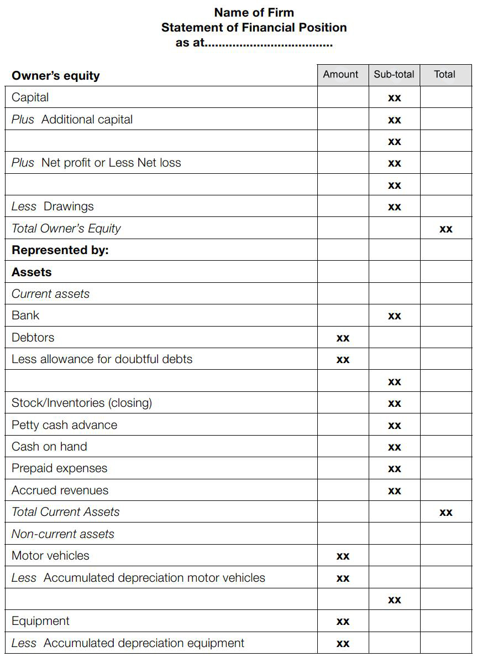
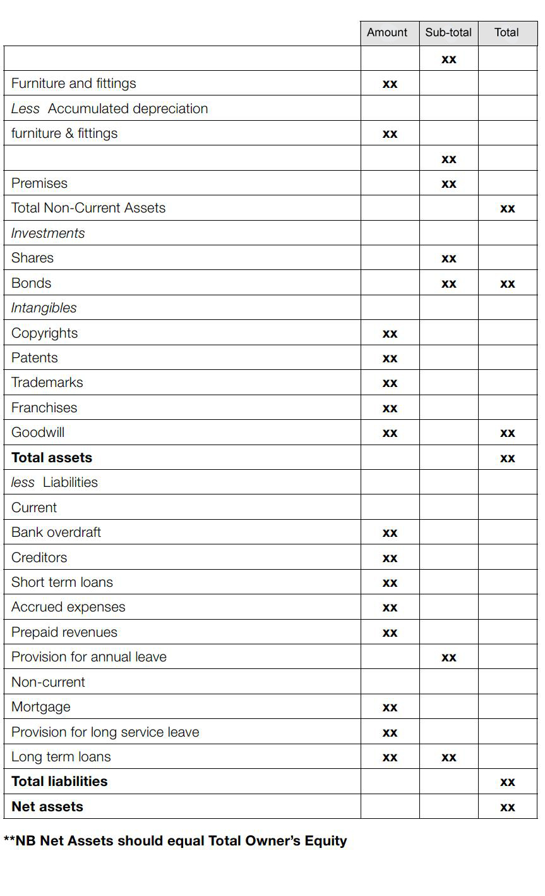

Exercise 4
From the following Trial Balance prepare a:
- Statement of Financial Performance for year ended 30 June
- Statement of Financial Position as at 30 June

City West Travel
Year ending 30 June
Cash at bank | $  2,448
Debtors control | 29,600
Provision for doubtful debts | 573
Stock (end May) | 19,170
Motor vehicles | 14,000
Accumulated depreciation – motor vehicles | 3,150
5% Government bonds | 6,000
Creditors control | 16,800
Capital | 40,481
Sales | 116,400
Rent | 13,330
Interest on borrowings | 300
Purchases | 79,300
Freight inwards | 1,297
Advertising expense | 385
Vehicles expense | 2,965
Office expenses | 1,320
Rent expense | 9,265
Salaries expense | 11,800
Insurance expense | 2,540
Discount allowed | 544
Bad debts | 400
Adjustments required at 30 June
Physical stock take on 30 June was $10,370.

Exercise 5
Rewrite the following data as a Statement of Financial Performance and Statement of Financial Position
Asiana Tours
Year ending 30 June
Accounts payable control | 8,065
Accounts receivable control | 19,307
Accumulated depreciation – motor vehicles | 16,664
Accumulated depreciation – office furniture and fittings | 1,711
Advertising | 1,962
Bad debts | 977
Bank overdraft | 2,258
Capital | 99,894
Discount received | 246
Doubtful debts | 200
Drawings | 1,418
Freight inward | 3,547
Insurance Expense | 855
Interest | 1,740
Inventory (1 July last year) | 9,184
Land and buildings | 145,380
Mortgage on freehold | 61,000
Motor vehicle expenses | 4,498
Motor vehicles | 43,340
Office expenses | 4,015
Office furniture and fittings | 17,966
Provision for doubtful debts | 700
Purchases | 109,116
Sales | 265,332
Sales travelling expense | 1,499
Telephone | 1,818
Computer | 8,000
Printing & Stationery | 2,000
Gas & Electricity | 487
Security | 12,000
Wages – office | 31,421
Wages – sales  Adjustments required, 30 June 2000 | 34,140
- Inventory on 30/06/00 – $8,571
- Depreciation motor vehicles – $6,146
- Depreciation office furniture & fittings – $865
- Note there is no depreciation on the Computer as it was purchased on the last day of the financial year.
Statement of Financial Performance
Name of Firm
Statement of Financial Performance for the Period Ending ...............
 |  |  | Amount | Sub-total | Total
Sales
Less Sales returns and allowances
= Net sales
Less Cost of goods sold
Opening stock (Inventories)
Purchases
Less Purchases returns
= Net purchases
Plus Freight inwards
Customs duty
Wharfage costs
Insurance on stocks
Any other costs of purchasing
= Cost of goods available for sale
Less Closing stock
= Cost of goods sold
Gross profit
Add Miscellaneous operating revenue:
Rent revenue
Commission revenue
Interest revenue
Other operating revenue
Discount received
Total of other operating revenue
Less Operating expenses
Selling & distribution expenses
Freight outwards
Advertising
Depreciation of motor vehicles
Salesperson’s salaries, wages, commissions
Motor vehicle expenses
Other selling & distribution expenses
 |  | Total
Administration expenses
Office stationery
Office salaries & wages
Rates & taxes
Telephone, power, light, etc.
Depreciation of office equipment
Other administrative expenses
 |  | Total
Financial expenses
Discounts allowed
Bad debts
Interest expense
Doubtful debts
Other financial expenses
 |  | Total
Miscellaneous expenses
Donations
Legal costs
Other miscellaneous expenses
 | Total
Total operating expenses
Operating profit before abnormal items
+/- Abnormal items
- additional bad debts
+/- other abnormal items
Operating profit
+/- Extraordinary items
+ Profit on sale of major segment of business
- Loss on sale of major segment of business
Net profit
Statement of Financial Position
Name of Firm
Statement of Financial Position as at.....................................
Owner’s equity | Amount | Sub-total | Total
Capital
Plus Additional capital
Plus Net profit or Less Net loss
Less Drawings
Total Owner’s Equity
Represented by:
Assets
Current assets
Bank
Debtors
Less allowance for doubtful debts
Stock/Inventories (closing)
Petty cash advance
Cash on hand
Prepaid expenses
Accrued revenues
Total Current Assets
Non-current assets
Motor vehicles
Less Accumulated depreciation motor vehicles
Equipment
Less Accumulated depreciation equipment
Furniture and fittings
Less Accumulated depreciation
furniture & fittings
Premises
Total Non-Current Assets
Investments
Shares
Bonds
Intangibles
Copyrights
Patents
Trademarks
Franchises
Goodwill
Total assets
less Liabilities
Current
Bank overdraft
Creditors
Short term loans
Accrued expenses
Prepaid revenues
Provision for annual leave
Non-current
Mortgage
Provision for long service leave
Long term loans
Total liabilities
Net assets

**NB Net Assets should equal Total Owner’s Equity

Operational reports
The business cycle described earlier is a continuous process that summarises day-to-day operations of all hospitality and tourism establishments. For the cycle to run smoothly, managers monitor each aspect of the cycle. Examples of reports that may be prepared summarising the activity for each of these aspects are reviewed below.


Cash reports
Cash and cash reserves in the business cycle include:
- Actual cash available for use in the business
- Arrangements for goods and services to be provided and payment made later.
To manage cash and ensure that there are adequate reserves or arrangements in place to produce goods and services, managers monitor actual cash flows compared to planned cash flows. The document prepared to facilitate this is often called a cash flow summary, a cash flow statement or a statement of changes to working capital.
The financial system provides managers with reports summarising actual cash flow information as and when required and managers can compare this to the cash budget for the same period.
Cash flow summaries
Purpose
Critical in the operation of any business, the cash flow report indicates the present financial liquidity of the property.
Again, this report will compare ‘actual’ figures to ‘projected’ ones.
The purpose of this report is to present information on which management can decide action to ensure the short term financial stability of the venue.
The cash flow statement reports the cash
- Generated

- Used
Free availability of cash is very important in order for any companies to survive.
Statement of cash flows reports the company’s:
- Cash flow position
- Cash flow movement by activities
If a profitable company is short of cash, it might not be able to survive and is at risk of liquidating the company.

Format
The cash flow summary used for internal purposes has no particular format but will always contain:
- Cash receipts details and totals
- Cash payments details and totals
- Net cash flow
- Bank balance at the start of the reporting period
- Bank balance at the end of the reporting period.
When a cash flow is prepared for external requirements, it separates cash activities into three areas:
- Operating
- Investing
- Financing.
Cash inflows and cash outflows for each category and are reported and an overall cash movement calculated.
Preparing cash flow summaries
Cash receipts
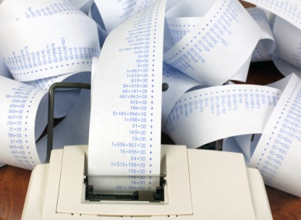
Usually, the first component of the cash flow summary to be prepared is cash receipts. Cash receipts from operations results from payment for goods and services when they are provided and amounts received from debtors to settle their account. This information is reported to accounting personnel daily from point of sale reports and daily cash received reports and entered into appropriate journals. The cash flow summary reports the total amounts for the two sources of cash receipts from the journals separately.
Cash payments
Cash payments or cash disbursements is the next section of the cash flow summary to be completed. All cash payments made for the reporting period are included in the cash flow summary by category of expense. This is similar to the profit and loss report but only includes expenses where cash has been paid.
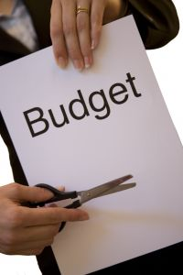
The net cash flow can now be calculated by deducting cash payments from cash receipts. This figure is added to or subtracted from the bank balance at the start of the reporting period to determine the total cash available to the business.
Cash budget
Cash flow summaries will also include the cash budget for the current reporting period and even future or past reporting periods as well. Managers can compare the cash position compared to the plan to evaluate the performance of the business.

Routine cash reports
The routine cash reports described above are most often used by management to monitor and control cash flow. Daily recording of cash receipts provides timely information that allows managers to assess the funds available to pay costs associated with producing goods and services so that the business cycle can maintain a continuous flow of operations.
Daily Takings report
Given the high volume of cash transactions that can occur in tourism establishments, the daily takings report is one of the key routine reports prepared.
It is completed at each point of sale terminal or register in the organisation and summarises the cash received for the day or shift.

Typically, supervisors close the terminal or register and a register tape or document printed or displayed on screen details the cash receipts. This detail is entered and the tape attached to the daily takings report.
The cash contained in the register or terminal is counted, recorded on a cash slip less the float from the start of the day or shift and entered into the daily takings report. It is totalled and should agree to the register tape. Any discrepancies must be noted, investigated and resolved.
The daily takings report is forwarded to the accounts department and the cash and cash slip to the personnel responsible for banking. At this point, the ledger account and bank account are updated with the cash received for the day.
Daily cash received report
The daily cash received report is typically completed by accounts receivable personnel and summarises the amounts settled by debtors that day. The cash received from each debtor is entered and a total calculated.
A cash slip with the cash is forwarded to personnel responsible for banking. The daily cash received report may be used to update the accounts receivable subsidiary ledger and then forwarded to the accounts department to update the accounts receivable control account.
This process depends on the number and amounts of accounts receivable. You should refer to policies and procedures in your workplace to ensure you are aware of the particular process adopted.

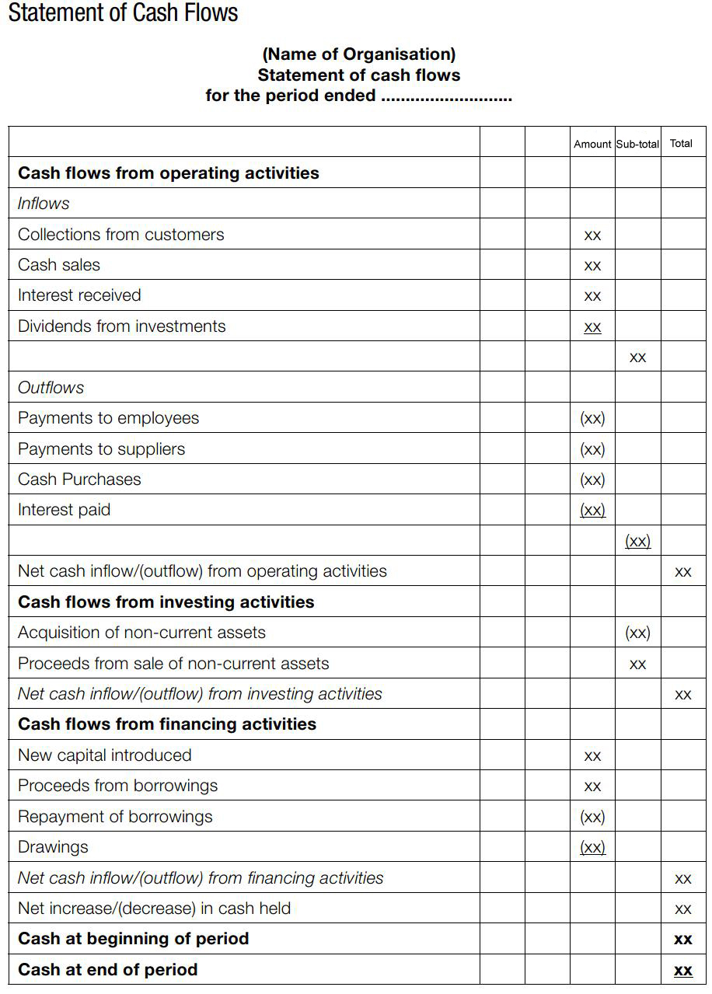

Bank reconciliation
The bank reconciliation provides management with an independent verification of the cash available for use in the business. Along with the cash flow summary, management can make informed decisions on the use of cash in operations.
The bank reconciliation report has been discussed in Section 1 of this manual.

Budgets
Budgets can be plans about the short-term future of up to a year. They can be expressed in money terms or in terms of quantities of things such as goods in stock, number of customers to be served per day etc.
A budget therefore is a statement of management’s planned outcomes for the business, expressed in dollars or quantities to achieve its objectives for a precise period of time.
Any line item that has a budget set for it can have a budget report generated.
Most budget reports combine several and related line items into the one report. In many cases the one budget report may cover all the areas.
Primarily, this report will compare actual figures for the period against the budget/target, and also compare it with same time, last year. The report usually contains dollar figures together with percentages and ratios where appropriate.
Types of budgets include:
- Sales budgets – to forecast sales revenue
- Labour budgets – to forecast labour expenses
- Material budgets – to forecast purchases of goods for sale or for use in preparing finished products

- Inventory budget – planning quantities to be held in stock and the amount of money invested in stock
- Overhead budgets – concerns other estimated operating expenses
- Capital expenditure budgets – plans for long-term assets to be purchased, replaced, upgraded
- Budgeted Financial Performance statement – concerns estimated profit or loss
- Cash budgets – concerns the estimated cash inflow, cash outflow and cash position of a business
- Budgeted statement of Financial Position – concerns estimated values of assets, liabilities and owners’ equity at the end of a budget period.

Sales reports
This report condenses revenue figures from all the revenue areas into one detailed document.
In dollar terms, the sales from these areas will be set out and compared to budgeted figures.
Comparisons will also be presented with the same time last year, together with a running year-to-date total.

Breakdowns of these figures will allow management to identify how the total sales figures for a department are made up.
Many of these reports will include written comments too, which may explain the reason for peaks or troughs in the revenue. Perhaps a new promotion started on that day, maybe there was exceptionally bad weather, or the road outside the property was closed all day for road repairs.
Reports for this section of the business cycle focus on the sales generated from providing goods and services to customers, guests and clients. They are unique to each establishment and are guided by operations and management requirements.
Daily revenue report or schedules
Purpose
Owners and managers wish to monitor revenue earned during business cycles as this revenue contributes to the overall financial performance of each department and the entire business. Whilst revenue is reported in profit and loss statements, revenue reports include the amounts of sales for the particular area of operations and other comparative data. This gives managers a detailed insight into operations enabling a more complete evaluation and review for decision-making.
Format
Revenue reports are designed to meet the requirements of individual organisations and have no particular standardised format. An example of a simplified revenue report for a tourism establishment selling tours might look like this.
Number of days due | Actual revenue (today) | Budget revenue (today) | Last year (same day) | Ratios
Total seats available
Number of seats sold in total
Merchandise sold

Preparing the revenue report
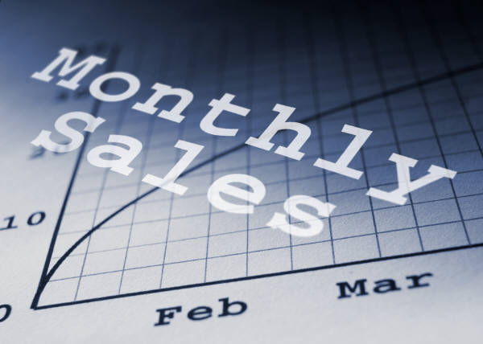
Actual sales for the reporting period
Depending on the organisation, there are different categories of sales that are included as revenue. For example, a tour operator earns revenue from each different tour or package offered.
Because a revenue report is produced frequently, most organisations will have established an electronic means of preparing the report, such as spread sheet software, so that managers receive the report in a timely manner.
For a computerised accounting system, it is usual practice to review the sales balances and if any adjustments are to be made, prepare a worksheet similar to the worksheet described earlier to record these changes. A full trial balance is not required. When there are no adjustments, the report is produced directly from the computerised system.
In a manual accounting system, ledger account balances would be entered into a worksheet or similar document and the revenue report produced.
Budget or forecast information
Daily, weekly and monthly budgeted sales are the most common sales that are included in a revenue report. This gives the users of the revenue report the information needed to compare the current day, week or month’s performance to what was planned when the budget was prepared.
In practice, because revenue reports are often produced to meet strict deadlines, some budgeted sales data remains the same on the revenue report from one time period to the next. It is adjusted only when a new basis of comparison is required. For example, monthly budget information on a daily revenue report will remain the same during that month and will only be updated at the start of the next month.
Previous period performance
Many revenue reports also provide managers with detailed sales information on the performance of each category of sales from the previous reporting period. This may be sales results from the previous month or year or both.
This information may be stored manually or electronically in a computerised accounting system or other software. Relevant data is entered directly into the revenue report and similar to budgeted sales amounts, only changes when the time period that is being reported changes.
Ratios for analysis
Many revenue reports will provide owners and managers with key financial and operational ratios that will the current time period but also may include budgeted and previous period ratios as a basis for comparison. Users of the revenue report review the absolute financial amounts and interpret relevant ratios to provide a detailed assessment of both current and future financial performance.
Common ratios that are calculated for the tourism industry are discussed Section 1.5 of this manual.
Ratios are generally calculated by electronic software such as a spread sheet, database or a computerised accounting system once the required data is entered appropriately. If a revenue report is prepared manually, the formulas for calculating ratios will often be at hand to ensure the timely completion of the revenue report.

Expenditure reports
In the same way managers are expected to achieve and monitor income targets, they are also expected to keep expenditure under control.

Expenditure reports reflect actual expenses by classification, and compare them to the budgeted expenses at the same time last year. A year-to-date total may also be supplied, together with an indication of whether each expenditure item is above or below target.
Ratios or other statistical analysis such as vertical and horizontal analysis will either be included in the report or managers can calculate the information based on the information the report contains and the particular aspect of operations they wish to evaluate.
Purchase summary reports
These reports group purchases by supplier and category to present an overview of where the purchases are being made, and how much is being spent.
This allows management to monitor dealings with suppliers with a view to cross-checking whether sales in these areas appear relative to the purchases that have been made.
Purchase order summary
To inform managers of departments and accounting personnel as appropriate, purchase order reports are prepared daily or weekly depending on the frequency in which products or services are ordered. These reports detail the amount and total cost of goods and services which have been ordered. Managers can add these to expense reports to estimate the costs or expenses that the department will incur.
In some organisations, the purchase orders are entered directly into the accounting system as expenses from the purchase order summary. This gives managers complete control over the timing and amount of expenses that will appear on their profit and loss statements and cost reports as no adjustments have to be made.

Payroll cost report
Purpose
Labour or payroll costs are one of the most significant expenses for organisations. It is usually monitored and controlled daily depending on the size of the organisation but is at least prepared monthly. Managers from each department and the establishment as a whole need to monitor hours worked and the rates of pay for the different categories of employees that work in the respective departments.
Format
The payroll cost report is designed by individual establishments to meet the needs of managers. For each department, the payroll costs that apply to that department will be included. For the entire establishment, payroll costs will usually be separated by department or functional area.
Payroll cost reports usually include at least the following information:
- Regular hours worked (stated as hours)
- Overtime hours worked (stated as hours)
- Total hours worked
- Total payroll cost - this may be separated into regular and overtime categories before a total is calculated.
This is calculated for each day and the month to date. The budget for the month or day will also be included and any operational ratios required by managers.
Preparing the payroll cost report

The payroll cost report is prepared from information in the payroll subsidiary ledger, based on hours and pay rates that have been approved by managers. In a computerised accounting system, reports are prepared automatically from payroll data and in a manual environment, payroll reports or summaries from each department contain the information required. For ease of illustration, a daily payroll cost report is discussed but the same principles apply for any other time period chosen.
Hours worked for the day
For each department or area, the total hours worked for the day by all employees are added and entered into the report. This is split between regular hours and any overtime hours. This allows managers to evaluate their staffing decisions and assess the impact on the total cost for their department.
Rates of pay
When employees are hired, an hourly rate or salary forms part of their employment conditions. This rate may be set outside the organisation by government bodies that set a minimum rate of pay for all employees, depending on the duties and responsibilities of the position.

Total daily payroll cost
To calculate the total payroll cost, hours worked is multiplied by the appropriate rates of pay. Usually departments will require this information for the different categories of staff that are employed by that department. For example, a food and beverage department manager may ask for the payroll cost report to be separated by kitchen staff, floor staff and supervisors.
Month to date calculations
Regular and overtime hours worked and the total payroll cost for the month to date are also included in the daily payroll cost report. This enables managers to review their payroll costs to date for accuracy, completeness and against expected costs.
Budget payroll
The budgeted payroll cost for the month is reported in the daily payroll cost report so managers can compare the actual cost to the cost that was planned or expected. At the time the budget was prepared, managers would have made certain assumptions to determine their staffing needs and therefore payroll cost. When managers can compare the actual costs to the budget, the accuracy and validity of their assumptions is confirmed. Also, if the actual results vary from the budget, managers can investigate reasons. This will improve control of costs for future reporting periods.
Ratios for analysis
The final calculations included in the report are relevant ratios that management use to monitor and control payroll costs. This is most commonly the payroll cost expressed as a percentage of sales. We have referred to this as the labour cost percentage earlier in this manual. A pre-determined labour cost standard, the current daily calculation and the month to date percentage are usually contained in the report. There may also be a percentage for the labour cost for the same time last month or year.
Often, this is the first part of the report the department manager will look at as a labour cost percentage that varies significantly from what was expected would always be investigated.

Stock reports

These reports identify stock levels at each of the different revenue centres within the property.
Management can monitor this stock level to identify whether too much stock is being held in that area, given the sales and stock turnover that occurs.
Management may be able to reduce this stock level whilst not adversely affecting performance, thus freeing up funds for more productive use elsewhere in the organisation. In addition, management may notice that additional reserve stock levels should be obtained to support a particular revenue centre.

Stocktaking sheets
These sheets are used to record actual stock-on-hand at predetermined times. Some premises conduct daily stock takes, some weekly or monthly, with some doing only an annual stock take to comply with legal and taxation requirements.
One function of the stocktake sheets is to assist in the calculation of the ‘cost of goods sold’ for a certain area for a certain time period.
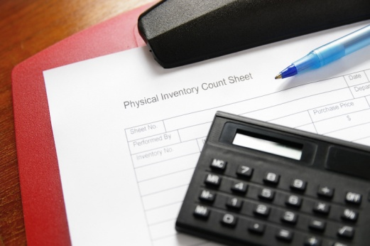
The basic formula being:
(Opening stock + Issues/Requisitions) - Closing Stock = Cost of Goods Sold
For example, if a department has $10,000 worth of stock (at cost price) at the start of the month (called Opening Stock), and then requisitions further stock during the month to the (cost price) value of $30,000 and then has a closing (cost price) stock level at the end of the month of $5,000, we can calculate the cost of goods sold for the month as follows:
($10,000 + $30,000) - $5,000 = $40,000 - $5,000 = $35,000
Another function of the stocktake sheet is to provide an overview of the actual stock lines that are being carried by the property, on an item-by-item basis. This allows management, with their local knowledge of the venue and their customers, to determine whether or not this blend of products needs to be changed in any way so as to increase the number of stock turns.

Wastage reports
This is not a common report as many believe that the time and trouble needed to compile them outweighs their benefit.
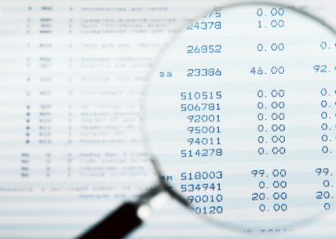
These reports will highlight stock that has not been used as intended, to produce revenue.
These reports can identify situations where too much perishable stock is being bought, and storage practices that are sub-standard and thus causing product loss.
The report can also help identify finished products that are not popular and not selling, as well as other items that are proving to be unfit for the purpose they were purchased.
Management may elect to follow up these issues with suppliers to recover expenses, or negotiate some other resolution. It may be the case that the product purchased, or the supplier used, will have to be changed.

Receivable reports
These reports are especially useful in the hospitality industry as they allow (‘force’) managers to regularly review and monitor costs to the property.
Control of costs is the fundamental focus of this report, and the invoices supporting these purchases may accompany this report to enable fuller information to be supplied to the decision makers, and to allow more rapid follow up of problem or suspect areas.
Accounts receivable ageing schedule
The accounts receivable ageing schedule details the amounts owing from debtors by days outstanding; it is reviewed using this example format:
Number of days due | Current | Less than 30 | 30-60 | 60-90 | 90+ | Total
Accounts Receivable | 4,900 | 490 | 1,400 | 140 | 70 | 7,000
Percentage | 70% | 7% | 20% | 2% | 1%

Variance reports
This report provides an overview of all variances that have been identified throughout the property.
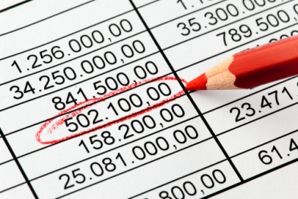
These variances are usually restricted to variances between ‘budget’ figures and ‘actual’ figures.
These variances will cover both the positive and the negative variances, and will present both dollar figures and percentages.
This is an extremely useful report in that your ability to deliver ‘on budget’ is usually vital in any business situation.
These reports may be used to compare performance in one area of the property with another. This may be done to see if there is an establishment-wide trend, for example, of increased revenue, or whether the outcome is specific to one particular area.
The reports can also be used between establishments where there are different properties owned by the one company.

Supporting information reports
The business may elect to generate a number of reports reflecting specific items, or areas, of the establishment’s performance. These may be standing or ad hoc in nature. They may be daily or weekly in frequency.
Examples of supporting reports include, but are not limited to:
- Number of actual enquiries
- Number of customers

- Units sold
- Types of packages or tours booked
- Actual products and services booked
- Average spends of customers
- Staff wage costs
- Productivity.

Check financial reports for accuracy prior to distribution
Before any information or reports leave your hands it must be standard practice to check them for accuracy and completeness.
It is essential you establish a reputation from Day 1 for producing data that can be relied on.
Accuracy
It should follow that where the source documents and figures on which financial reports are based are accurate, then the report itself should be accurate.
This is certainly the case with computerised systems but where manual reports are produced it is not unknown for transpositional errors to occur.
This means that you may inadvertently copy down $45,876.00 as $54,876.00 yet still enter a final total that is correct but which does not ‘add up’ when the given figures are totalled by another person.
An effective way of guaranteeing accuracy is to obtain the help of another authorised colleague and use the system of ‘one read, one visually check’ to validate the figures.
Another way is to use your familiarity and understanding of the business and review the reports before they are distributed to see if they ‘make sense’ from your knowledge of the operation.
Possible problems at this stage are:
- Using incorrect source documentation
- Using incomplete source documentation
- Using out-of-date source documentation
- Transcription errors
- Putting the decimal point in the wrong place
- Placing the right figure against the wrong description
- Missing out a figure when calculating

Activity 32 - Understanding financial reports

From a tourism establishment of your choice, you are required to obtain one recent example of a financial accounting report and one recent example of a management accounting report and list the following for each report:
- The name of the report
- The reporting period
- The purpose for which the report was produced
- At least two accounting assumptions that are relevant to this report
- Comment on the format of the report – why is the format chosen? Does it follow any of the formats discussed?



2.2 Forward financial/statistical reports promptly to the appropriate person/department

Introduction
Once financial reports are prepared and finalised, they are ready to be distributed to relevant parties. There are a number of aspects of this distribution process that require careful thought and planning so that the confidentiality and integrity of financial information is maintained.

Distribution of reports
The forwarding of the reports may simply entail leaving a hard copy of reports in the in-tray for each department or manager.
In some properties, e-mail may be used.
Each establishment will have its own roster for the distribution of reports.

Commonly financial reports do not have as wide a circulation as other operations reports and possible recipients include:
- Management at, or above, a prescribed level
- Owner
- Investors in the property
- Designated Sales and marketing people
- Accounts department.

Reporting periods
Financial reports are often required to be prepared in a certain time frame or by a certain date for a variety of reasons.
This deadline may be imposed by external parties such as banks and government agencies to meet security or funding requirements or by owners, especially if the organisation is part of a group of companies.
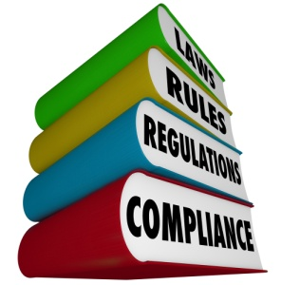
Often managers are required to report financial activities to owners' daily, weekly or monthly and therefore need financial reports to review to meet this deadline.

Confidentiality of reports
All financial reports contain information that is confidential and potentially sensitive such as employee’s pay details or pricing strategies to gain an advantage over competitors. Therefore, there must be great care taken to ensure that these reports are distributed appropriately so that confidentiality is not compromised.
It is also necessary to maintain secure and confidential workplace practices when preparing all financial reports. This includes signing out of confidential programs in a computerised system, securing confidential documentation and maintaining an orderly workspace.

Report distribution processes
Depending on the size of the organisation, you may find that the same financial activities are summarised into financial reports in different ways to distribute to different users.
For example, at the end of a month, the manager requires a detailed report on the revenue and expenses for a department or activity and at the same time requires a profit and loss statement for the entire organisation as well as each department.

For a smaller organisation, managers may require a profit and loss statement and then request more detail in the form of other management reports as required.
It is important to ensure that there are detailed protocols or procedures in place that describe these requirements so that financial reports are distributed appropriately.
It is also important to maintain a complete and current list that identifies personnel, departments and organisations that receive financial statements.
This should always be checked for personnel changes or any other procedural changes prior to the distribution of financial reports.

Report distribution information
Management accounting reports are prepared and distributed to appropriate personnel within the organisation as frequently as is required to effectively manage the business.
To manage this process, a schedule is prepared or maintained that holds such details as:

- Name of report
- Reporting period
- Date report to be completed
- Personnel to receive report
- Distribution method such as electronic or hard copy
- Other notes.
To accompany this, there may be a form that records when reports were sent, received and returned depending on organisational procedures. For example, if a report is sent electronically, a receipt can be sent indicating that the report was received. If a report is prepared as a hard copy, appropriate personnel may manually sign this form to indicate that they have received the report.
To maintain confidentiality, management accounting reports that are available electronically will require a password and are often only available for a certain period of time.
Hard copy reports may need to be returned or only viewed in a secure environment. Most organisations recognise that it is difficult to maintain security for hard copy reports so would only distribute confidential or sensitive information securely.


Activity 33 - Understanding financial reports

Create a distribution list for reports that are produced as part of the production of goods and services part of the business cycle.
Include all managers and personnel of a tourism organisation you think require the report and the procedures you would follow to ensure confidentiality if relevant.

REPORT DISTRIBUTION LIST
MANAGER / STAKEHOLDER | REPORT REQUIRED




Work Projects
It is a requirement of this Unit you complete Work Projects as advised by your Trainer. You must submit documentation, suitable evidence or other relevant proof of completion of the project to your Trainer by the agreed date.
2.1 Please complete the following activities relating to this Performance Criteria:
- Activities 30,31,32
2.2 Please complete the following activities relating to this Performance Criteria:
- Activity 33

Summary

Complete financial reports
Accurately complete routine financial/statistical reports within designated timelines
- The need for reports
- The accounting period
- Impacts on frequency of statements and reports
- Users of financial information
- Financial report topics
- Summary of reports prepared in the tourism organisations
- Statement of Financial Performance / Profit and Loss Statement
- Statement of Financial Position / Balance Sheet
- Operational reports
- Cash reports
- Budgets
- Sales reports
- Expenditure reports
- Stock reports
- Wastage reports
- Receivable reports
- Variance reports
- Supporting information reports
- Check financial reports for accuracy prior to distribution
Forward financial/statistical reports promptly to the appropriate person/department
- Distribution of reports
- Reporting periods
- Confidentiality of reports
- Report distribution processes
- Report distribution information

Presentation of written work

Introduction
It is important for students to present carefully prepared written work. Written presentation in industry must be professional in appearance and accurate in content. If students develop good writing skills whilst studying, they are able to easily transfer those skills to the workplace.


Style
Students should write in a style that is simple and concise. Short sentences and paragraphs are easier to read and understand. It helps to write a plan and at least one draft of the written work so that the final product will be well organised. The points presented will then follow a logical sequence and be relevant. Students should frequently refer to the question asked, to keep ‘on track’. Teachers recognise and are critical of work that does not answer the question, or is ‘padded’ with irrelevant material. In summary, remember to:
- Plan ahead
- Be clear and concise
- Answer the question
- Proofread the final draft.

Presenting Written Work
Types of written work
Students may be asked to write:
- Short and long reports
- Essays
- Records of interviews
- Questionnaires
- Business letters
- Resumes.
Format
All written work should be presented on A4 paper, single-sided with a left-hand margin. If work is word-processed, one-and-a-half or double spacing should be used. Handwritten work must be legible and should also be well spaced to allow for ease of reading. New paragraphs should not be indented but should be separated by a space. Pages must be numbered. If headings are also to be numbered, students should use a logical and sequential system of numbering.
Cover Sheet
All written work should be submitted with a cover sheet stapled to the front that contains:
- The student’s name and student number
- The name of the class/unit
- The due date of the work
- The title of the work
- The teacher’s name
- A signed declaration that the work does not involve plagiarism.
Keeping a Copy
Students must keep a copy of the written work in case it is lost. This rarely happens but it can be disastrous if a copy has not been kept.
Inclusive language
This means language that includes every section of the population. For instance, if a student were to write ‘A nurse is responsible for the patients in her care at all times’ it would be implying that all nurses are female and would be excluding male nurses.
Examples of appropriate language are shown on the right:
Mankind | Humankind
Barman/maid | Bar attendant
Host/hostess | Host
Waiter/waitress | Waiter or waiting staff

Recommended reading
Alfredson, Keith & Ernst & Young; 2009 (2nd edition); Applying international financial reporting standards; John Wiley & Sons
Andrew, William P & Schmidgall, Raymond S; 2007 (1st edition); Financial management for the hospitality industry; Pearson Prentice Hall
Chatfield, Robert E & Dalbor, Michael C; 2009 (1st edition); Hospitality financial management; Pearson Prentice Hall
Cornett, Marcia Millon & Adair, Troy A; 2015 (3rd edition); Finance: applications & theory; New York McGraw-Hill Education
DeFranco, Agnes L & Lattin, Thomas W; 2007 (1st edition); Hospitality financial management; John Wiley & Sons
Futura Training 2008; (1st edition); Manager's guide to hospitality financial management; Futura Training
Guilding, Chris; 2013 (1st edition); Accounting essentials for hospitality managers; Abingdon, Oxon Routledge
Jagels, Martin & Ralston, Catherine E & Ebooks Corporation; 2007 (9th edition); Hospitality management accounting; John Wiley & Sons
Jiambalvo, James; 2013 (5th edition); Managerial accounting; Hoboken
Price, John Ellis & Haddock, M. David; 2015 (14th edition); College accounting; New York McGraw-Hill Education
Rayman, R. A; 2006 (1st edition); Accounting standards: true or false? Routledge
Waybright, Jeffrey & Kemp, Robert S; 2015 (3rd edition); Financial accounting; Boston Pearson

Trainee evaluation sheet

Audit financial procedures
The following statements are about the competency you have just completed.
Please tick the appropriate box | Agree | Don’t Know | Do Not Agree | Does Not Apply
There was too much in this competency to cover without rushing.
Most of the competency seemed relevant to me.
The competency was at the right level for me.
I got enough help from my trainer.
The amount of activities was sufficient.
The competency allowed me to use my own initiative.
My training was well-organised.
My trainer had time to answer my questions.
I understood how I was going to be assessed.
I was given enough time to practice.
My trainer feedback was useful.
Enough equipment was available and it worked well.
The activities were too hard for me.

The best things about this unit were:

The worst things about this unit were:

The things you should change in this unit are:

Trainee self-assessment checklist
As an indicator to your Trainer/Assessor of your readiness for assessment in this unit please complete the following and hand to your Trainer/Assessor.

Audit financial procedures
 |  | Yes | No*
Element 1: Monitor financial procedures
1.1 | Check transactions accord with enterprise procedures
1.2 | Balance transactions accurately
1.3 | Check balances prepared by others are in accordance with enterprise procedures
1.4 | Implement and control financial systems in accordance with enterprise procedures
1.5 | Monitor financial systems and provide input on possible improvements to appropriate personnel
1.6 | Identify and resolve discrepancies or errors according to level of responsibility and in consultation with designated persons
Element 2: Complete financial reports
2.1 | Accurately complete routine financial/statistical reports within designated timelines
2.2 | Forward financial/statistical reports promptly to the appropriate person/department

Statement by Trainee:
I believe I am ready to be assessed on the following as indicated above:
Signed: _____________________________ | Date: ____________

Note:
For all boxes where a No* is ticked, please provide details of the extra steps or work you need to do to become ready for assessment.





